|  |  |
| --- | --- |
|  |  |



App Architecture, App Services, AKS, Containers, Azure Functions, Networking

- - - - - - - - - - - -

**Part 2 of 4**

**Contents**

Azure Compute . . . contd. 3

Architecture Diagrams 3

Importing Azure Icons to Visio 4

Resources [ Getting the Stencils etc. ] 4

Process [ Setting up your Visio ] 5

A word of Caution ! 10

App Services 11

Auto Scaling App Services 15

Setting up the App Service – Inventory 16

Deployment Slots 43

Deployment Types 56

Basic deployment 56

Rolling Update 57

Blue Green Deployment 58

App Services Tips and Tricks 59

AKS 59

## Azure Compute . . . contd.

### Architecture Diagrams

**. . . contd in next document as this one becoming too large . . .**

We are going to build the architecture diagram of our ReadIt Web app together while building it. Now, when designing architecture for Azure apps it's always a good idea to use Azure symbols in the diagram and not just generic boxes, arrows and other shapes. Now, actually there are hundreds of them.

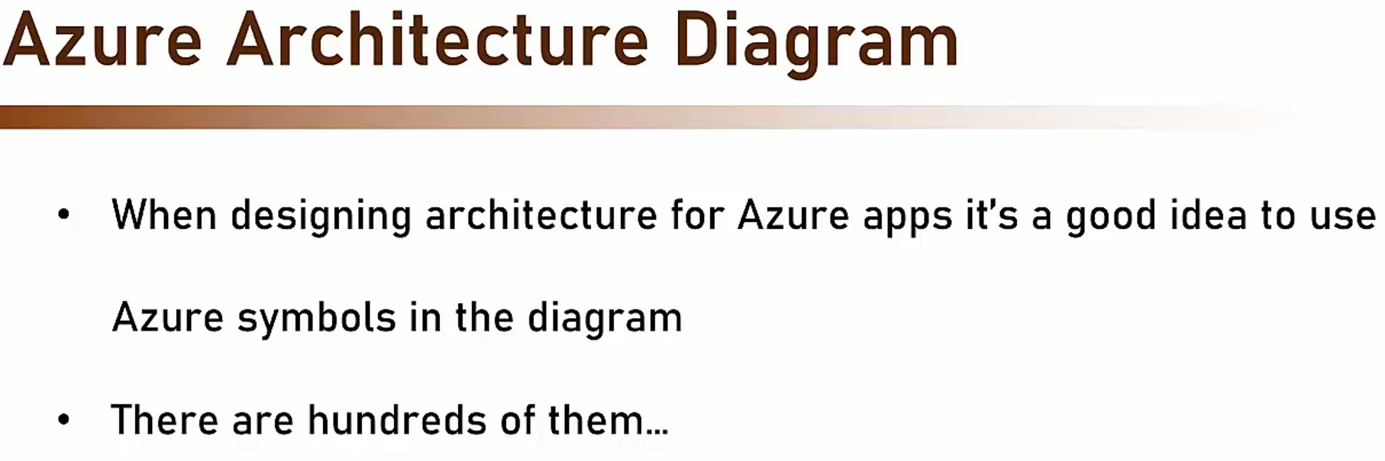

There are hundreds of Azure symbols that we can and should use, and the best way to actually use them is simply to download Azure icons. And this can be done with this link.

<https://learn.microsoft.com/en-us/azure/architecture/icons/>

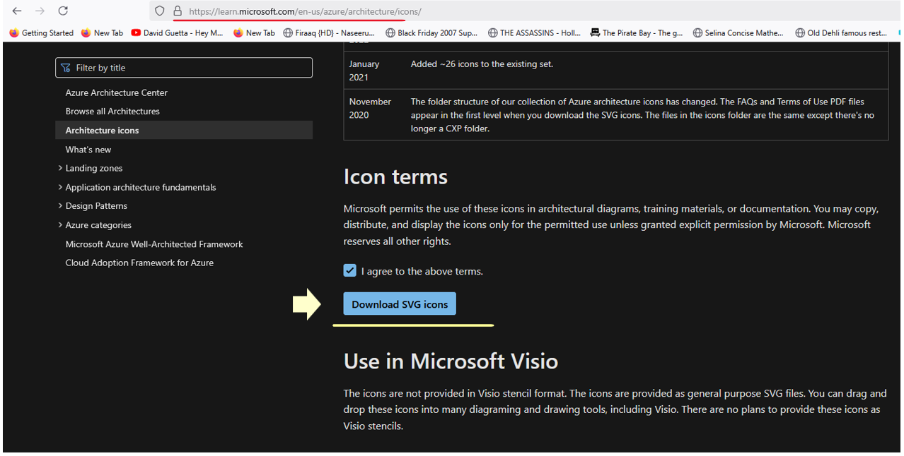

So using this link, we can download a set of Azure icons which will be used in our architecture diagram. So I highly recommend you download these icons so you can use them in your future architecture diagram that you will create for your Azure apps. So let's see them. So let's open another page in the browser and copy the link to the icons and hit enter. And here we have the page of the Azure architecture icons. We can scroll down and agree to the terms and download the SVG icons.

And the download is done. Click on the zip file and let's copy this folder to our let's say C drive right here. As you can see, there are right now 343 items that were downloaded.

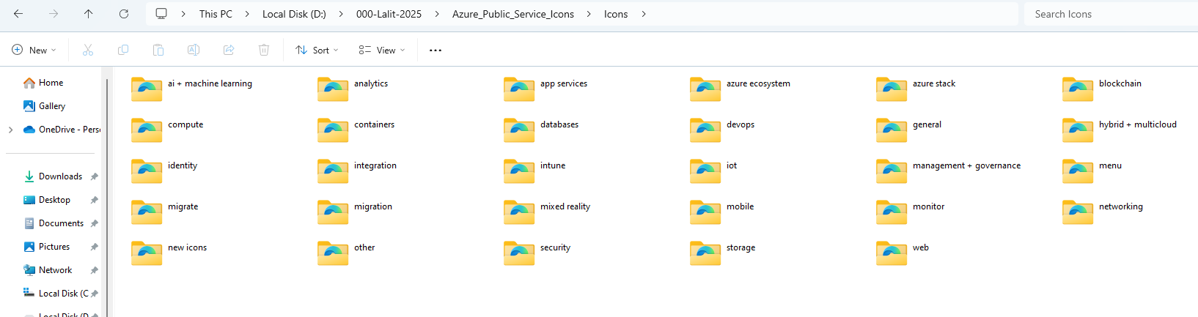

~~And here you can see the icons divided by the resource types. And for example, let's go to compute and with compute, look for the virtual machine icon, which is right here and click it. Now you want to open this file in a browser that supports SVG. Most modern browsers support it. But just to make sure, I'll pick this browser Google Chrome, and use it as a default and okay. And while it's quite small, but you can see here the icon of the virtual machine. Now if you take this file, the SVG file and drop it for example, on a PowerPoint slide, then it'll look much better and you can of course resize it. Now since it's an SVG file, a vector file and not a JPEG or PNG or gif, then you can resize it and it won't get pixelated. So whatever size of icon you want to use, it will always look great. So this is the icon of virtual machine. Let's look at some other icons. For example, let's look at the skillset icon. I will zoom in in the browser and you see this is how skillset looks in Azure diagrams. We can see more examples that we are familiar with if we'll go back to icons and into general and click the subscription icon. So this is how subscription is represented in architectural diagram of Azure. And the last icon I want to show is of resource group which you already familiar with. And this is how resource group looks like in Azure architecture diagrams. Now of course there are hundreds of icon here and most of them you are not familiar with yet, but we will go through many of them as we will progress in this course.~~

Above is all about using SVG Icons – We will work with stencils instead in Visio 😊

App Architecture

So this is how our cloud architecture, the ReadIt app cloud architecture looks right now. We have two virtual machines, one is used for the catalog app and one is used for the weather API. So this is the first and the very basic architecture of the Read It app and of course, as we progress through all the other elements of this course then more elements will be added to this architecture.

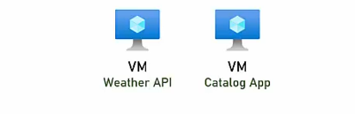

**Youtube Video**

<https://www.youtube.com/watch?v=UjPZAC1AbKc>

### Importing Azure Icons to Visio

#### Resources [ Getting the Stencils etc. ]

**Visio - Azure Stencils instead of SVG Graphics**

<https://blog.sandro-pereira.com/2020/03/09/microsoft-integration-and-azure-stencils-pack-for-visio-new-version-available-v6-2-0/>

<https://github.com/sandroasp/Microsoft-Integration-and-Azure-Stencils-Pack-for-Visio/blob/master/Azure/SVG/Azure-API-for-FHIR.svg>

**Visio - Azure Stencils**

<https://github.com/sandroasp/Microsoft-Integration-and-Azure-Stencils-Pack-for-Visio/tree/master>

**If you use Chrome then we have the Amazing Icon Downloader**

<https://chromewebstore.google.com/detail/amazing-icon-downloader/kllljifcjfleikiipbkdcgllbllahaob>

#### Process [ Setting up your Visio ]

Download all the Visio Stencils required from here and place them into a folder

<https://github.com/sandroasp/Microsoft-Integration-and-Azure-Stencils-Pack-for-Visio/tree/master>

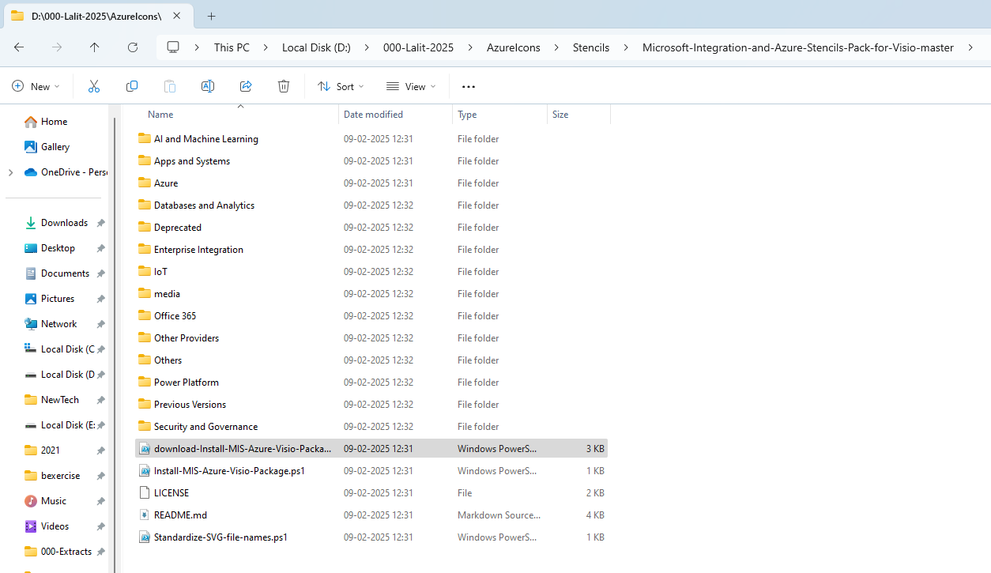

Each of these folders has the images and the stencil as well

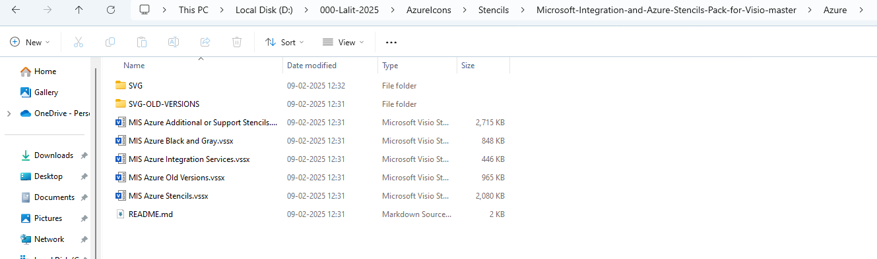

Lets import the stencils into Visio now

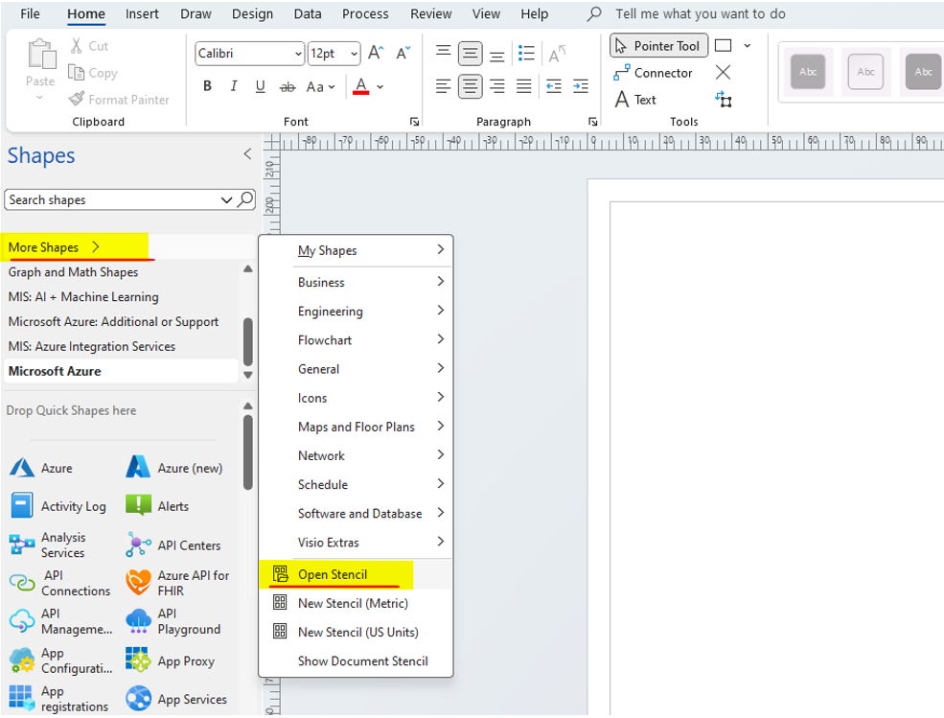

And we got all of them opened up as a Stencil in Microsoft Visio now – we can draw the Azure Architecture Diagrams now

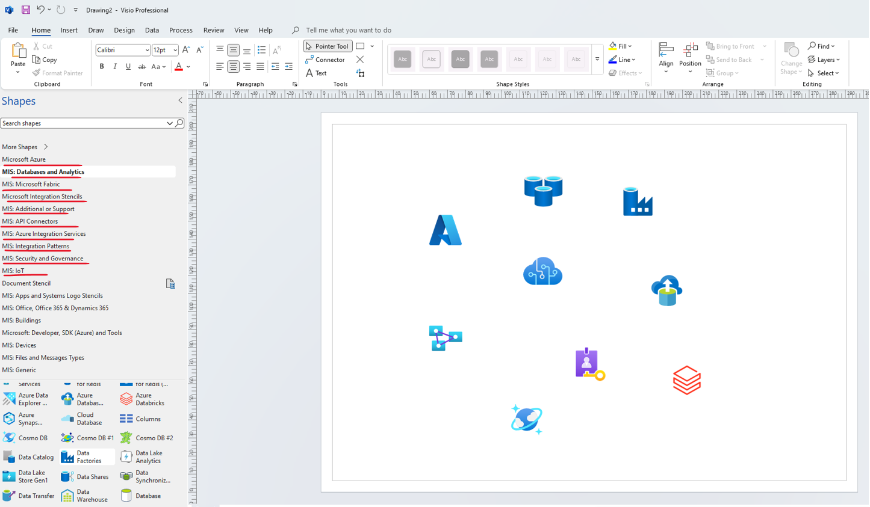

If you want them available each time drag them into the MyShapes folder

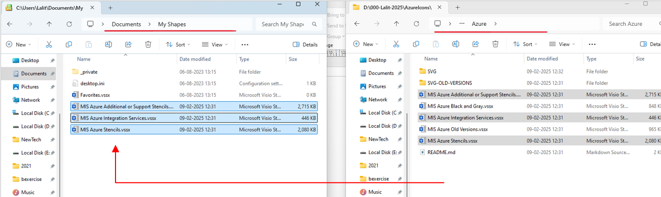

So we brought all of them into the My Shapes folder

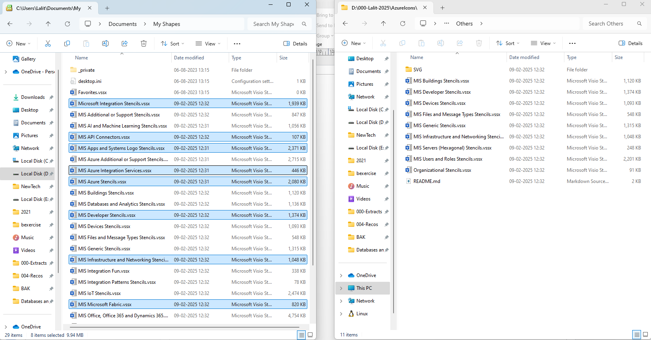

Lets open Visio again now

They will all appear under the My Shapes > Favorites

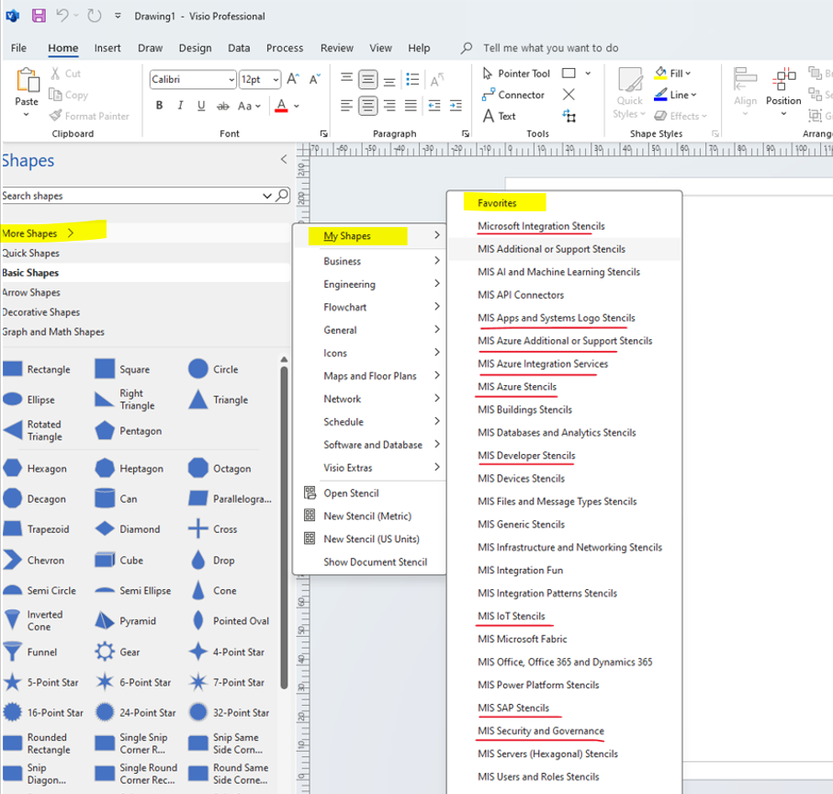

Select them and they start appearing

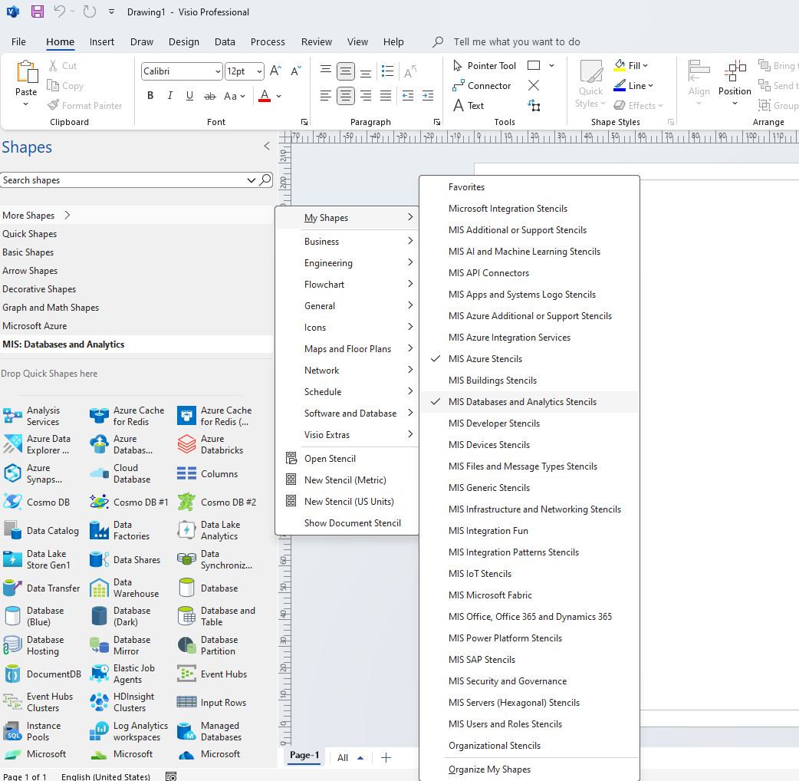

### A word of Caution !

Now before moving on to the next topic, which is app services, I want to say a word of caution. Look at the Catalog app, at the virtual machine containing the Catalog app. This machine is directly accessible from the internet and also can be RDPed from anywhere. So anyone who knows the virtual machine public IP address, can now RDP into it. And these are a giant security risks. So as a rule of thumb, never leave a virtual machine open to the internet this way. This is a huge security risk and never should be done.

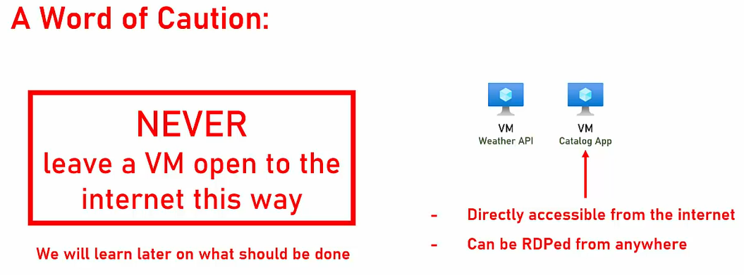

This is not a best practice. Never leave a virtual machine open to the internet this way.

Shutting down the Machines

If you're not planning on playing more with the VMs we just created (the Catalog VM and the Weather VM), then it might be a good idea to shut those machines down, so you will not pay for them when not in use. So in this case - simply shut them down.

### App Services

App Services is a fully managed web hosting for websites and it allows you to publish your code and then it just runs. So, you don't have to create a virtual machine and install anything on it and be responsible for its maintenance and updates and patching and hot fixes. It just runs.

|  |  |
| --- | --- |
| Now, because you are not creating the virtual machine, then you don't have any access to the underlying servers. So even if you want to, you cannot access the underlying operating system and install anything on it.  Now, one of the advantages of App Services is that it's always secured and compliant. Microsoft is responsible for the security and the compliance of the underlying infrastructure, and it makes sure it always up to date. |  |

Now, one of the nice things about App Services, is that it integrates well with many source controls and DevOps engines such as GitHub, Bitbucket, Azure, DevOps, DockerHub, and lots more.

|  |  |
| --- | --- |
|  | So, for example, you can deploy a new version of your app by uploading a new version to GitHub and then App Services will automatically pull it and deploy it on your service. Now, App Services support the following platforms, .NET, .NETCore, Node.JS, Java, Python, and PHP.  So, if you develop in one of those platform and statistically you are, then App Service is definitely an alternative you want to explore. In addition to all of these platforms, App Services also supports containers. So, if you package your app in Docker, then you can simply upload it to the App Service and it'll just run. You don't need any complex setup or long configuration for it to run. You just upload the container and it runs.  Now, App Services support the following app types, web app, web APIs, and web jobs, which is basically batch processes. So, even if your web app has some long running processes for example, for processing large amounts of data, then this also can be implemented using App Services. |
|  | Now, App Services are extremely easy to deploy. Here are the steps you need to take. First, you need of course, to develop your app, then create the web app, which can be done either from the portal or sometimes even from the IDE itself, and publish your code, which usually is done in one click.  And after that, voila, you have your App Services. |

When creating a new App Service, you will be asked to select the App Service tiers, and these are the main tiers of App Services.

<https://azure.microsoft.com/en-us/pricing/details/app-service/linux/>

Now, usually you will go for the standard tier, which offers the right combination of performance and scale for most web apps, but if you want just to play along and to test some things, then you can go with free, which offers an extremely limited storage space and is using shared servers, or the basic tier, which is on one side dedicated, so it's installed on a dedicated server, but is quite limited from the storage point of view and from the compute power.

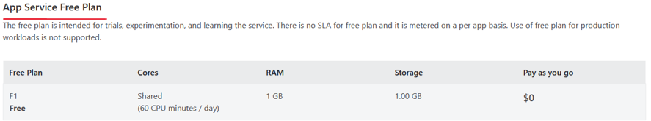

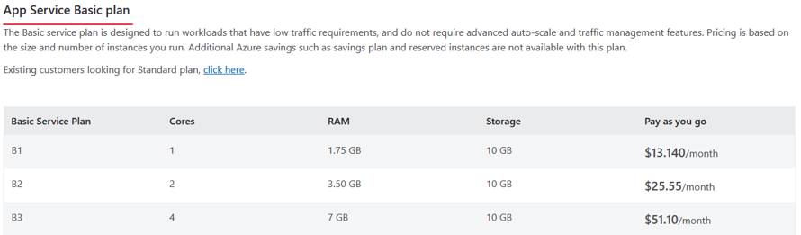

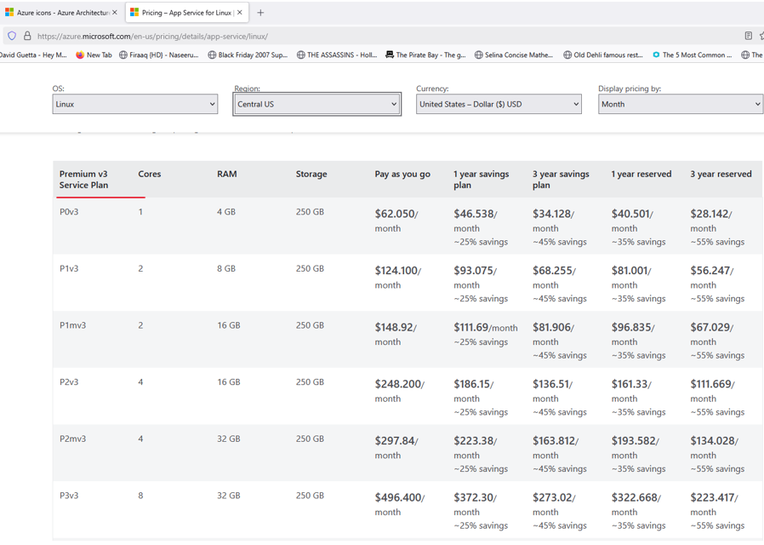

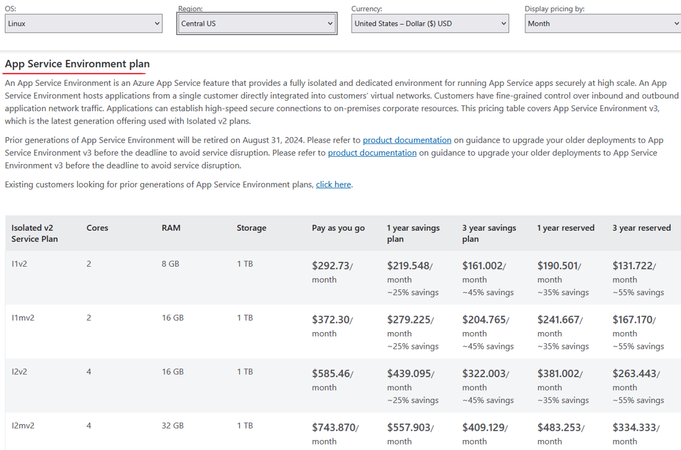

On the other side, you have the isolated plan, which offers a completely isolated environment for App Services which sits in its own virtual network, which is not the case for the other App Service tiers. Now, note that price is highly affected by the operating system you will select. So in general, Linux App Services are much cheaper than Windows App Services, quite similar to what happening with the virtual machine. Now, note that the prices that are displayed here on this table are the lowest price for each tier, but the price goes up with CPU and RAM. So for example, if you will go with a standard App Service, but select stronger plan with more CPU and more RAM, then the price will also go up. So at the bottom of the slide, you see the link to the full details of the App Service tiers, and I highly recommend to take a look there.

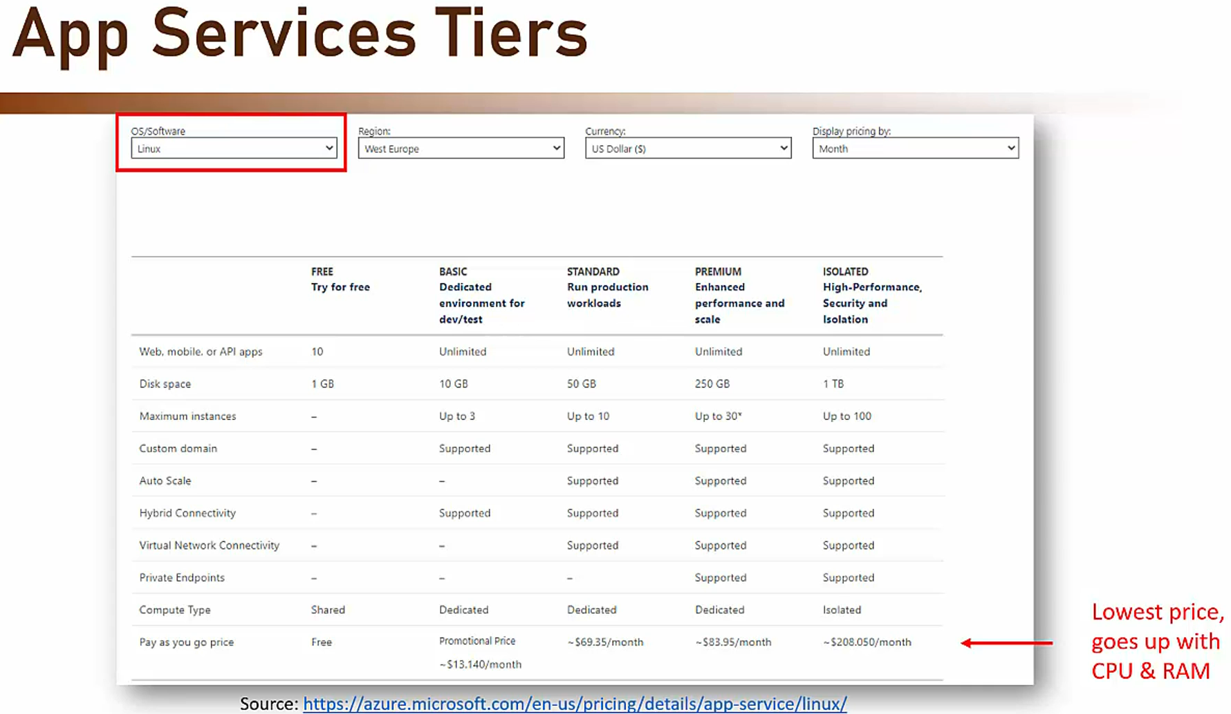

Deploy Java App: <https://learn.microsoft.com/en-us/azure/app-service/quickstart-java?tabs=springboot&pivots=java-javase>

Deploy Python App: <https://learn.microsoft.com/en-us/azure/app-service/quickstart-python>

Deploy using ARM Template: <https://learn.microsoft.com/en-us/azure/app-service/quickstart-arm-template?pivots=platform-linux>

Deploy custom Container: <https://learn.microsoft.com/en-us/azure/app-service/quickstart-custom-container>

### Auto Scaling App Services

One of the nice features of App Services is autoscaling. App Service can be autoscaled to support spikes in load, which means that you can start with single instance, and when the load on the website will suddenly increase, then the autoscaling feature can automatically add instances to the App Service. And after that, when everything goes back to normal, then these instances will be removed. Now the autoscale is based on various metrics, and it's extremely flexible.

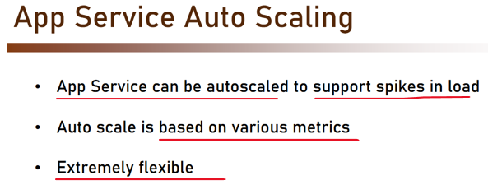

And this is how it looks like, and it's probably looks quite familiar because this is the exact same definition that we used for the virtual machine skillset. So for example, in this screenshot, you see that the scale out rule is based either on the CPU percentage or on the HTTP queue length, meaning there are many requests that are waiting in queue and can't be served because the server is busy.

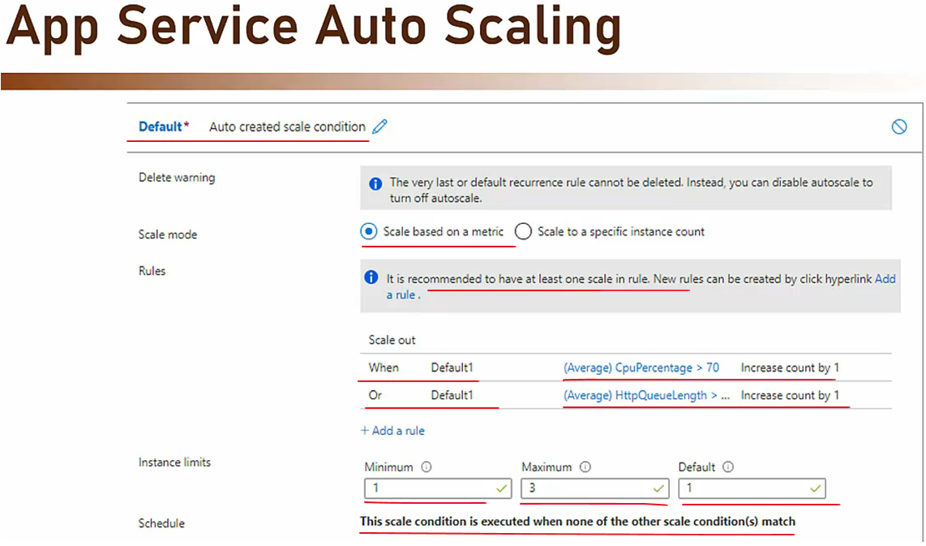

So when one of these condition is met, then the autoscaling will add another instance to the App Service. And so the autoscaling feature adds a great flexibility to the App Service.

<https://learn.microsoft.com/en-us/azure/app-service/manage-automatic-scaling?tabs=azure-portal>

### Setting up the App Service – Inventory

We are going to deploy the inventory part of the Readit store as an app service. The inventory component is used to manage inventory of the store. So for doing that download and open the inventory-baseline-01.zip file from the resources of this lecture. In this zip file you will find a folder named inventory. Copy this folder into the Readit folder that we created earlier, which currently holds only the catalog part. Let's paste this folder here. Go into this folder. Open VS Code in this folder. So right click and open with Code. And as we mentioned before, you can also do that through the command line.

|  |  |
| --- | --- |
| And here is the project open in VS Code. Now before going through the code and see what exactly we have here and of course before deploying it to the cloud, let's first run it locally to make sure that everything runs as expected. So simply hit F5 and let's make sure that the code is running. |  |

So now the code is building, it might take a few seconds.

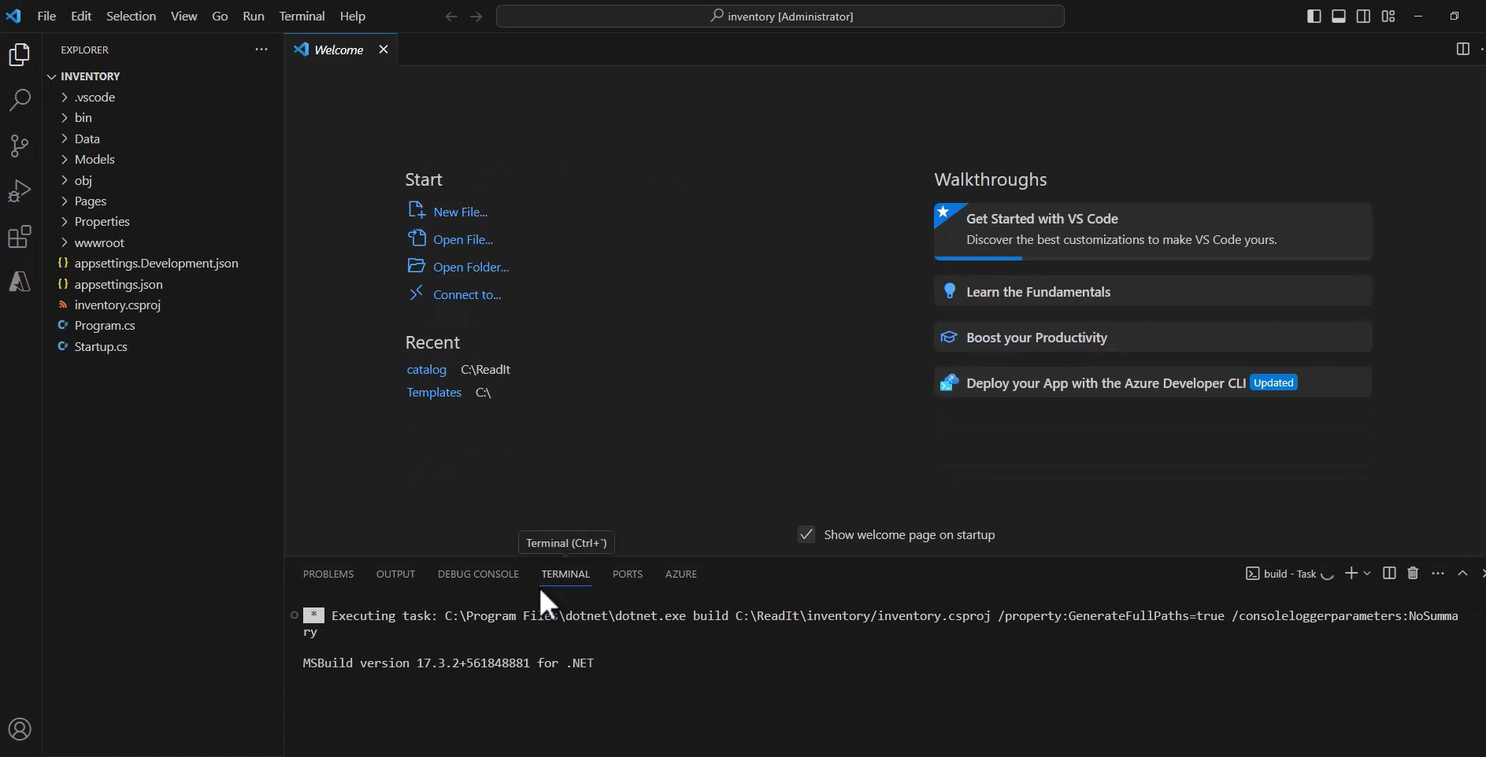

Right, looks fine. And now VS Code is running our code and browser is open and here is the inventory. So from this page we can manage the inventory of the store, naturally currently we don't have any inventory here and that because we are not connected to any real database, so no inventory here.

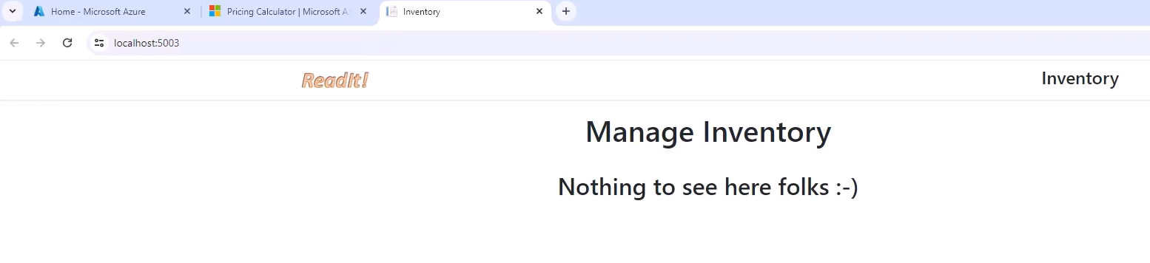

So anyway, it looks fine. So now let's go back to our code and let's see what we have here. And actually the most interesting parts in the inventory are two files, the index.cshtml, and the index.cshtml.cs. So the cshtml as we saw earlier is basically just an HTML file showing the details of the book. And note that we basically have here a table with five columns. The first four are name, author, pages and price.

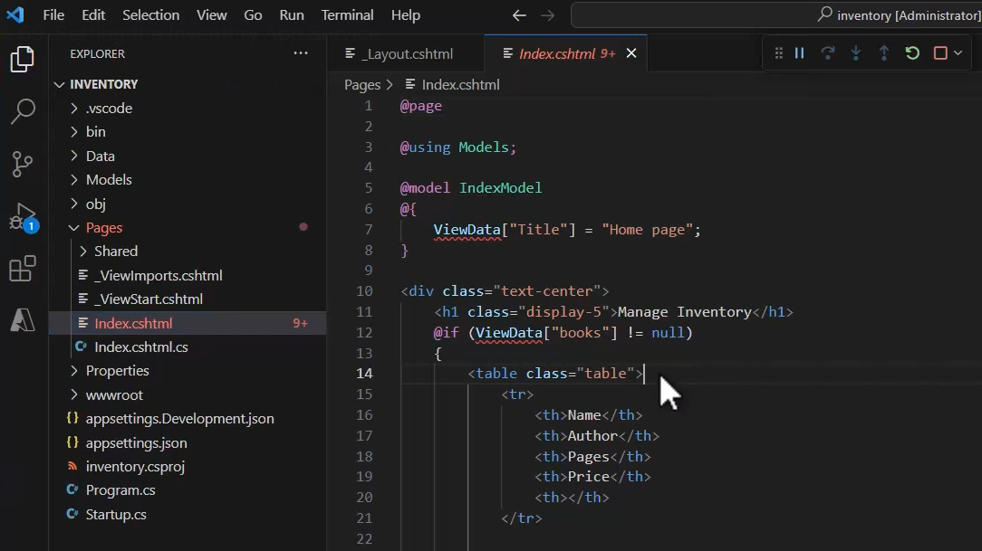

And the last one will show the actual amount of books in the inventory, which is set right here. And we also have a button here that we're going to click when we want to change the inventory. So all in all quite a simple HTML file. Now in the CS file we have two interesting methods. The first one is the get method, which will retrieve the list of books from the database. And currently this code is commented out because again we don't have any database to retrieve from.

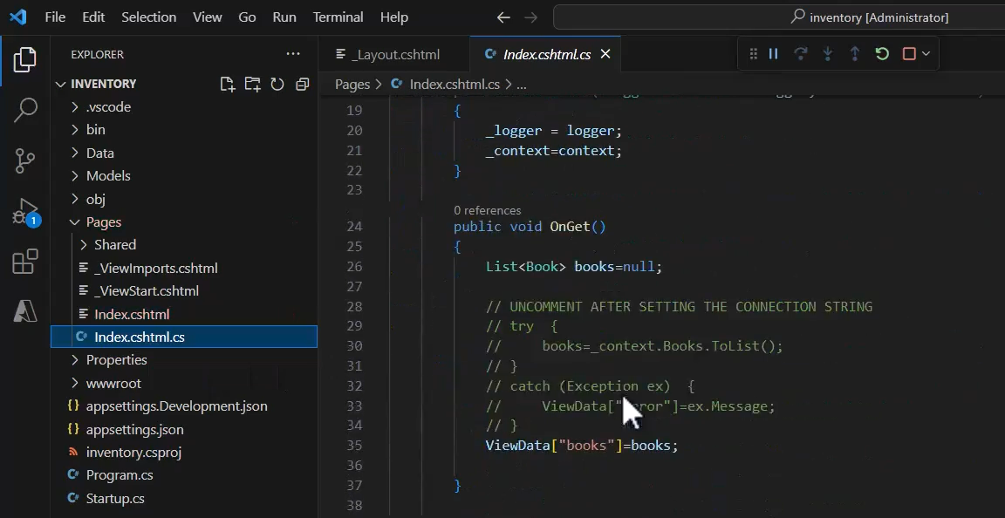

And the next method is the OnPostSaveInventory, which will be run when we click the button to set the inventory. So here what we do is go to the database and find the book that we want to set its inventory and then set the InStock column with the new quantity of books in the inventory. And of course after that we are going to save the changes. Now again, currently we don't have any way to run this method because the button is commented out, but of course later we will take care of that.

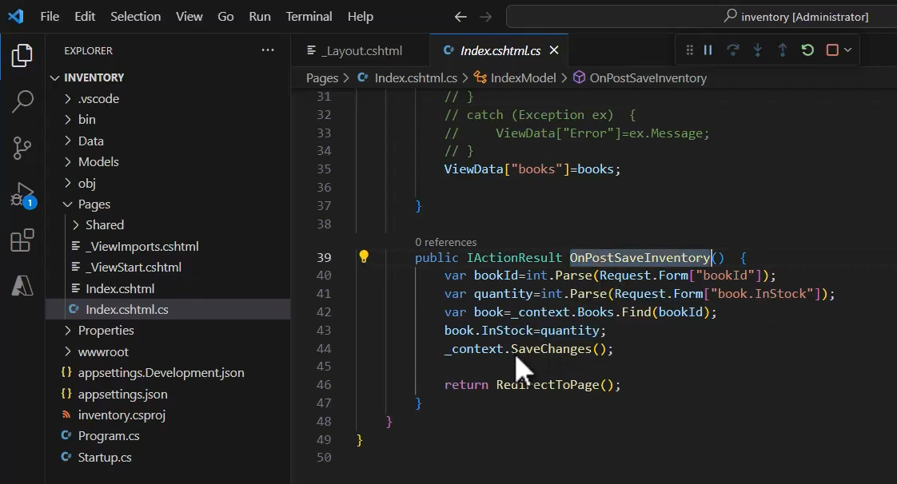

Great, so this is the inventory and now we want to deploy it to an app service in the cloud.

|  |  |
| --- | --- |
| Lets first create such an app service. Let's stop the execution and go to the portal and create a new app service. So in the search bar type app service |  |

|  |  |
| --- | --- |
| and click app services and create, create web app  The subscription is our regular subscription. The resource group we will use is the one we used before. So that would be the readit-app-rg. And next we need to name our app service. |  |

Now the most important thing to note about naming app services is that its name should be unique across Azure, and that means that the name that I will use here for this app service will not be available for you. Now note this slider, unique default host name, and this new capability of Azure allows you to use automatically generated name for the app service which will ensure the name is unique across Azure. Now we are not going to actually use it, but I do want to show you how it looks. So the name I will take for the app service is going to be memi-readit-inventory and note what Azure did here. It added this well random characters to the name and also the region that is currently selected. I will pick later another region. But the important thing here is that's a combination of the names that I provided here with these characters give me a unique name for the app service.

|  |  |
| --- | --- |
|  |  |

Now I don't want to use this name because well it actually too long and too cumbersome. It is very useful if you access this app service using a DNS server, which exposes a much more convenient name but we are not going to do that and therefore I'm going to stick to the short name ( see the above right side image for option selected – we disabled the Try a unique default hostname. But again, it's important to be aware of this very useful option. So let's turn off the default host name and now the name is going to be memi-readit-inventory.azurewebsites.net. And again this name will not be available for you because the name must be unique across Azure. So this is what we are going to use. Next, we need to select what exactly we want to publish and we are going to publish code and not container. We will be dealing with containers later with the AKS. Next we are going to select the runtime stack and our code is built on .NET 8. So pick this option.

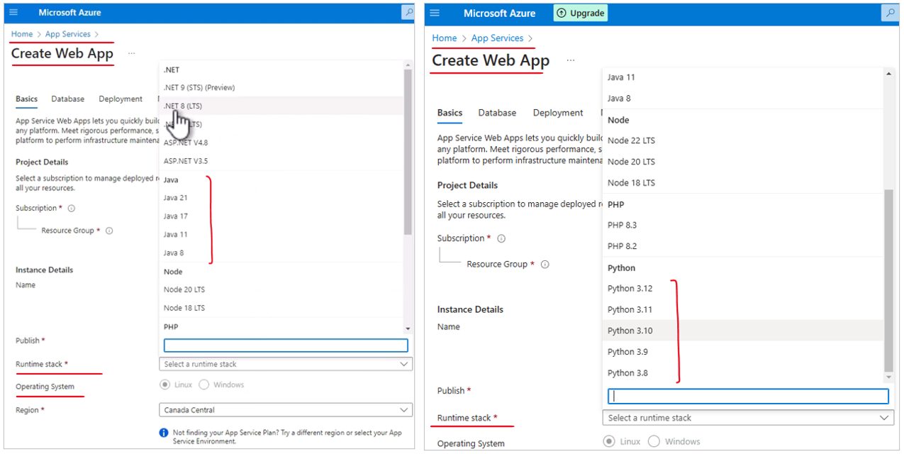

Next we are going to select the operating system and we are going to stick with Windows, which provides much better support for .NET code with app service. Next, let's pick the region and I will go as usual with West Europe. You of course pick the region that you are using in your case. And now let's take a look at the pricing plans. Now when creating app service, we need to select its pricing plan and let's understand what exactly we mean by pricing plan. Basically when we create app service, we actually create two components. We create the app service which is the component that host the code, but we also create a plan. And this plan is the infrastructure hosting the app service. In fact, you can use one plan to host multiple app services. Now since we are hosting our app service on Windows, then a Windows plan will be created for us and you can see that this is a new plan. So again, this is the infrastructure. Now for the plan, we need to select the pricing plan.

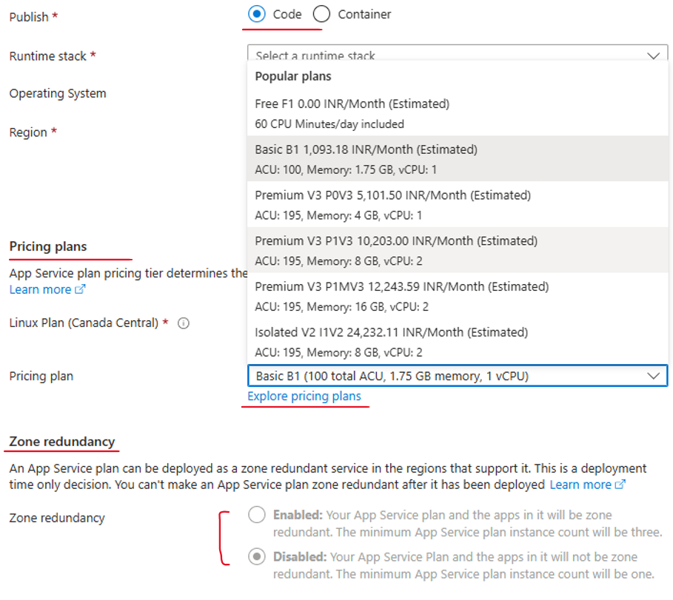

Click on Explore Pricing Plans

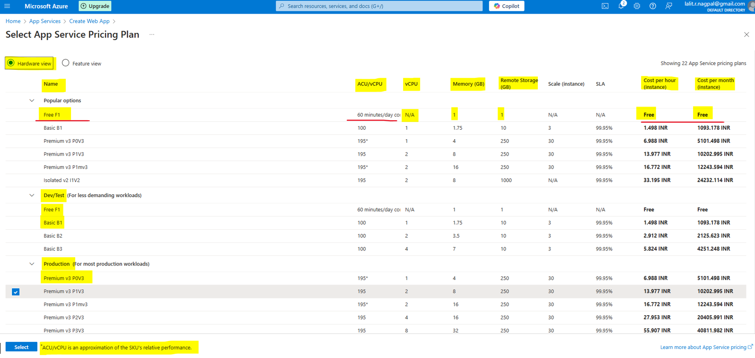

Now this infrastructure is basically a virtual machine that we cannot access, although as we will see later, we can do some actions with this virtual machine. Now when creating the plan, we need to select the pricing plan, which basically defined the compute power and memory of this virtual machine or infrastructure. And this is selected using the pricing plan. So click explore pricing plans and you can see here the various plans and the cost. So first there is the free plan, which allows up to 60 minutes a day of free browsing. And of course as you can guess its cost is free. Then we have the D1 plan, which is a shared plan, meaning you are going to share your infrastructure with other clients and also it allows maximum of 240 minutes use per day.

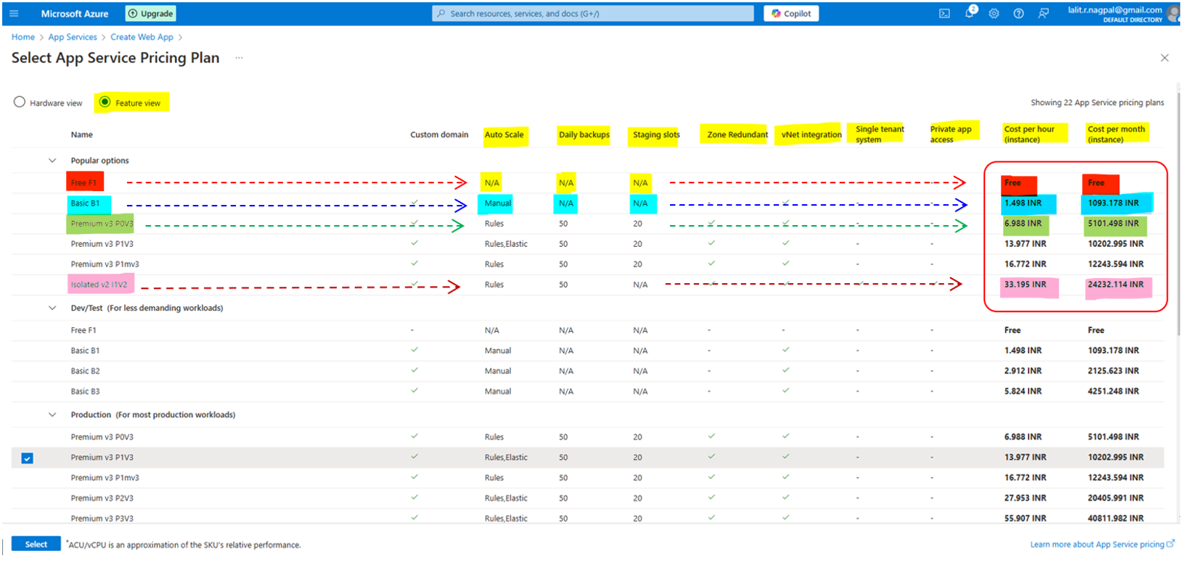

Then we have the basics and the standard and premium etc. You can see the cost difference between these plans & what we are going to use here is the standard S1. The reason is when considering features of various plans, then the standard plan offers some features that we are going to use later.

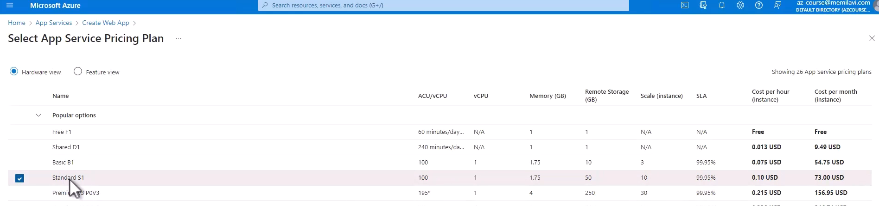

Now if you will switch here from hardware view to feature view, then you can see that the standard plan offers something that is called staging slots. And we are going to discuss these slots later in this section and I want to have the ability to use these slots and therefore we are going to pick the standard S1. Now note, the cost of the S1 plan is $73 per month. Now if you are on a trial account then you are not going to pay anything, but this is definitely something that you should consider. So go to the S1 plan and select. So that's it basically.

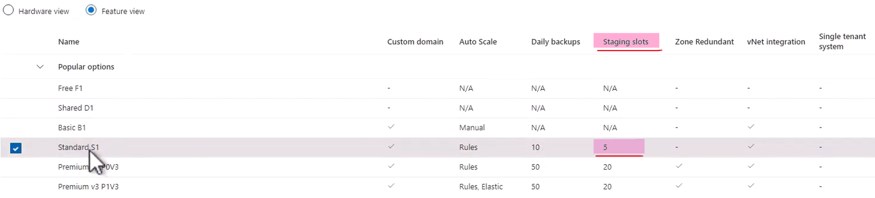

So now click review plus create and let's wait for the validation to complete, great, and create.

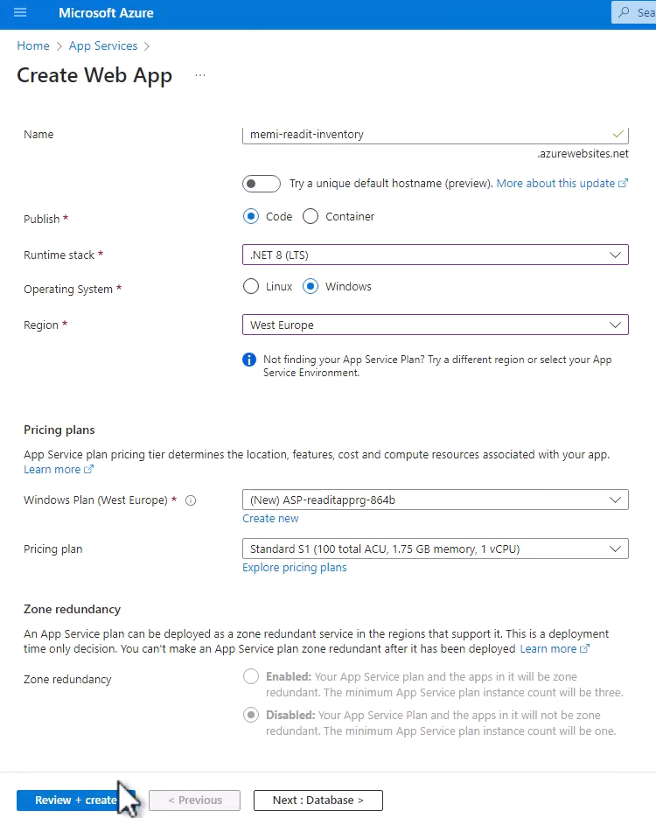 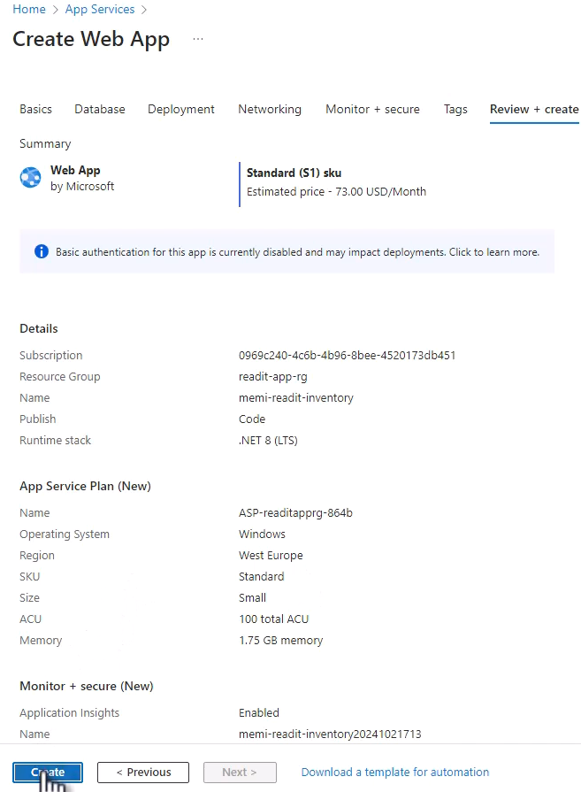

And now Azure is creating our inventory app service for us. Let's wait for that to complete. So deployment is complete. And now let's take a look at the app service that we created. So click go to resource and here is the app service.

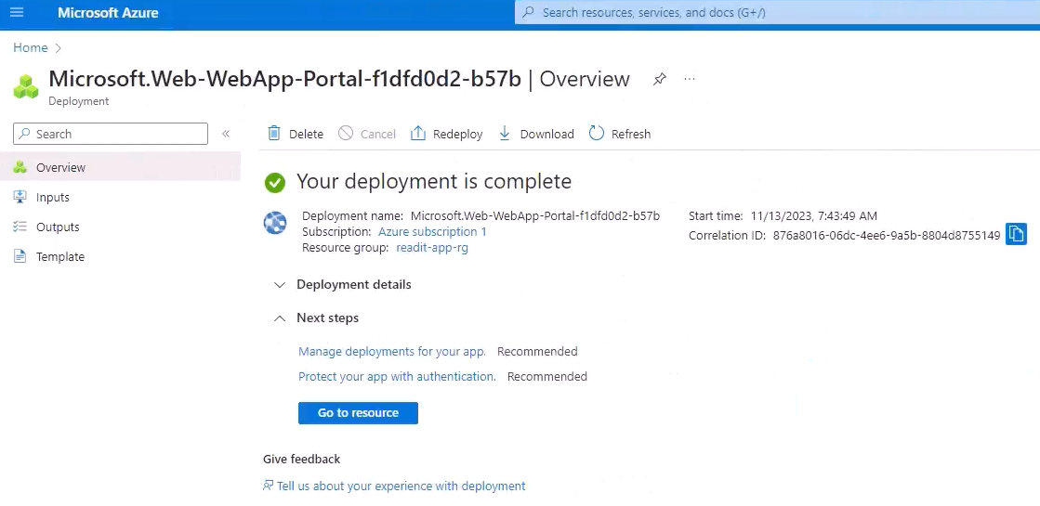

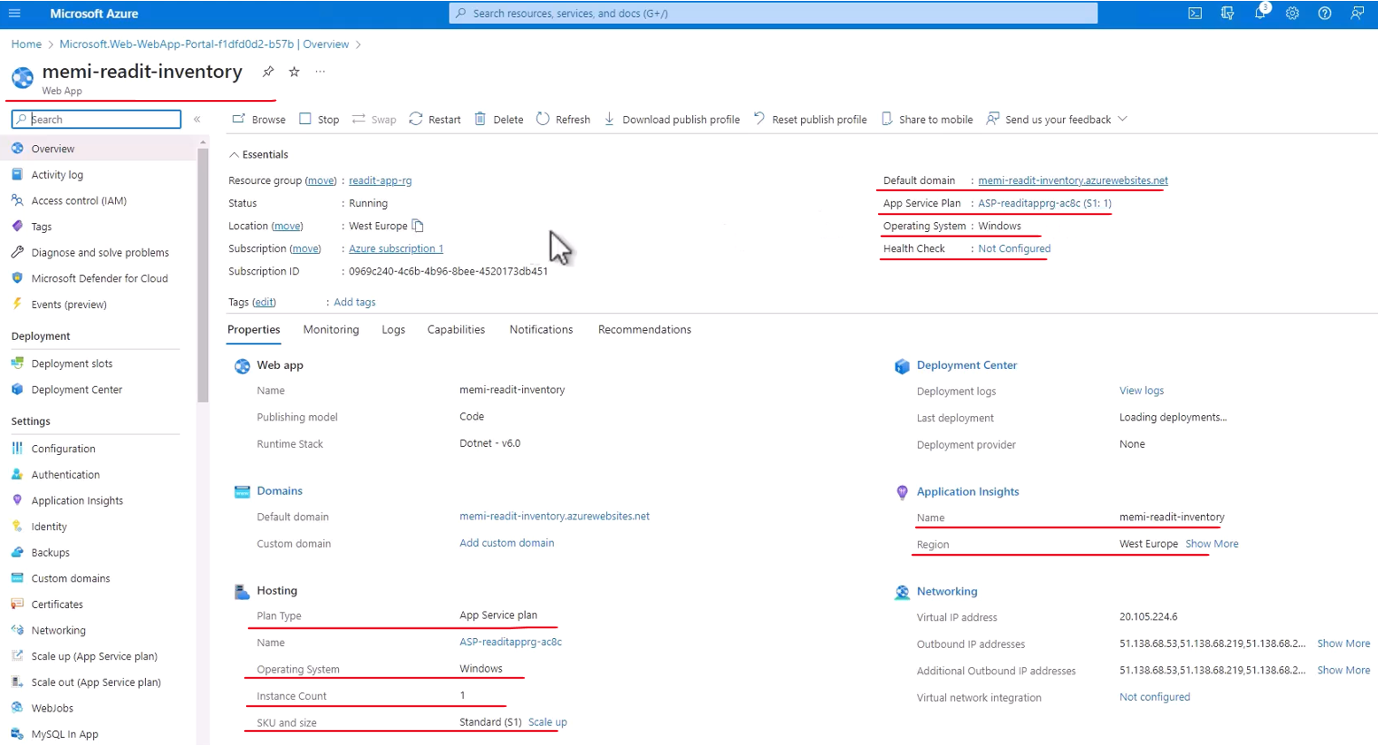

You can see its name and note that this name is basically have a full domain of the name we selected .azurewebsites.net. We can see also the app service plan is S1 just as we asked for. And the location is again what we configured. Now let's just make sure that the app service is indeed running. So click the default domain here, the full name of the app service, and we see a placeholder waiting for our code to be deployed.

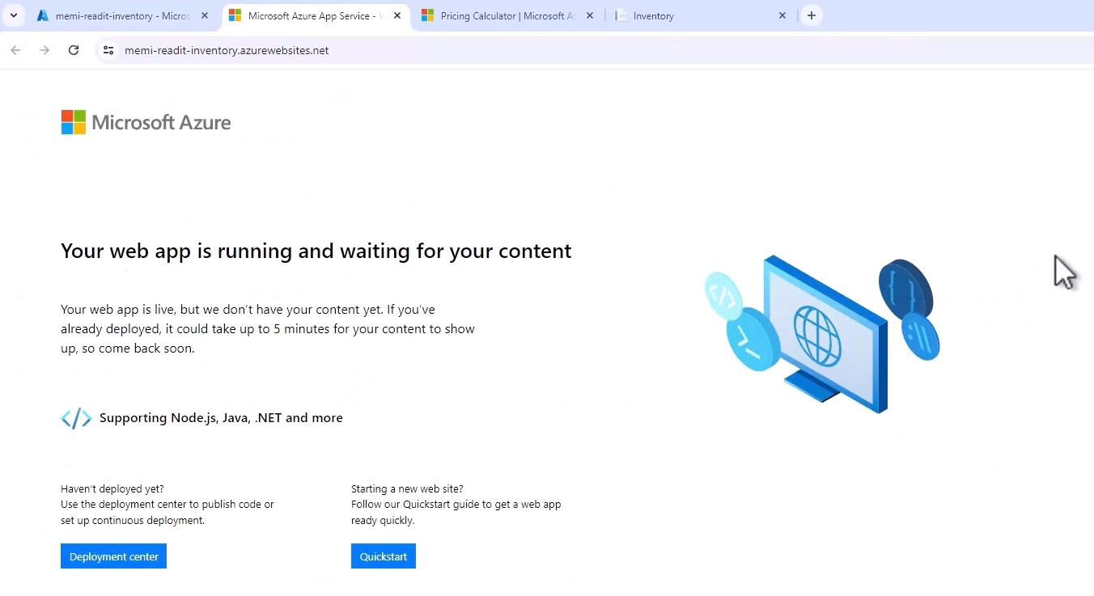

So this is what we are going to do now. So go to VS Code and right click somewhere on this pane, on the explorer pane. And note this item, deploy to web app. And this item is here since we installed the Azure extension, which added the various Azure deployment options to the menu.

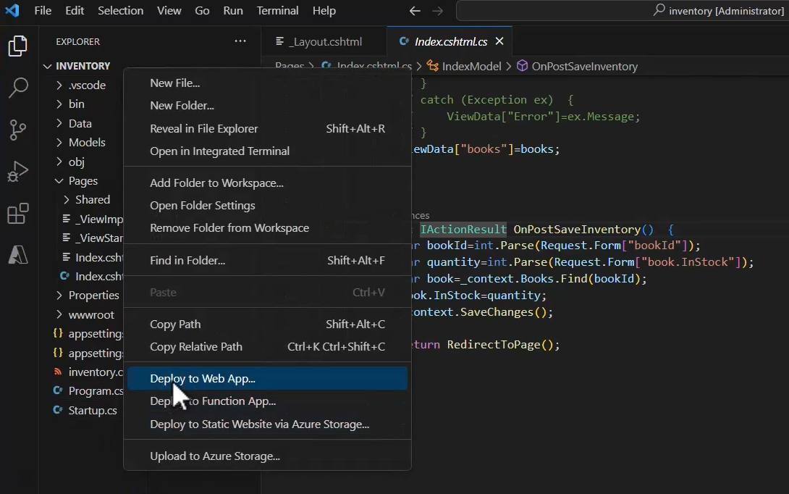

So click deploy to web app. And now of course we need to sign into Azure since VS Code has no idea who we are and what are our resources in Azure. So click sign in to Azure, and now the browser will open and we will need to sign in.

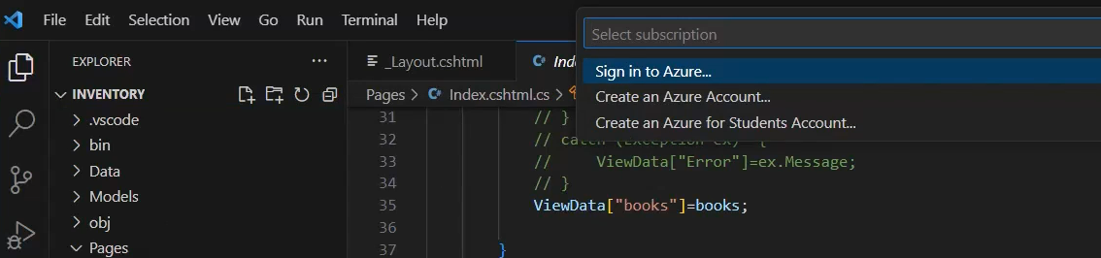

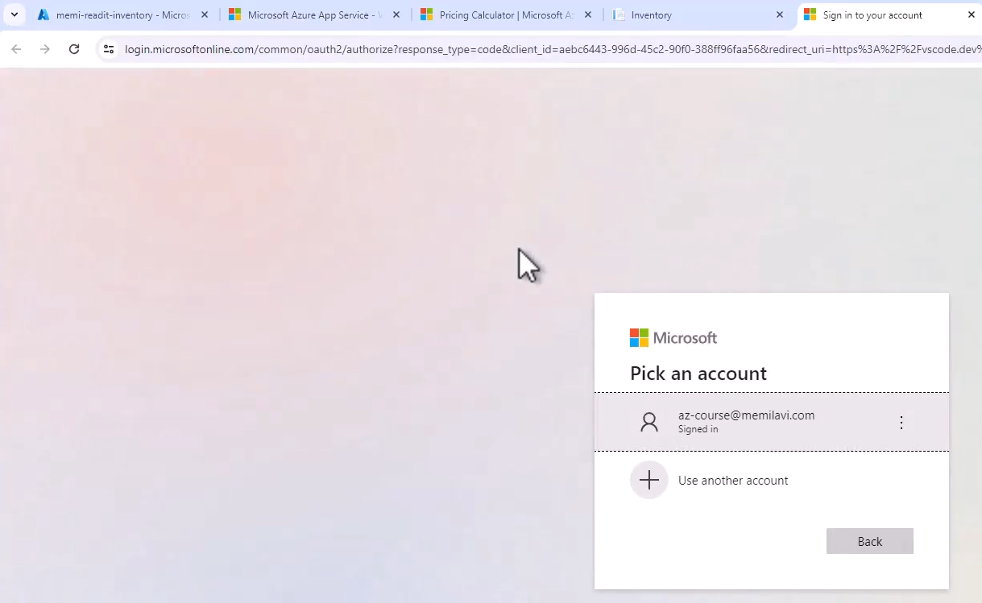

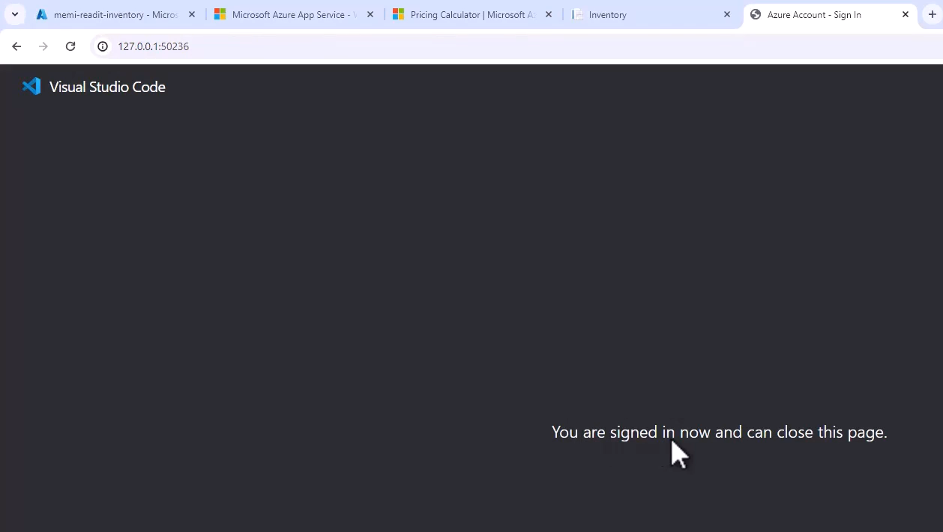

So simply click your account and we are signed in and can close this page. So close the page and go back to VS Code. And now we need to select this subscription. So click this and select your subscription.

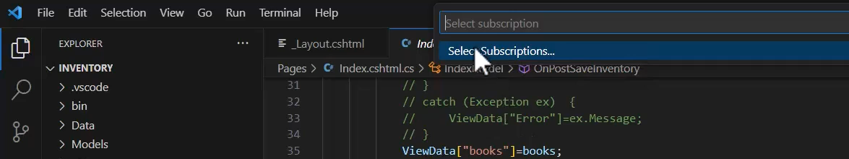

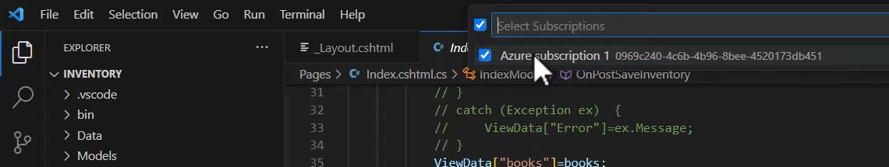

You naturally will see only a single subscription here, so make sure the checkbox is checked and okay. And now we need to select the app service that we want to deploy to.

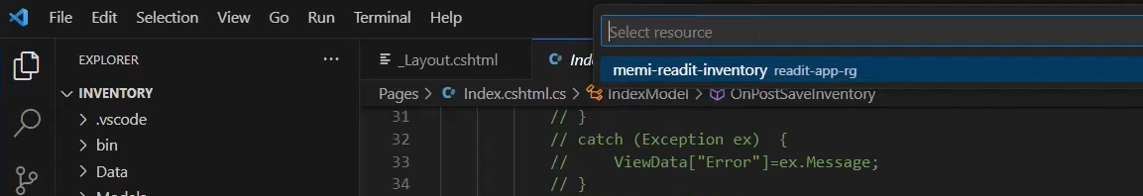

And again, naturally we have only a single app service here, which is the memi-readit-inventory. Again, in your case the name will be different. This is also the name of the resource group where the app service is located in. So pick it and now VS Code asks us whether we are sure we want to deploy to this app service and notes that this will override any previous deployment and cannot be undone. Well that's fine with us. So deploy.

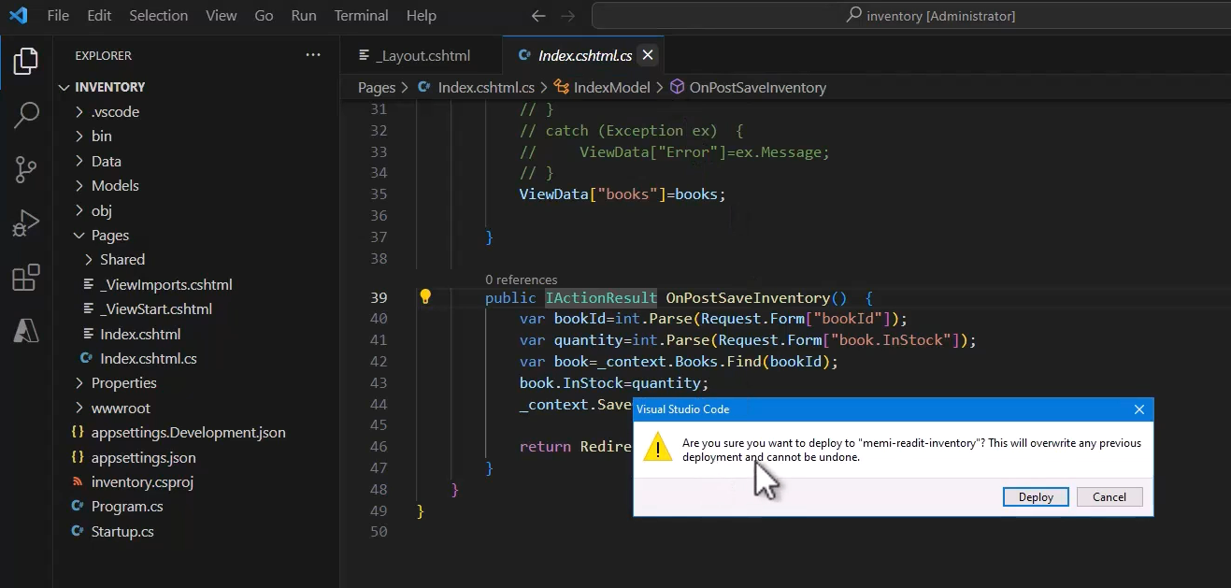

So now VS Code is deploying our code. So first the code is going to build and then the deploy will begin. Let's wait for that to complete. So build is done and now deploying began.

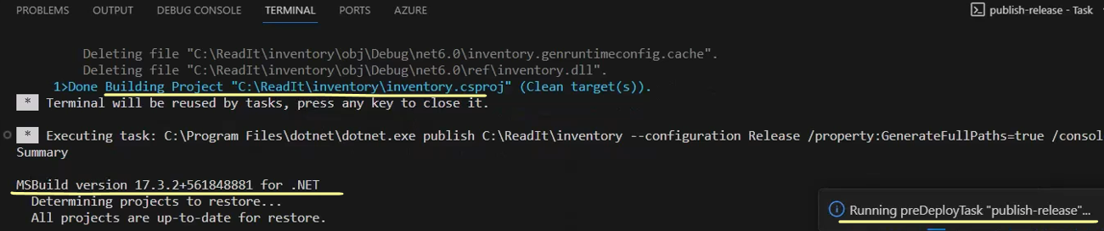

So click the output window here and you can see the progress of the deployment.

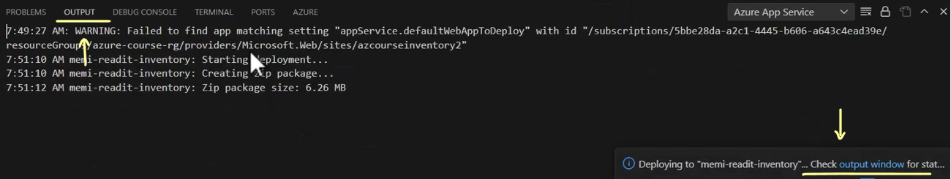

Great, and the deployment has completed successfully. Now let's see that in action.

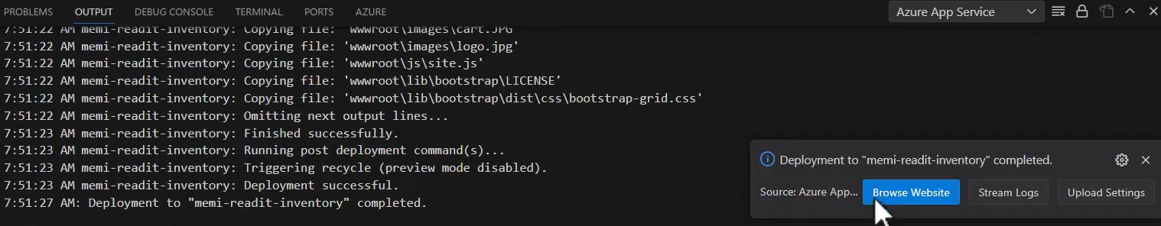

So click the browse website right here and let's see what we have. And great, deployment was indeed successful and now you can see our inventory right here running in the app service, note the URL here.

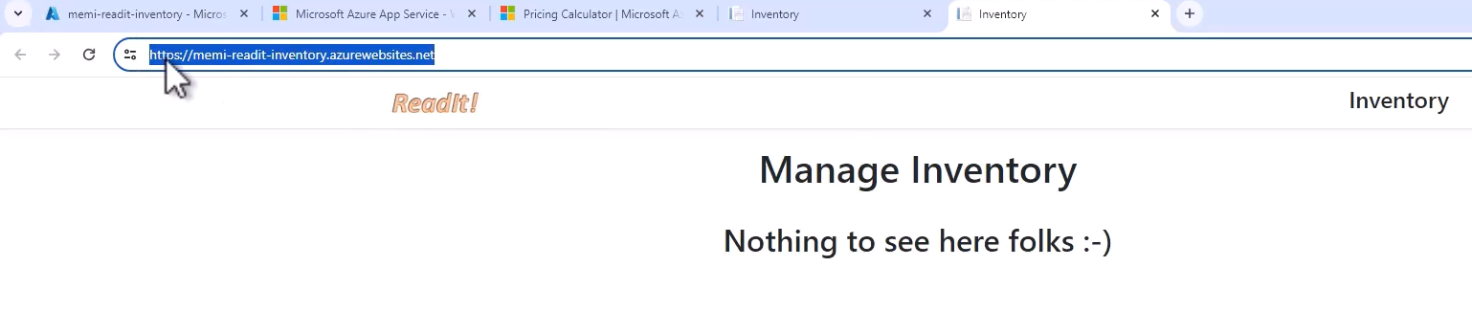

So we are accessing the app service that we created earlier, but now it runs the inventory code. So we deployed the code successfully from VS Code. Great. Now let's take a quick look at some features of the app service. So let's scroll down here and click app service editor and here, open editor.

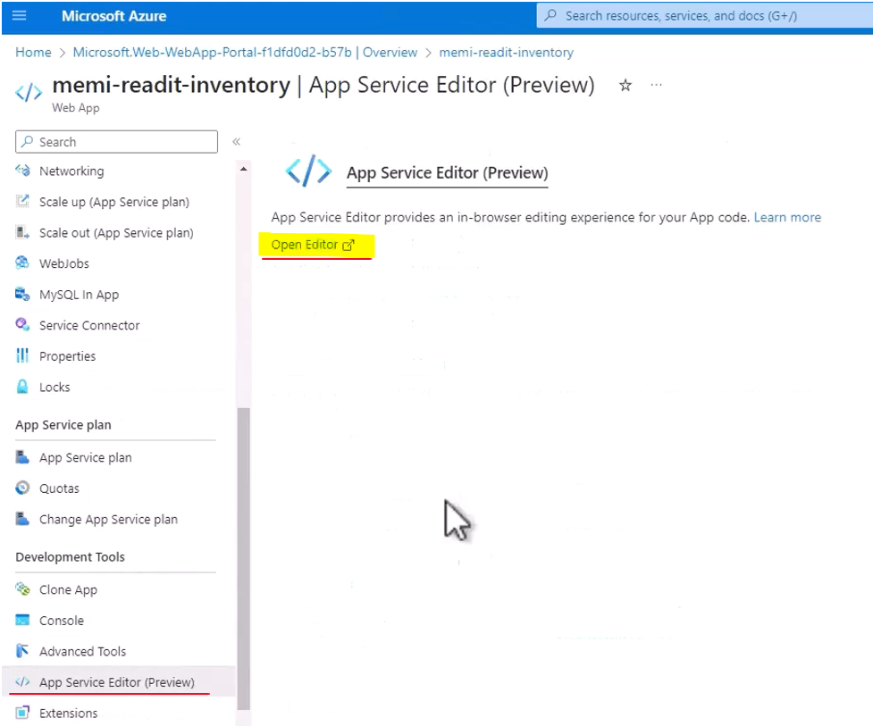

So using this editor you can perform various actions and see various data about the app service. And probably the most interesting part in this editor is the list of the files that are currently installed as part of this app service. And you can see here all the files that were uploaded to the app service and which the app service is running.

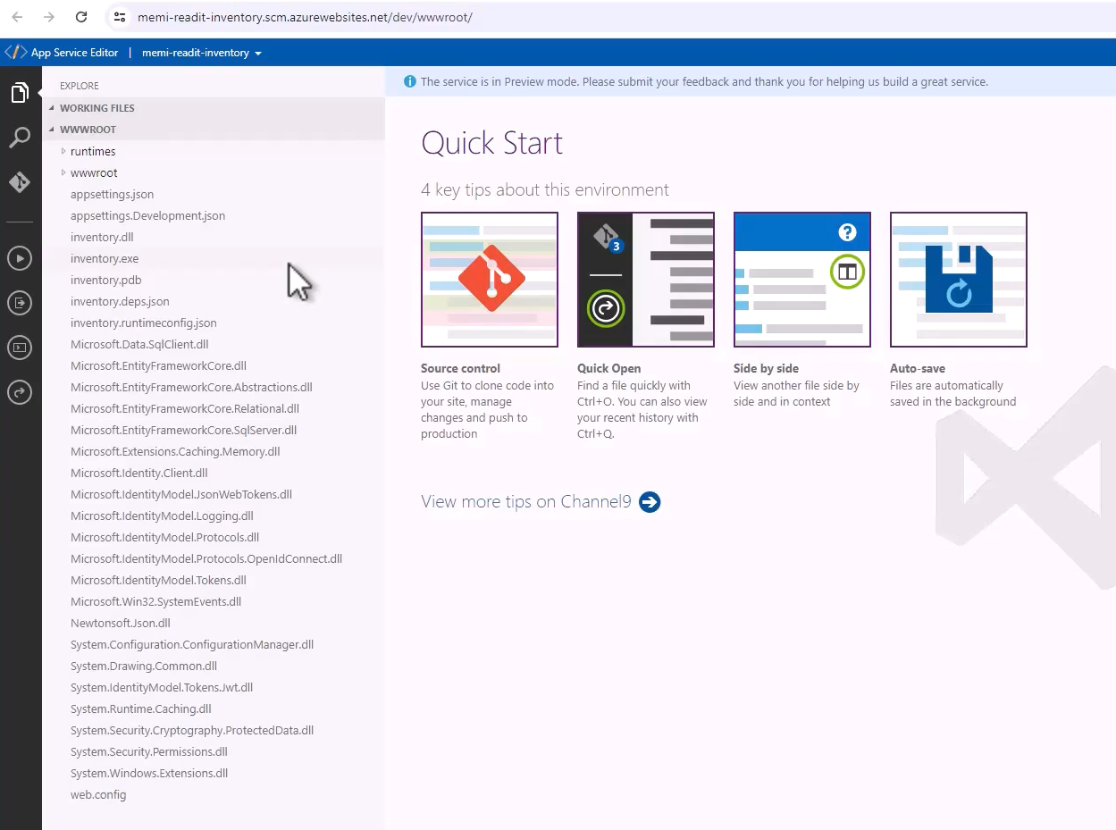

Now you can not only see the list of files, but you can actually see the contents of these files. So click the appsettings.json file, and here is the file. Now you can not only take a look at the file, but you can also make changes.

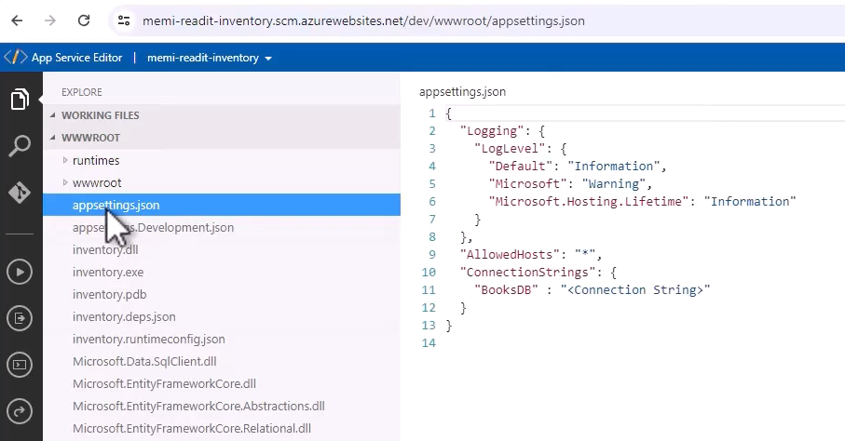

We are not going to do that now because there aren't any changes we want to make, but this is definitely possible. So this is one nice feature of the app service. Now another thing I want to take a look at is the console. So click the console and now we have a command line access to the virtual machine running our code. So for example, type dir, and remember we are running on a Windows infrastructure and therefore we can use the dir command, and you can see the list of files that were uploaded to the machine.

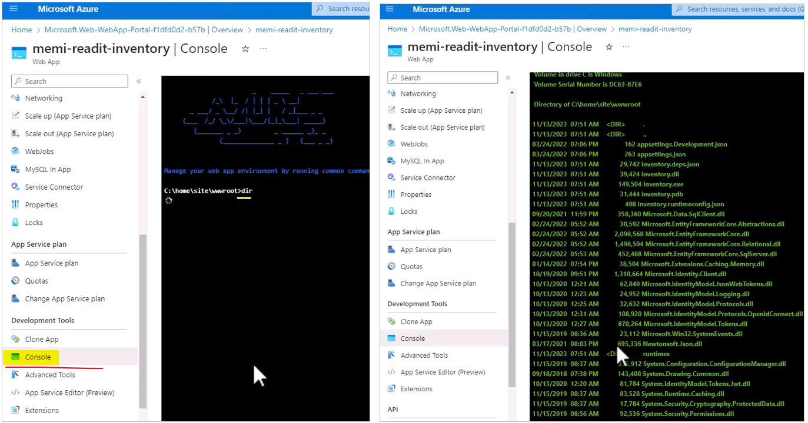

Now you can navigate to subfolders and for example, let's go to wwwroot folder, and let's dir this folder too and you can see what's in this folder.

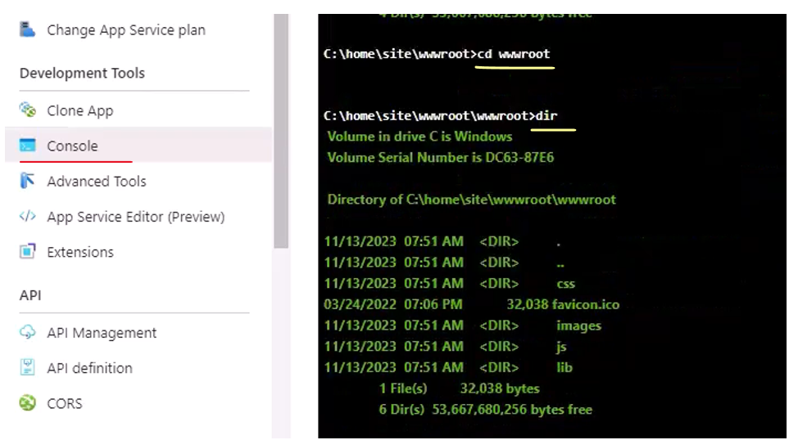

So again, we can have a command line access to the underlying infrastructure of the app service.

Now click app service plan right here.

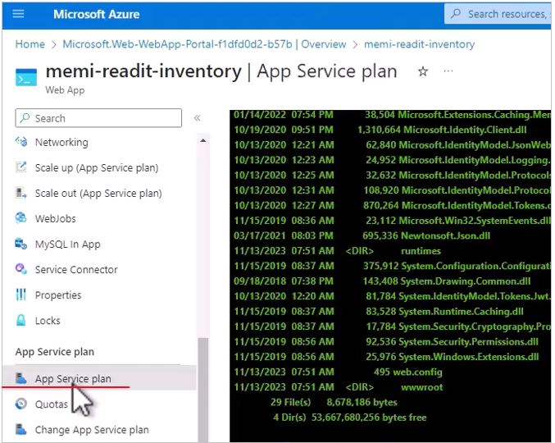

And here you can see some metrics about the infrastructure. So remember the app service plan is basically the virtual machine powering the app service.

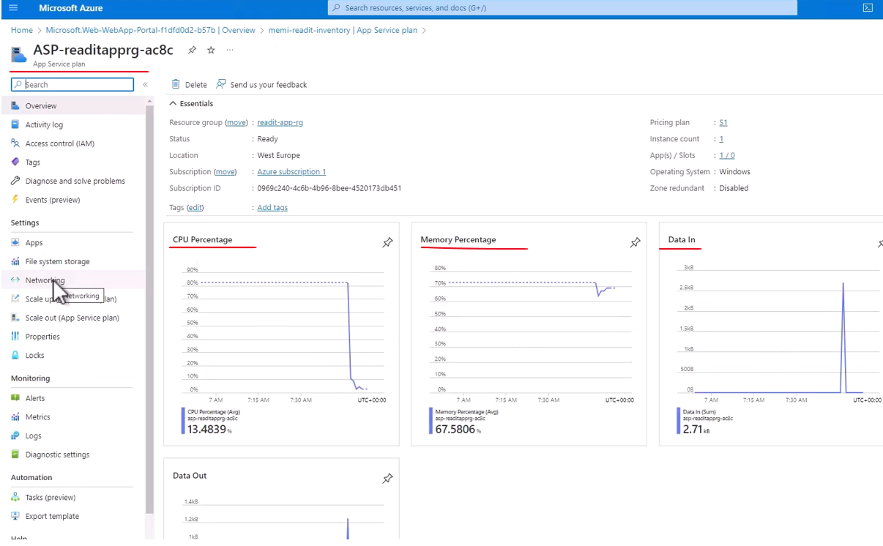

So you can see the CPU percentage, memory percentage, data in and so on, and interesting metrics that you might want to look at in later phases. Let's close this and go back to our app service and now click scale out.

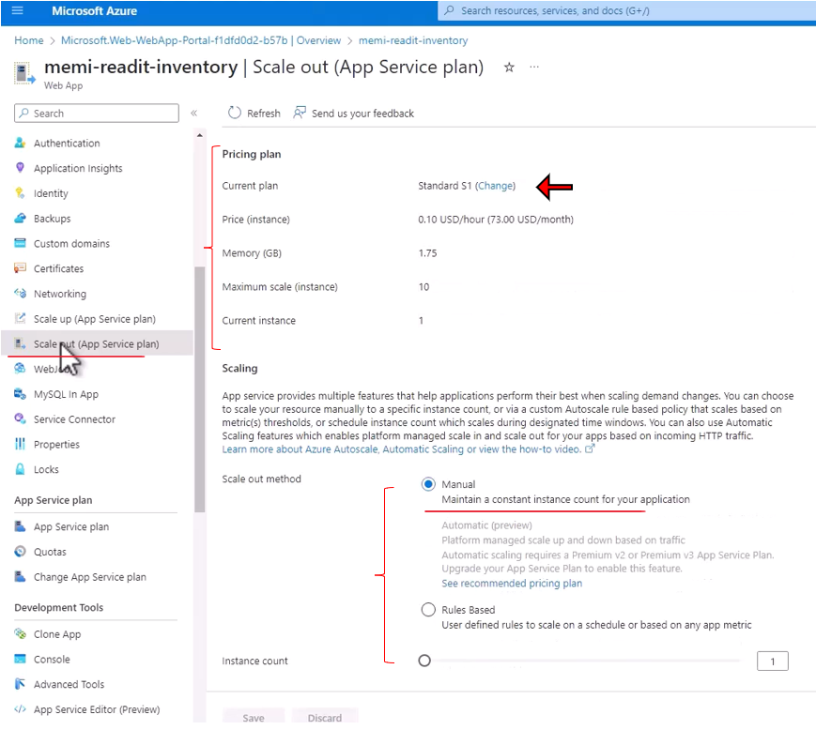

And if you remember, we saw that we can select the plan that we want for our app service. And currently we are in the standard S1 plan and we can change that. So if you will click change, then we will be routed back to the plans page that we already saw earlier. And from here you can select a different one. So you can definitely change the plan after deploying your app service. Next, let's click back here, we can also set the scaling type of this app service. And currently the scale out method is manual, meaning we can set how many instances we want to have for this app service. And currently we have one instance, but we can raise this number so that if we expect a load that is applied to our app service, we can handle it by increasing the instance count.

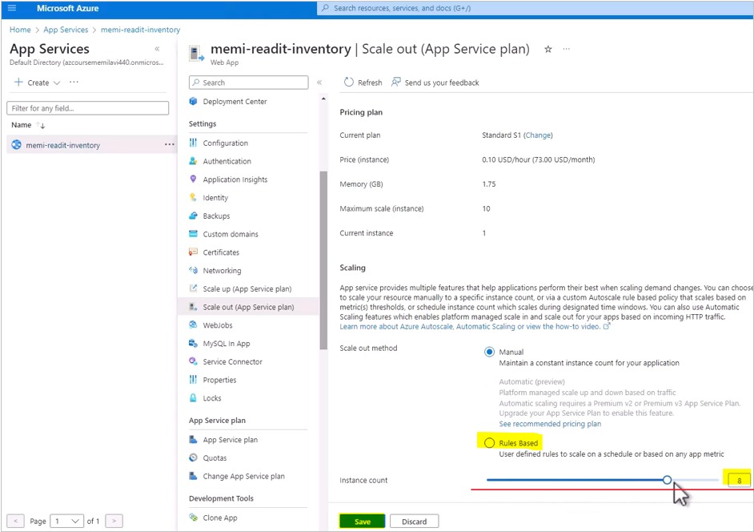

However, in addition to manual, we can also set rule-based autoscaling. And if you will click this link

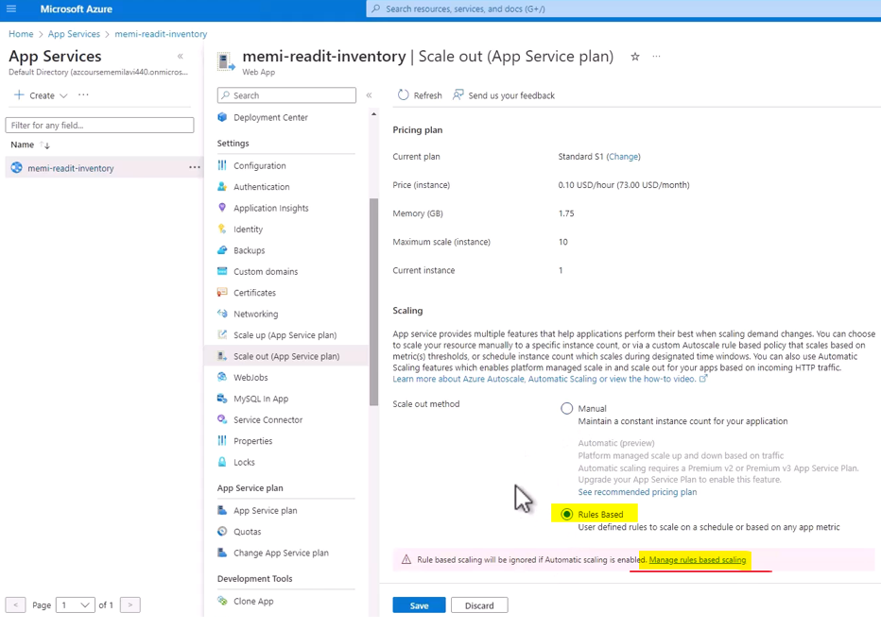

You can see that we can define custom autoscale for the app service.

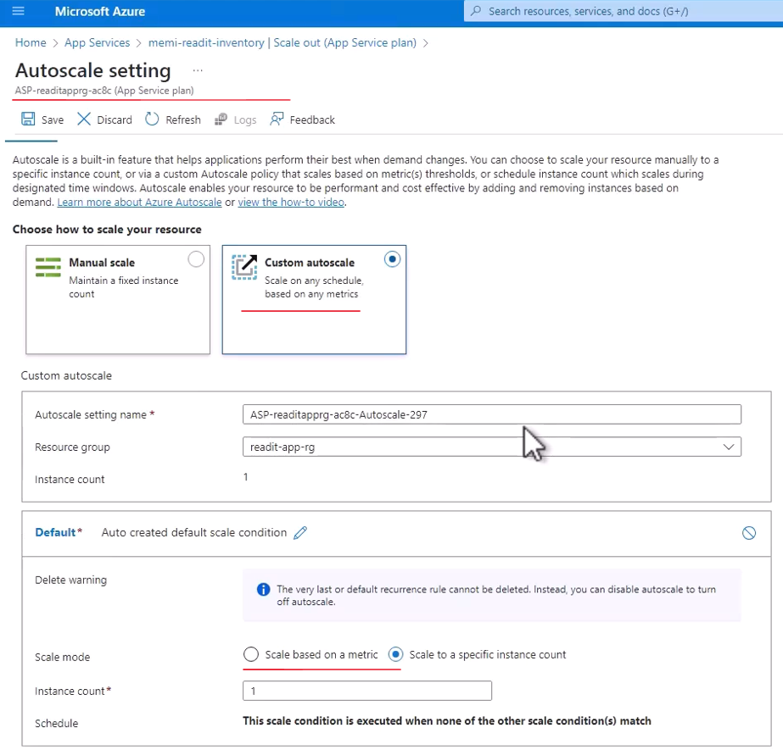

And this is very similar to what we saw with scale set, so I'm not going to demonstrate it here again because again, it's really, really similar. But you can also define autoscaling rules for app service. Great, so let's close this again and let's go back to the overview. And one last thing I want to show you is the outbound IP addresses. So app services have multiple outbound IP addresses and if you need to define a firewall for another resource so that only access from app service is allowed, then you should be aware of the possible outbound IP addresses.

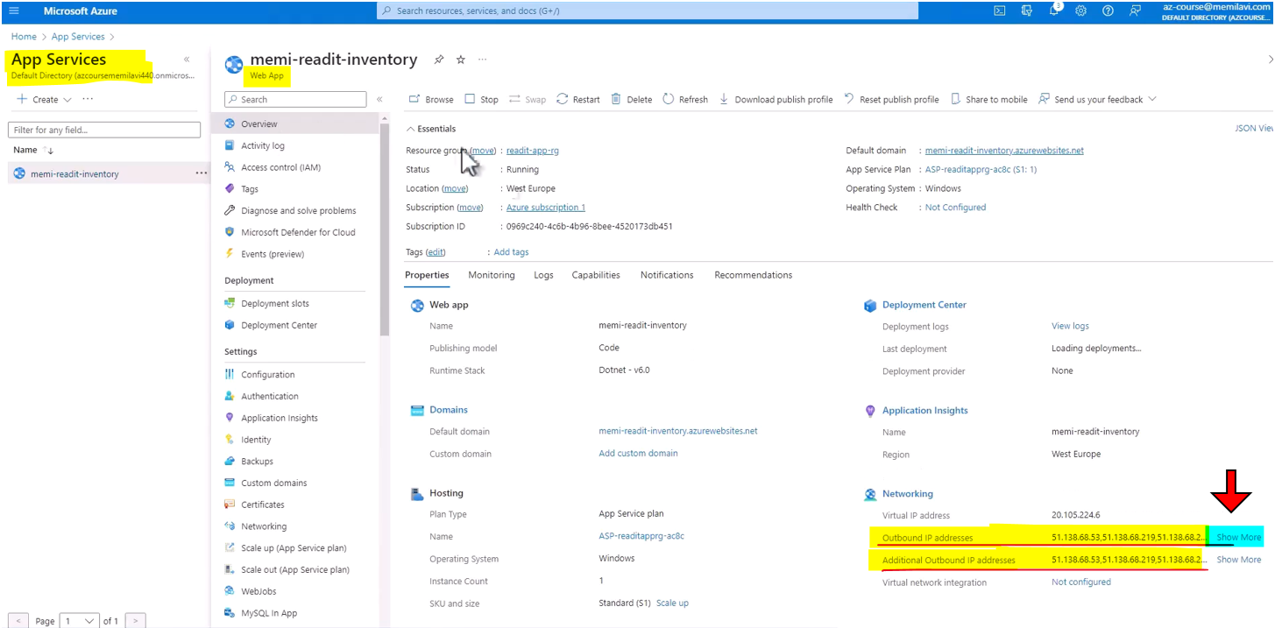

So click the show more here, and this is the list of possible outbound IP addresses from this app service.

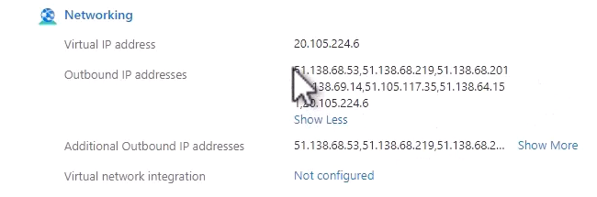

So if you will need to know where requests are originated from, then you can find it right here. So anyway, our app service is now fully deployed and the inventory is running and now you know how to deploy app service from VS Code to Azure.

### Deployment Slots

One of the most interesting features of app services, which is deployment slots. Now, when uploading code to App Service, the new version is accessible immediately, as we just saw when we deployed our code and could immediately browse through it using the App Service default domain. However, sometimes we want to test the version before publishing it so that we can make sure it functions correctly before external users can actually use it. And for that, we have deployment slots. So deployment slots allow us to upload code and test it separately from the main site. And after validation, we swap the slots and promote it to production, promote the new code, of course. Now, new slots are created from the portal, and we will see how to do that. And the number of allowed slots depends on the plan. So for example, standard plans allow for up to five slots.

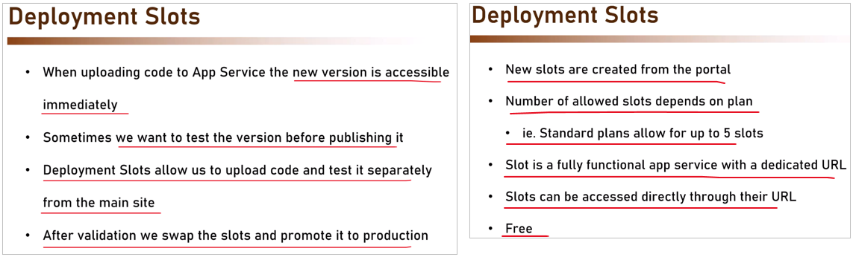

In plans lower than the standard, for example, the free, the shared, or the basic, do not have slots at all. And this is the reason why we went for the standard plan for the app service that we deployed. Now, a slot is basically a fully functional app service with its own URL which can be used in order to access the slot specifically and see how the code looks before swapping it for the main URL of the app service. So as we say, the slots can be accessed directly through their URL. Now, note that slots are free. They do not incur additional cost in addition to the app service cost itself. Now, one of the more interesting features of deployment slots is traffic splitting, which means that traffic can be split between slots, which means that some users will be routed to the production site or the production slot, and some to the new slot. And this is great for some deployment scenarios when, for example, you want to deploy the code gradually so that at first only a small fraction of the users will access the new website. And according to their feedback, you will know whether you can make the new version accessible to all the users.

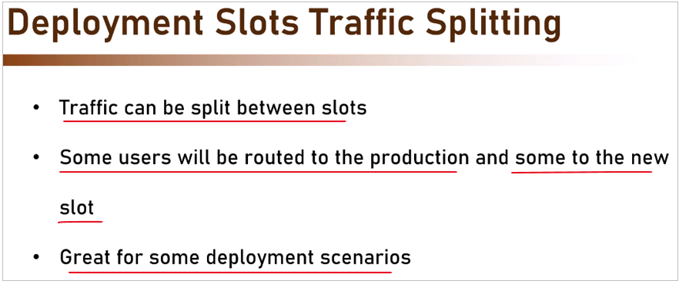

So let's go back to the portal and to our app service and note the deployment slots item right here. So click this menu item, and from here, we can add slots to our app service, and note that currently, we already have a slot in our app service, which is the default one, and this is a production one, meaning when clicking the default domain of the app service, this is the slot that we are going to access. So this slot is currently running, and note the traffic percentage.

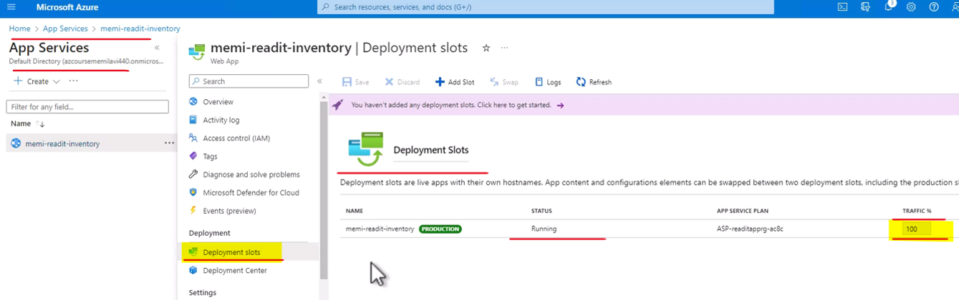

So 100% of the traffic will be routed to this slot, which makes sense since currently this is the only slot available in our app service. So let's add a new slot and see how to use it. So click add slot right here, and the configuration of the slot is actually quite simple. And what we are going to do is to give the slot a name, and basically that's all. So let's name the slot, and note that when naming a slot, basically the name that we define here is added to the full name of the web app. So in my case, my web app is named memi-readit-inventory and of course in your case the name is slightly different, which means that if for example, I will name this slot staging like that, then note the full name of this slot, memi-readit-inventory-staging. And this is how I can refer to this specific slot and access it directly. I don't want to clone any setting from any other slot so add. Let's wait for the slot to be added.

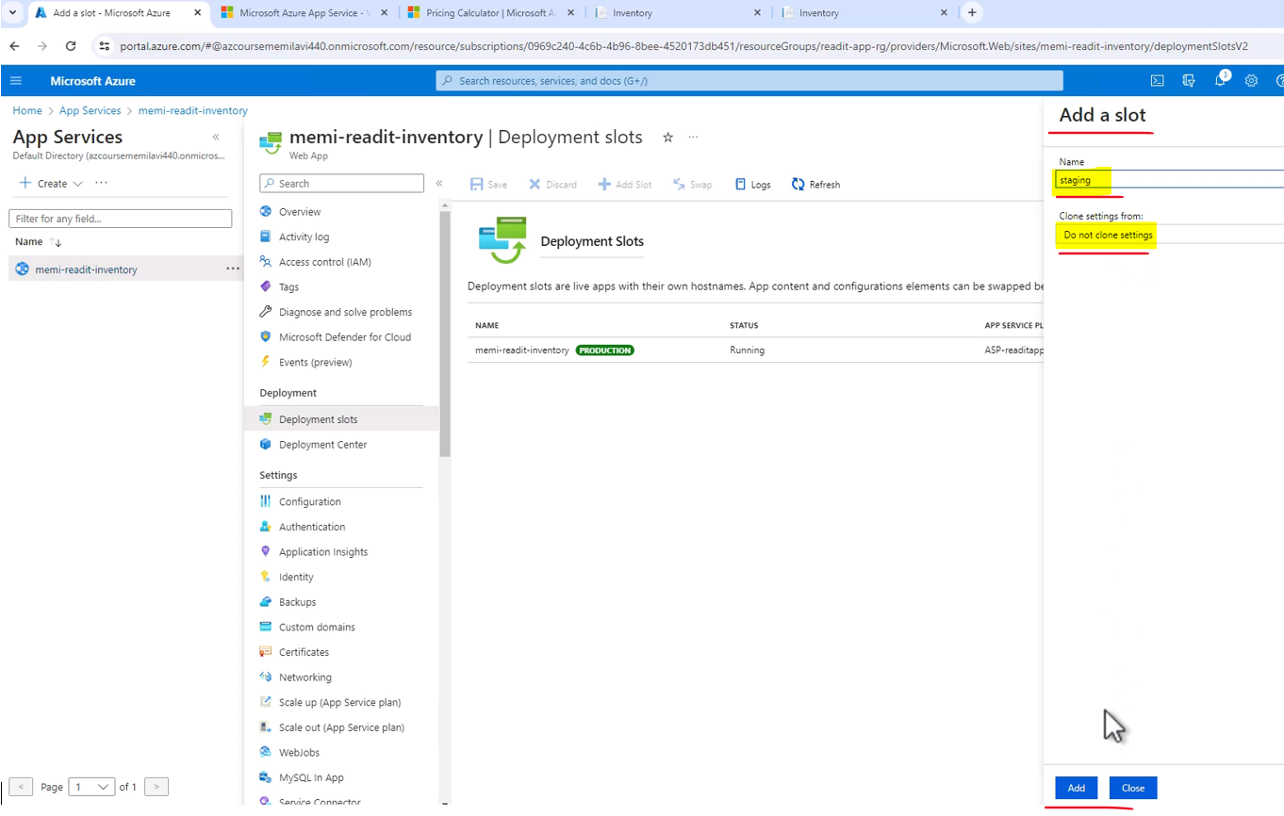

The slot was added successfully. So here is the slot and now let's take a look at it.

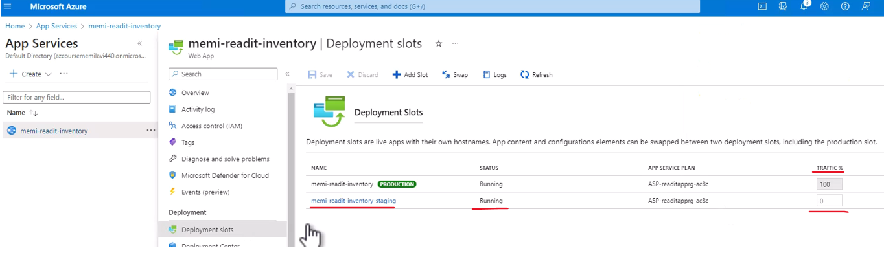

So click this slot and note that this slot is basically a fully functional app service with its own default domain right here. Now you can take a look at the name of this service right here and by the appearance of the forward slash and the name of the slot, you can conclude that this is basically a deployment slot. It's also appears here right next to the app service text. So this is basically a deployment slot, meaning we can now deploy code to it.

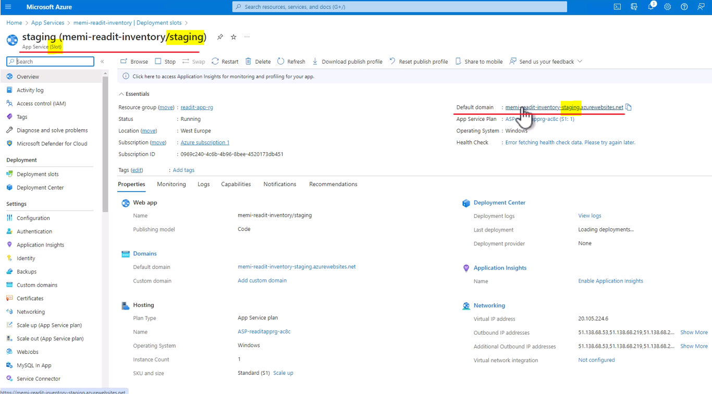

Now if you will click the default domain of the slot right here, then you will get, and let's wait for that so you can see it, the default placeholder of app service meaning this slot. And again, note the URL that we are currently looking at. So this slot is currently waiting for a code to be deployed to it.

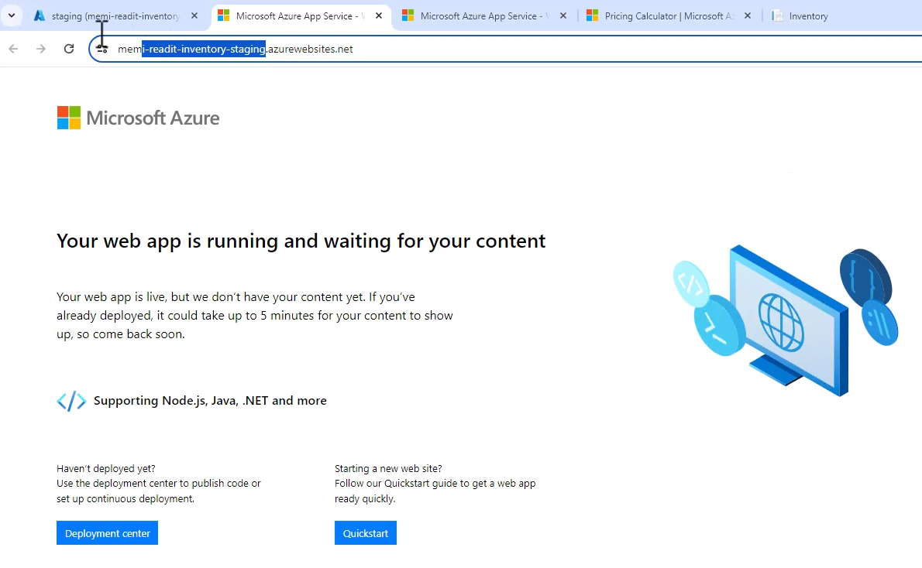

Now one more thing I want to take a look at and let's close the slot window, is the traffic distribution and note that currently the production slot gets all the traffic and the new slot, the staging slot gets none.

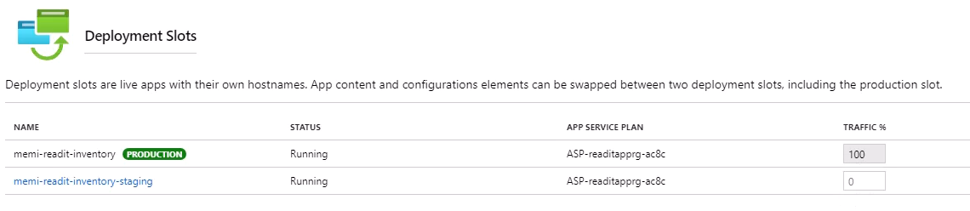

Now remember, the traffic percentage or the traffic splitting affects only access to the default domain of the app service. It does not relate to the dedicated URL of the slot. So you can always access the specific slot by clicking its default domain. Great, so now let's deploy code to the new slot. So let's go back to VS code. And before doing anything with the code and deploying, I think this is a great opportunity to take a first look at the Azure extension that we installed previously. So click the Azure icon right here.

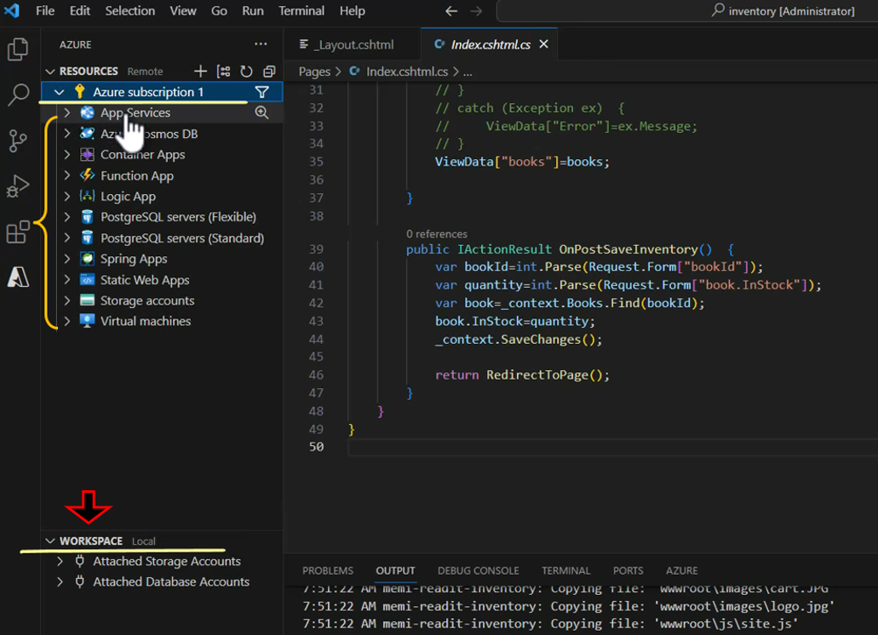

And note what we have here. We have our subscription and some workspaces that we might be using later. Now expand the subscription and here you can see the various resources that you can access through this extension. Let's hit refresh just to make sure that we see here the most up to date resources. So expand first the virtual machines even though we are not dealing now with virtual machines, I still want you to see what you can do with this extension, so expand the virtual machines and note that we have here two machines, there catalog-vm and the weather-vm. Both are there allocated or stopped. So if you didn't stop the virtual machines, it might be a good idea to do that now so that you will save money. And if you right click on one of the machine, you can see the list of actions that you can do with this machine. So for example, you can copy its IP address and start, restart, stop, and even delete this virtual machine or view its properties. So that's about virtual machines.

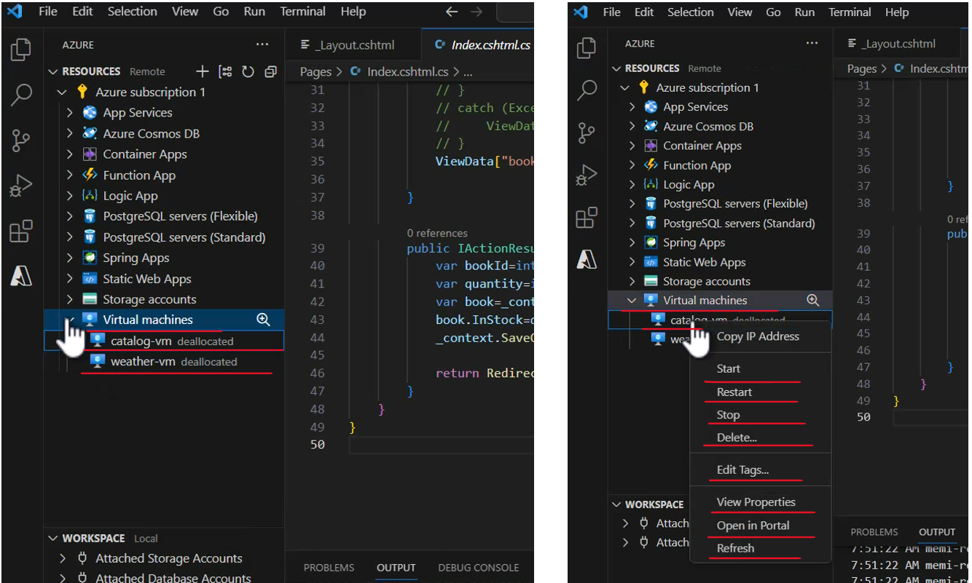

Now let's go to the app services node right here so expand it. And not surprisingly, we see here a single app service, which in my case is memi-readit-inventory. Let's expand this app service and you can access from these application settings and some other properties of the app service and also the deployment slots. So expand the deployment slots. And here is the deployment slot that we just created. Now, right click this deployment slot and you can see that there are various actions you can do with it. And the one that we are most interested in is deploy to slot.

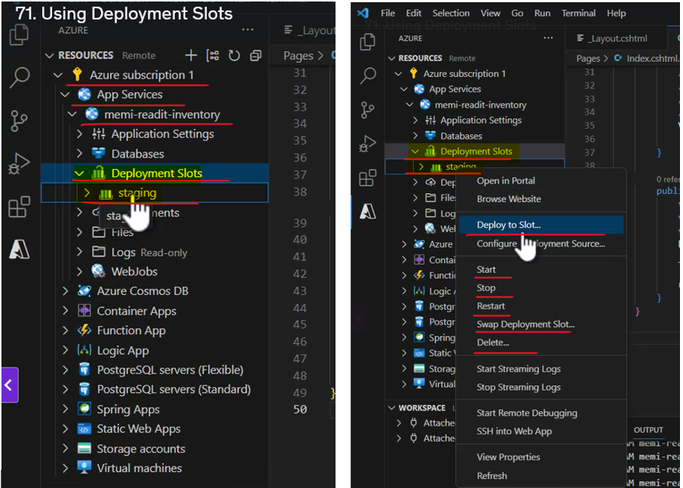

So we can deploy our code directly to the new slot from here from this extension. So before doing that, let's make a small change to our file so that we can see the new version of the inventory. So for that, let's go back to the explorer and open the indexcshtml file. And in the manage inventory title right here, simply add v2 like that. And let's run it to see that the change really did take effect, so hit f5. Let's wait for the code to build and run and it's running. And here is the inventory v2 .

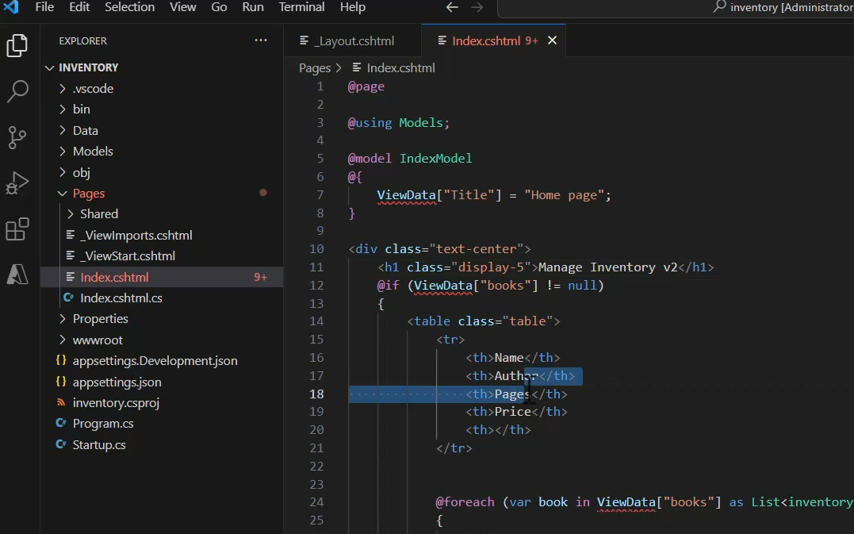

On Local

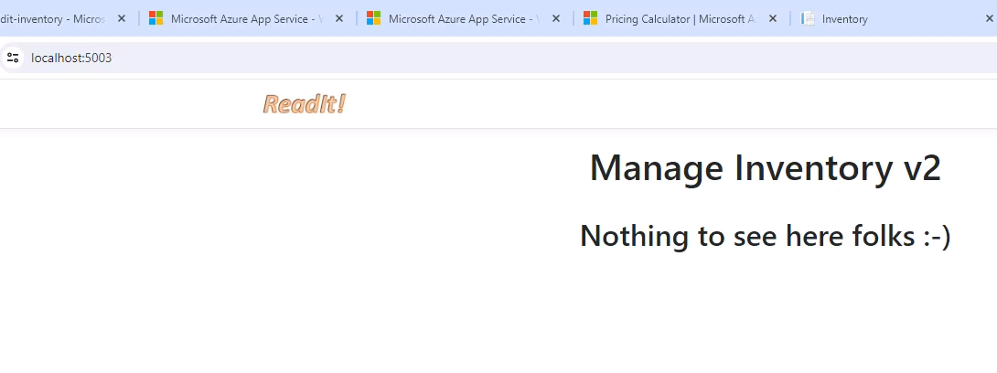

Deploy to the Deployment slot

So our change did take effect. Let's also close these, we don't need them right now. Let's go back to VS code. Great, so now let's deploy the updated version to the new deployment slots. So let's go back to the extension and right click on staging slot and deploy to slot. So click it and are you sure you want to deploy to this slot, and then note the name of the service we are going to deploy to, which includes the staging at the end. I guess we definitely want to do that, so deploy.

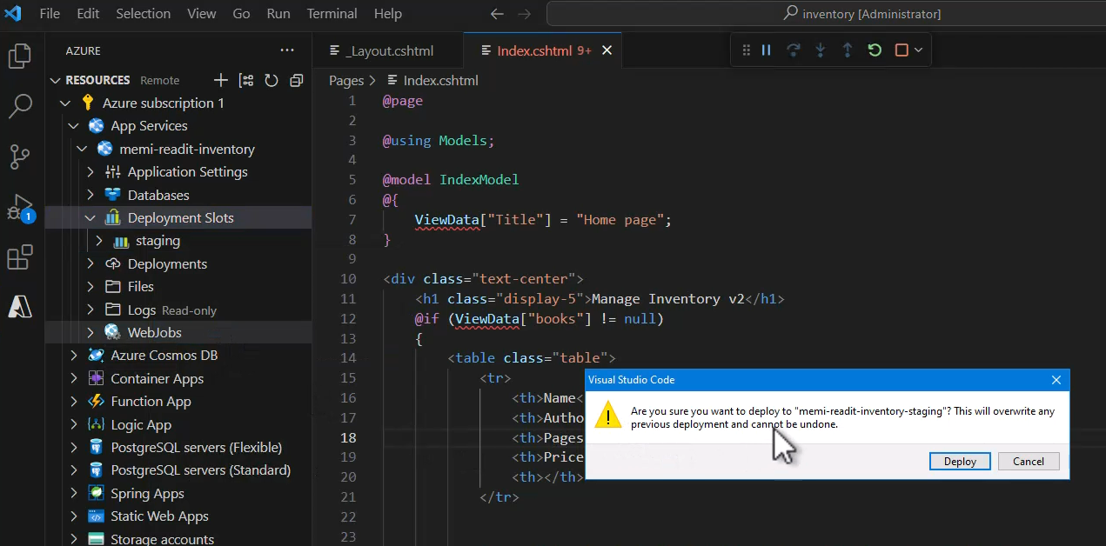

And this might take a few seconds or perhaps even a minute or two, so let's wait for that to complete and build was complete successfully. Let's click the link to take a look at the output window and see the deployment progress. So let's wait and see.

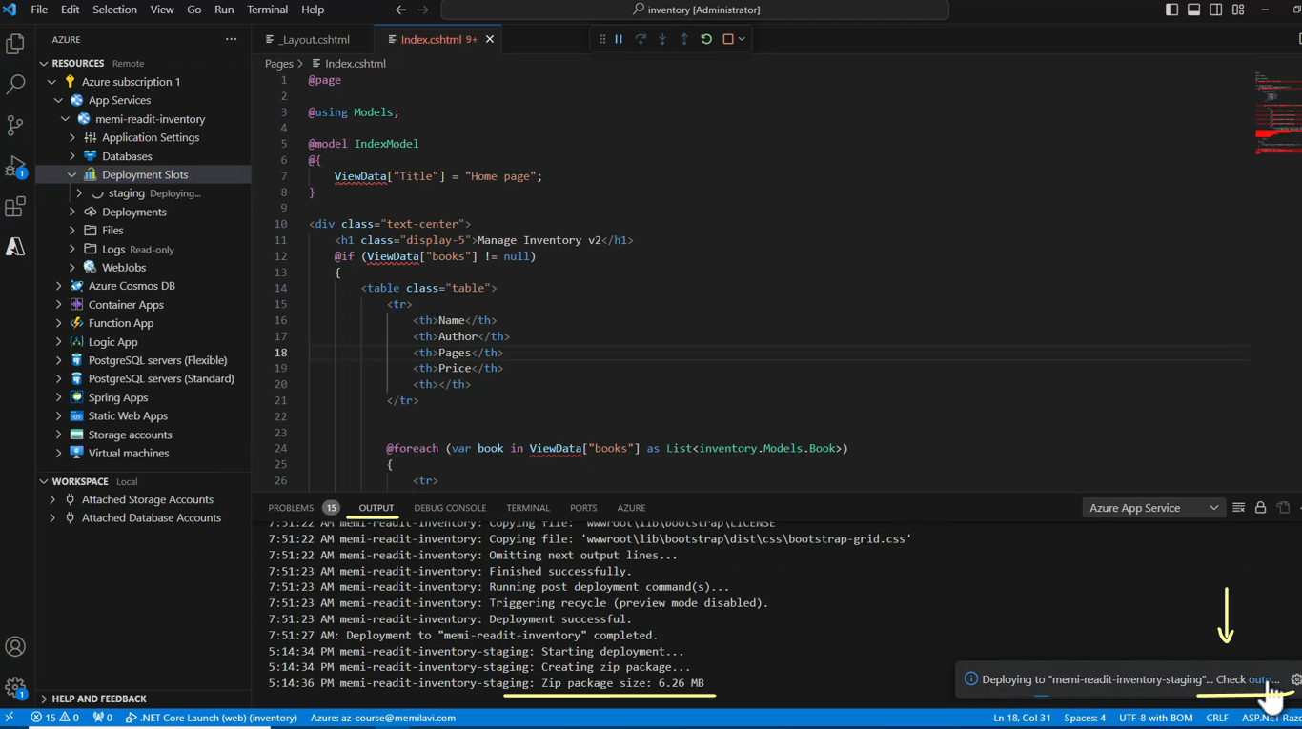

And deployment was complete and note the message here, deployment to memi-readit-inventory-staging completed. And also this is what you see in this message. So browse website and let's see what we will have here.

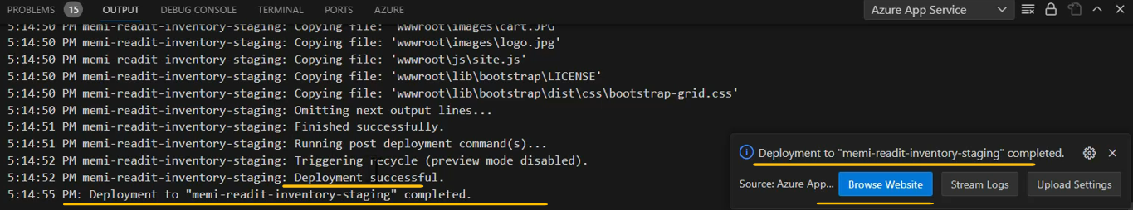

So first note, the URL, the URL points to the staging slots that we created and the codes that we have here is indeed the new code, the v2 code.

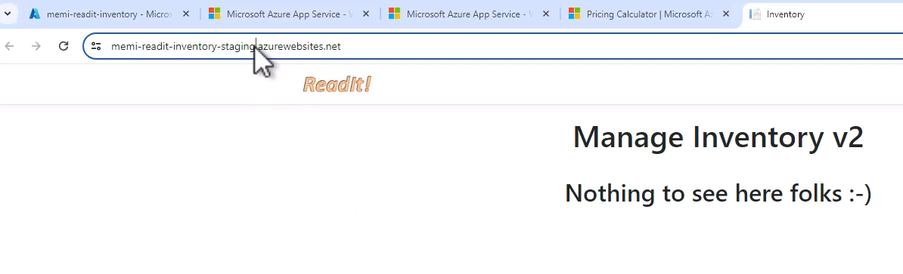

Now if you'll go back to the website and let's go to the overview and click the default domain of the app service.

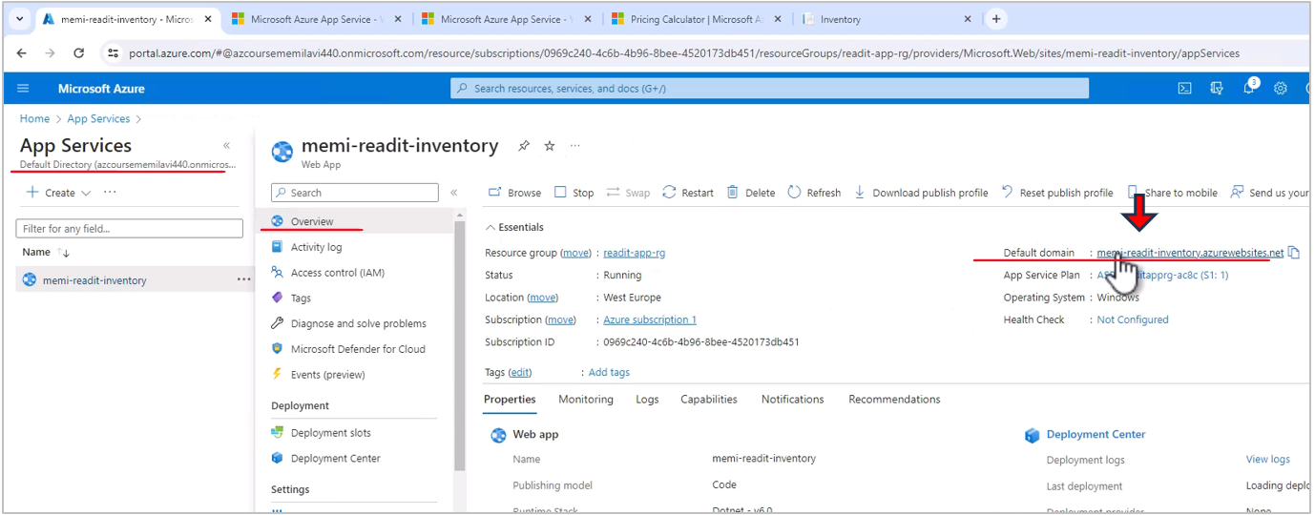

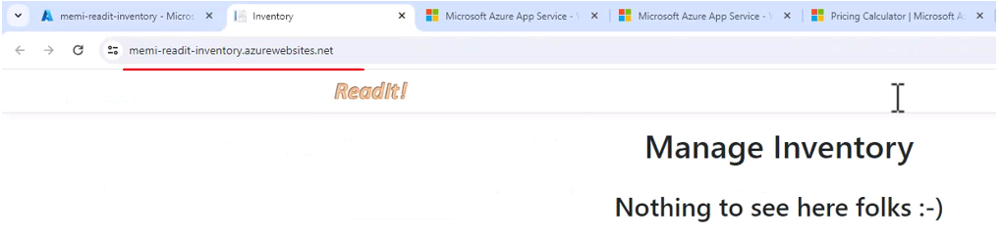

Then you will see the old version. So let's hit refresh just to make sure we see the most up to date version of the app service. And yes, we always see the old version. And with the staging slot we see the new version. No matter how many times we refresh the page, we always see the old version here and the new version here.

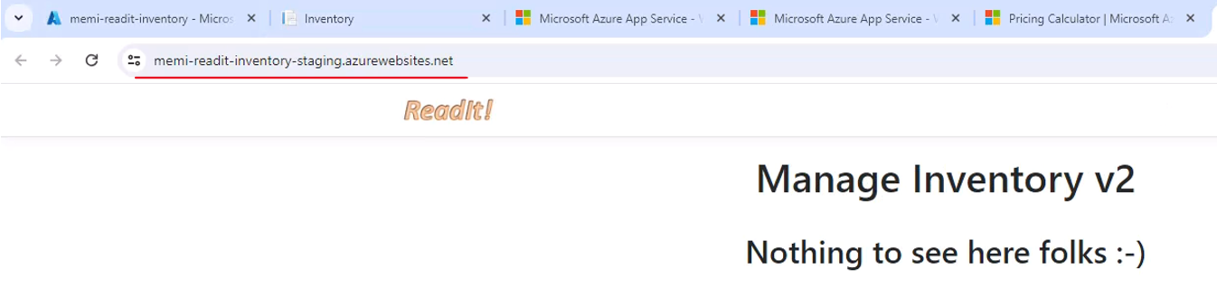

Let's adjust to make it more comfortable. Let's move the tab right here. So this is the main app service and this is the staging slot. Now let's go back in the portal to the deployment slots and let's play a little bit with a traffic percentage. So currently all traffic that reaches the default domain of the app service is routed to the production slot and the none is routed to the staging slot, but we can change that.

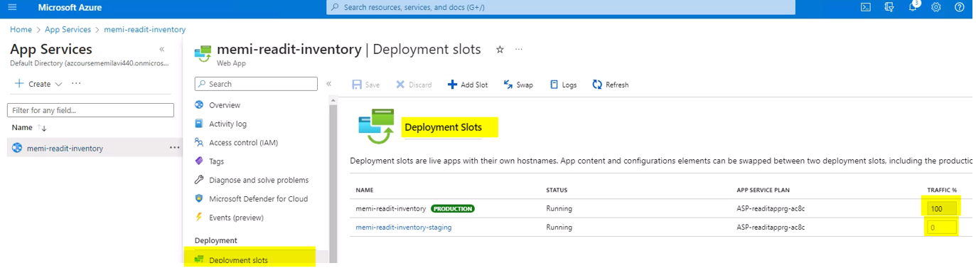

So let's change these to 50, which immediately changed also this field to 50 and let's save it.

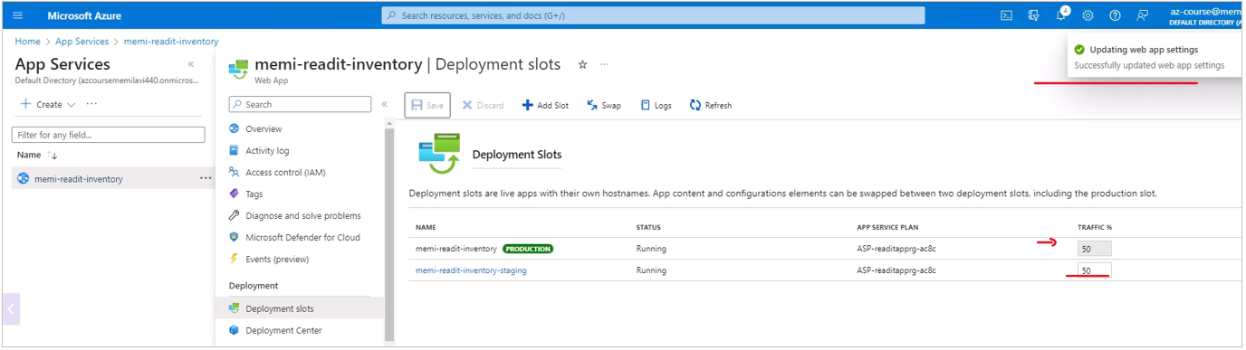

And what we are doing now, we define that half of the traffic for the main app service will be routed to the production slot and half will go to the staging slot. And let's see whether this indeed happens. So let's go to the app service, to the main URL of the app service and simply hit refresh a few times and let's see what will happen. So refresh the page here and you might be seeing as in my case, that we still don't see the new version.

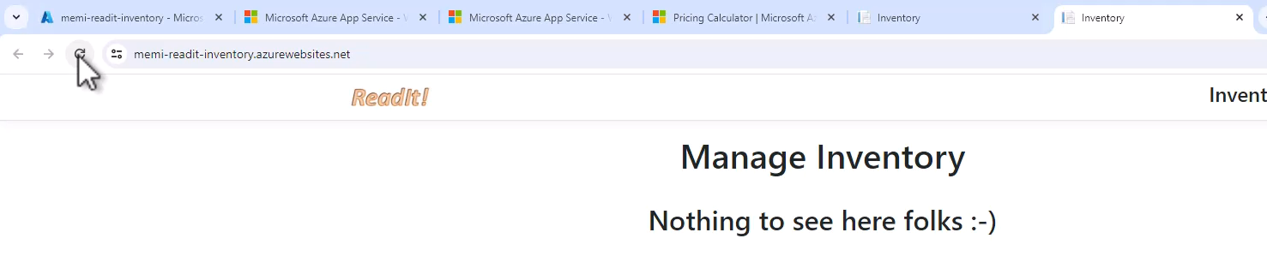

Now the reason for that is because Azure puts a special cookie on your browser and it identifies what was the first slot that you accessed after changing the traffic percentage and in my case, I was routed to the original version, the one without the v2, and from there on I will always be routed to this version, which means that if I want to see the other version using this URL, I will need to either remove the cookie pointing me to this version or simply go to incognito mode.

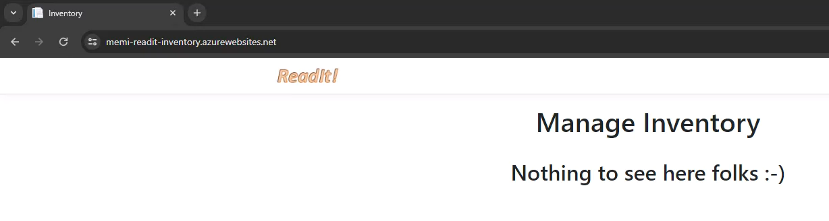

So let's do that, copy this URL, and let's open here incognito mode. And remember that I still can't be sure that now I will be routed to the new version, but let's see what will happen. So paste the URL and again, make sure this is the default URL of the app service and not of the slot. And hit enter and we still see the original version. Now we can continue check that with other incognito mode or even with different browser. So for example, let's open another browser and test it with it. So I opened Edge and let's paste the URL and see what we will get. No, we still get this version. So anyway, it's really difficult to test that from a single computer and you will usually do that with a lot of users. So some of them will get the new version and some of them will get the original one. And anyway, this is how it's done.

Now what we want to really do is after we tested the new version, which we did here and made sure that it works just fine, we want to swap the slots, meaning we want the original URL to always point to the new version and basically to make this version the production one. So let's see how to do that. Let's go back to the slot here and let's change the traffic percentage back to where it was so that 100% of traffic will go to the production.

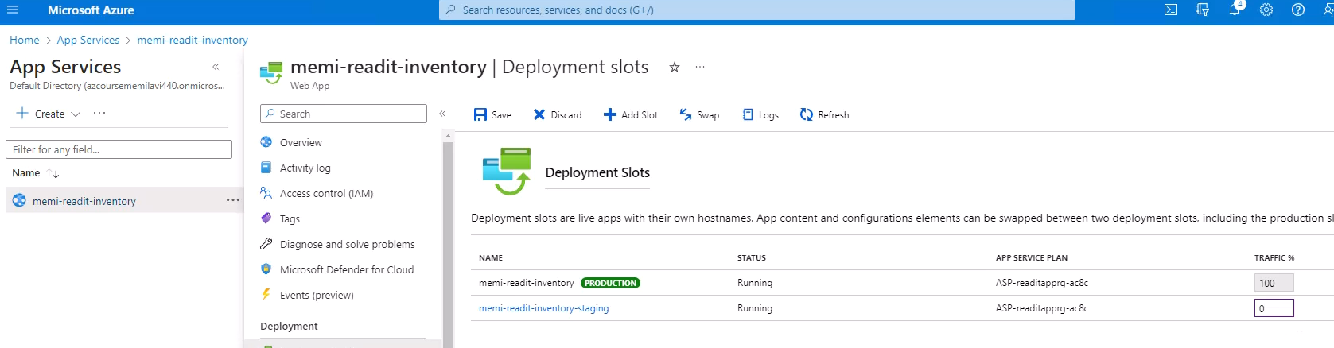

Let's save that. Great and now we want to swap the slots so click swap. And here we need to select what is the source and what is the target. And usually you will go from the staging to the production like that. And if there are settings that you want to change between the versions, you can see them here, but in our case, this is not relevant, so click swap and let's wait for the swap to complete.

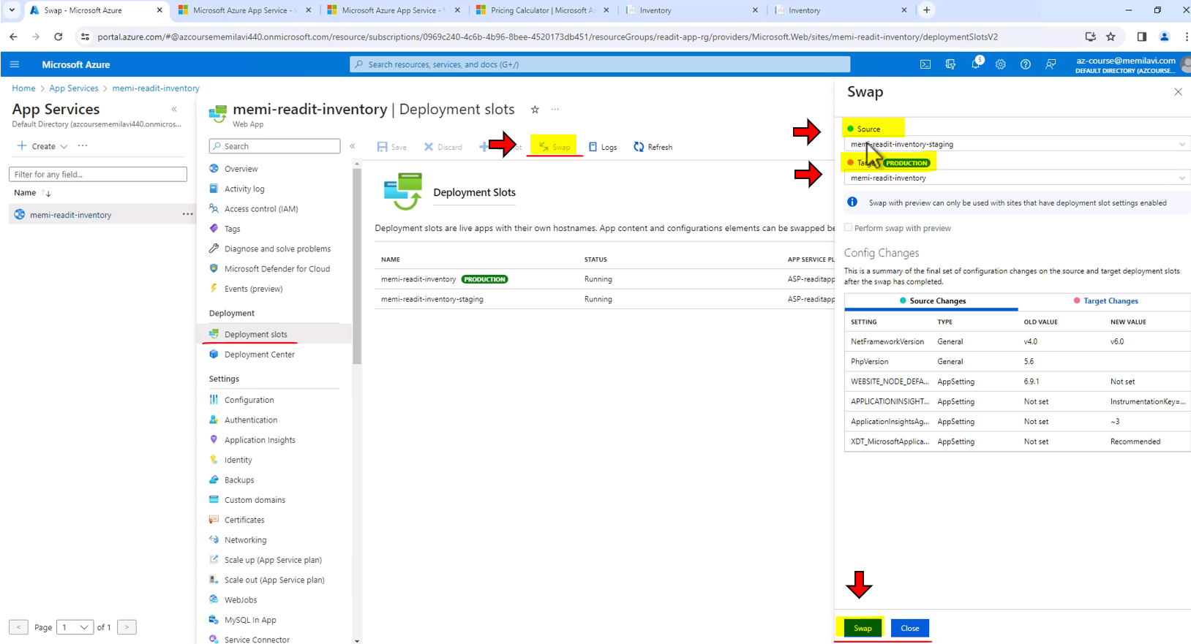

Great, and the swap was complete. So let's see whether this is indeed the case.

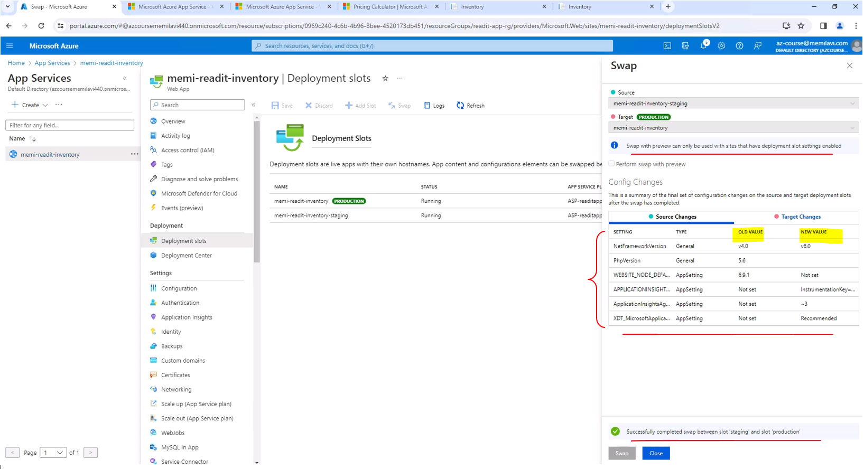

Let's close the swap popup and let's go back to the URL of the staging, which currently shows the v2 of our code so let's refresh it. And now we don't see the v2, meaning the staging slot now shows us what was the production code because again, we swapped the slots.

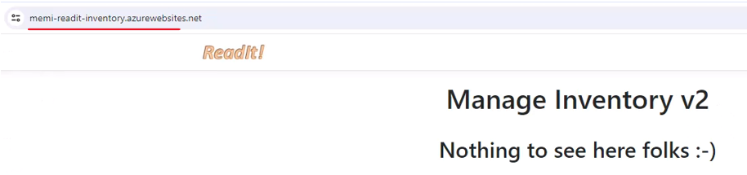

And now let's go to the main URL, which is this one. And of course what we want to see here is manage inventory v2, and let's see whether this is indeed the case, so hit refresh. And yes, we do see here the v2 , meaning the slots were indeed swapped.

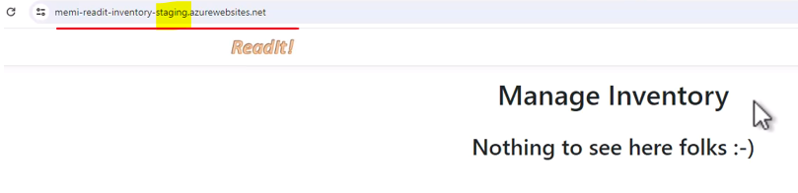

This is how we work with deployment slots & how we can add staging environment for your app & allowing many deployment types.

### Deployment Types

|  |  |
| --- | --- |
| Traffic splitting enables various types of deployment.  These types are  Basic,  Rolling, and  Blue-green. |  |

#### Basic deployment

|  |  |
| --- | --- |
| So basically with basic deployment, all instances update to the new version at once. So if we have three instances running V1, then in a single click of a button, all these instances are now migrated to the new version. So this is a basic deployment.  And what are the pros and cons of this deployment type? Well, the pros are quite obvious. It is very simple to do that, and it is fast, again, in a single click of a button, the version is deployed in all instances. What about the cons? Well, it is risky since if the new version is buggy, then the system might get unusable due to the bugs that were deployed to all instances. |  |

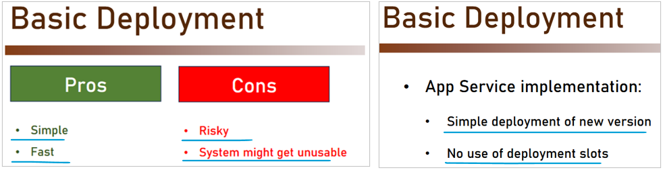

Now, how do we implement basic deployment in App Service? Well, very simple. We simply deploy the new version to the App Service and we are not going to use any deployment slots. And in this case, the new version will immediately become the production version of the App Service, thus implementing basic deployment. So this is the first deployment type.

#### Rolling Update

With the rolling update, deployment instances are updated gradually in batches and only if no errors are found, then the deployment resumes. So if this is the initial situation, so we have three instances, for example, that are running V1 of the code, then at first we migrate the first instance to run V2, then the second, and lastly the third one.

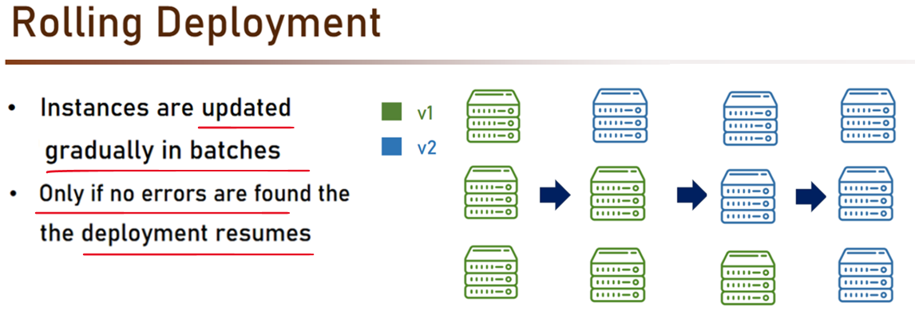

|  |  |
| --- | --- |
|  | Now, what are the pros and cons of this deployment type? Well, the pros of course, is that it allows rollback. So if there is a problem with the version, we simply can roll back the deployment and no harm done.  What about the cons? Well, mainly we need to support two versions simultaneously because as you saw in the diagram, there will be a situation that our app will run V1 and V2 simultaneously, and I need to be able to support these two versions, which makes it not so easy to manage. |
|  | Now how do we implement running deployment with App Service?  So we are going to deploy to a slot and then set traffic percentage, so that small percent will be routed to the new version and gradually increase the percent of traffic to the new version until it reaches 100%. And then after you are sure that the new version is bug free, swap the slots. So that's rolling deployment. |

#### Blue Green Deployment

|  |  |
| --- | --- |
| With a blue-green deployment, what we do is that new version is uploaded and accessible only to testers.  So external users will not be able to access the new version. And after verification complete, then traffic is routed to the new version.  So basically what we have is this, we have instances running V1, and then in addition to these instances, we have other instances running V2 & only after we are happy with V2, we can remove safely V1 & stay only with V2 & then route all requests to the new version. |  |
| What are the pros and cons of the blue-green deployment?  **Pros:** Well, first it is much more simple because I don't have to support two versions simultaneously. Remember the new version is accessible only by the QA teams. In addition to that, I know that the new environment is always tested. There won't be any situation that the new environment is becoming the general available one without testing it and verifying that everything runs as expected. | **Cons:** Well, first the cost, because I have more instances and note that this drawback is not relevant for our case, since there isn't any additional cost for deployment slot. |
| D  So how do we implement the blue-green deployment with App Service? Well, first we deploy to a new slot, then the testers will work on the new slot using its dedicated URL. And from the point of view of the general users, nothing has changed. They continue working with the original URL and they don't even know that there is a new version that is currently tested by the testers. And only after testing is complete, we will swap the slots. So this is how we implement blue-green deployment with App Service using deployment slots. And this is how in general you work with App Service and with deployment slots. |  |

**Architecture so far that we have is as below**

|  |  |
| --- | --- |
| So previously we had two virtual machines, one for the catalog app and one for the weather API.  And now, we have another element in our architecture, which is the app service which is used for the inventory app. |  |

### App Services Tips and Tricks

By default, App Services can be accessed using http and https. You can make it https only in the TLS/SSL settings in the App Service menu.

App service can run also batch processes, or continuous jobs, and not only web apps with the request / response paradigm. This can be done using the WebJobs menu item, where you can upload exe file that will run always, or on scheduled times.

Want to know the IP address of the App Service? Take a look at the Properties of the page. You can find there the Virtual IP address of the App Service, and also - the Outbound IP addresses. Note the plural - App Service can have more than one outbound IP address.

Want to know how much storage did you use, and what are the current usage statistics? Go to Quotas for this data.

Shutting Down App Service

With VMs, I recommended you to shut down the VM when not in use.

With App Service, this is not the case. While you can stop an App Service (using the Stop button at the top of the Overview page), all it will do is to stop the functionality of the App Service, but you'll still pay for it.

That's an important difference between App Service and a VM.

* With VM - you pay only when the VM is On.
* With App Service - The only way to stop paying for it is to completely delete it.

This is another difference between VM and App Service you should keep in mind. ( Oh - and don't forget to add the Inventory App Service URL to the Resources Helper List )

## AKS

AKS is Azure Kubernetes Services, and basically, it is a managed Kubernetes on Azure.

|  |  |
| --- | --- |
| Now using AKS, you can deploy containers and manage them using the Kubernetes tool on Azure.  And what's nice about AKS is that there is no payment for the AKS itself. You pay only for the instances that are used by AKS, and by instances, I mean virtual machines, because AKSs runs on virtual machines, which, again, you don't have access to.  You just select the instance size that you want to use, and AKS takes care of everything else. |  |

Containers

You might have heard about containers before, but in order to really understand where the containers came from, we need to remember how traditional deployment was performed. So the way it was done until a few years ago was actually quite simple. The code was copied to the production server and was built there. Sometimes, depends on the platform capability, it was prebuilt and then copied to the server, but whatever the case was, the piece of software that was run on the production server was not the same piece of software the developer worked on. That resulted in a situation when problems were found on the production servers that were not found in the dev machines.

If you have even the slightest experience in the software development world, you must have seen this happens, and this led to countless of jokes and memes, which can be sound like this. It works on my machine. This sentence became the epitome of the deployment problem and the most frustrating part was that it was actually true. The software did work on the developer's machine, but for some obscure reason didn't work on the production machine. This, of course, led to a lot of wasted time and money that were spent trying to figure out what went wrong and what are the differences between the two machines. This problem haunted the software world for decades and it was clear something had to change and this is when the containers appeared.

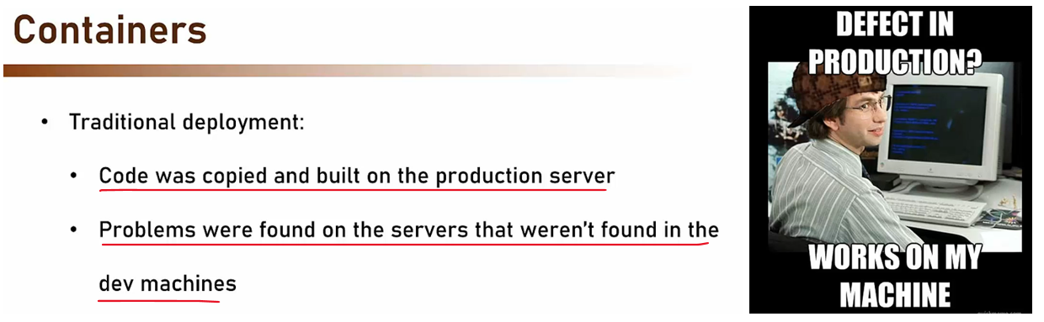



So what are containers?

|  |  |
| --- | --- |
| Well, containers are a thin packaging model. They package together software, its dependencies, and configuration files, and then can be copied between machines. This package creates an atomic unit that can be executed using whatever software and files are contained within it and completely independent from the rest of the machine it's hosted in with one notable exception, the container uses the underlying operating system. |  |
|  | So what we have here is an independent software and its dependencies that runs independently of the host machine, which immediately begs the question what's the difference between containers and virtual machines? After all, it looks like they both implement the same IDs, a package of software, and the files that runs independently on the host machine, and does not use its own file system and software. That is a very good question.  With virtual machines, we have the infrastructure, which is the hardware and the host operating system. On top of it, there is the hypervisor. The hypervisor is the component responsible for running the virtual machines and also for making accessible the host resources, such as disc, network, and more. On top of the hypervisor are the virtual machines themselves, each with its own guest operating system and applications. Now, the guest operating system here is important. |

With virtual machines, we can have a host running Windows 2016, and on it, one virtual machine running Windows 2012, and another one running Ubuntu. That's not a problem. With containers, this is not the case. As with virtual machines, we have the infrastructure, which here is mainly the hardware. On top of it, we have the host operating system, which is a regular operating system and then we have the container runtime. You can say that the container runtime is similar to the hypervisor in that it runs the containers and make accessible to them the host resources, such as networking and disc. But this is where the similarities end. The containers managed by the runtime are extremely lightweight in comparison to the virtual machines, and that's for one main reason.

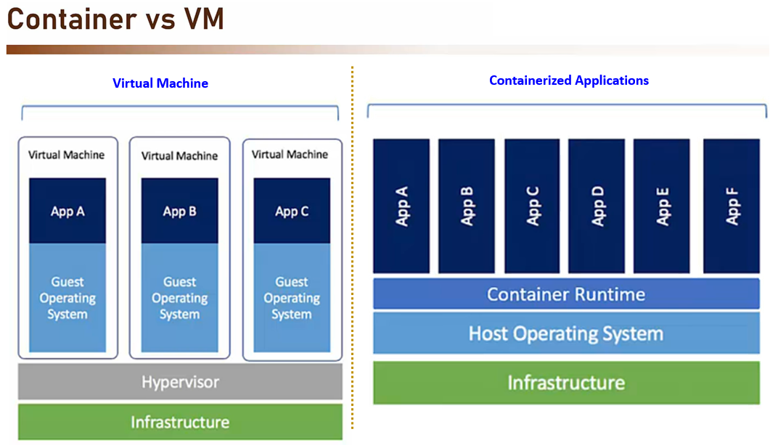

They share the operating system with the host as opposed to the virtual machines where each VM can have its own operating system, the containers have the same operating system as the host. So if the host runs Windows 2016, this will be the operating system of the container. If the host is upgraded to Windows 2019, all the containers will find themselves running Windows 2019. Now, as you will see later, this can be an advantage, but also a serious drawback. But anyway, that's the main difference between virtual machines and containers. Now the question we need to ask of course is why containers? What is our motivation for using them? Well, there are several reasons for that.

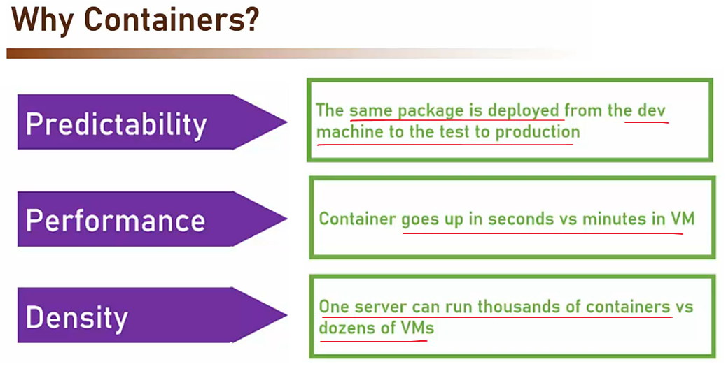

First predictability, the same package is deployed from the dev machine to the test to production. If it runs on the developer's machine, it runs on the production machine. No more, it works on my machine. Next performance, a container can go up in seconds as opposed to minutes required by the virtual machine to be operational. This of course, is the result of the container using the host operating system and not required to boot a whole new operating system that allows it to load much faster. Another reason is the density. What this means is that one server can run thousands of containers but this very same server will run only dozens of VMs. Again, this is the result of the containers being much lighter than virtual machines and requiring much less memory. So these are the main reasons for using containers. Now in my opinion, the predictability is the main reason that should be of interest to the development team and the architect, but the other two are also nice to have. Okay, so these are the reasons to use containers, but there sure are reasons not to use them, right? Well, yes, there are. Mainly one major reason and this is isolation.

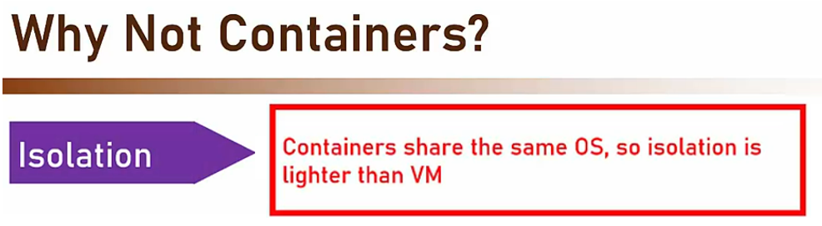

Containers share the same operating system, so the isolation between the containers are much lighter than between VMs. It's much easier to cross the boundaries between containers than between VMs and that means that if your application contains sensitive code or data, it should be probably deployed on an isolated virtual machine. Now, note that it can still use containers for the deployment itself. It just shouldn't share the host machine with containers of other applications. Okay, so this is the container deployment model and I hope you understood why it's so useful. And now let's move on and talk about the most popular container implementation in the world.

### Introduction to Docker

Docker is the most popular container environment in the world by far. It's the de-facto standard for containers. It's so popular that today when people say container they usually mean Docker. It was released in 2013 and immediately gained a huge popularity which just increased since then.

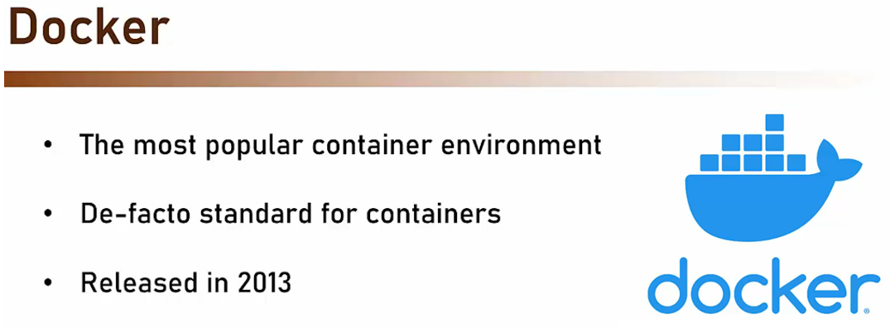

<https://docs.docker.com/get-started/docker-overview/>

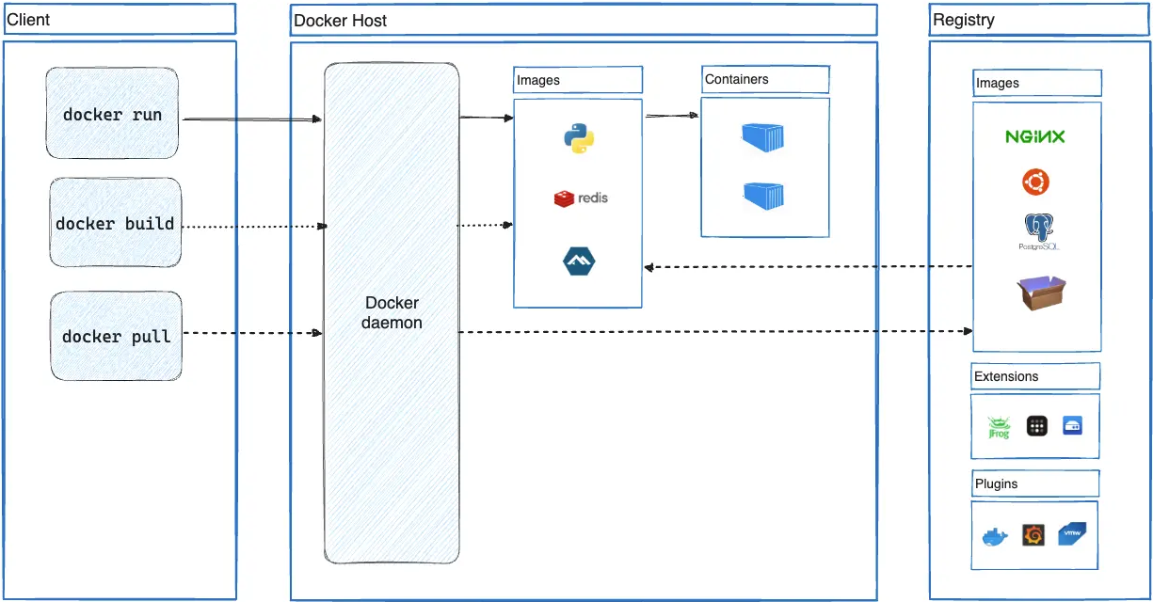

So how exactly does Docker works? What is its architecture? You can see here the main three parts of the Docker environment and let's go through them together. First, the Docker Server or daemon. This is a service that runs on the server and responsible for managing the Docker containers. It turns them on or off. It keeps tab of their activity. It builds containers based on images, as we will see in a minute, and it exposes API for management tools. This is the heart of the Docker environment and without it, nothing will work.

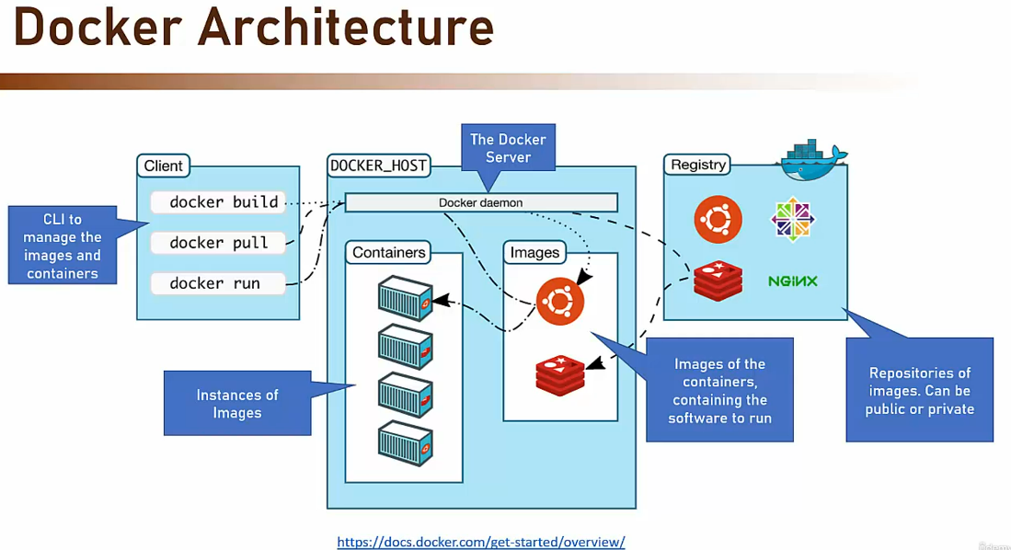

Next are the images. Image is the set of definitions and software for a container to run. If you are familiar with virtual machine images, that is the same idea. So for example, you can have an image for the front end of the HR application and an image of the database of the e-commerce system. Images are the building blocks of the containers. Now note that images are static files and they don't run. They are the basis for the containers but they themselves just lie on the disc and waiting to be called.

Now, where do we get the images from? For that, we have the container registries. Container registry is basically a collection of images from where you can pull the image you want and either use it as is or customize it to your needs. For example, you can pull an image for a baseline net core application and then customize it by copying into it your specific code components. You then get a new custom image you can use as a basis for the container. Note that container registries can be public. For example, Docker hub, which is used by many of Docker users for creating baseline images or private and then it's accessible only for you or the organization.

And then we have the containers themselves. A container is an image that is built and run. The container runs in a sandbox, created and managed by the Docker daemon, and is a living briefing instance of the image. The container is a full blown process and can do whatever it wants, assuming it has permissions. Again, similar to VM, it's a piece of software that runs on a machine isolated from the host, but can use its resources.

And then we have the client. The client, which is a CLI, command line interface, is where you can send instructions to the daemon. This is your gateway to the whole functionality of Docker and using it, you can pull images, customize them, run the containers, list them, shut them off, check the status, et cetera. This is where the IT guys or the DevOps guys will spend most of the time when working with Docker. So that is the basic architecture of Docker and these are the main parts in it.

Now, we said that one of the core capabilities of Docker is customizing images. The ability to pull an image from a repository and then add resources to it is one of the major success factors of Docker. And this customization is done using dockerfile. So dockerfile is a file that contains instructions for building custom images. It can instruct the Docker daemon to copy files, run commands, change working directory, and more. Dockerfiles are usually quite small because there are so many baseline images to begin from and the customization required is not that big.

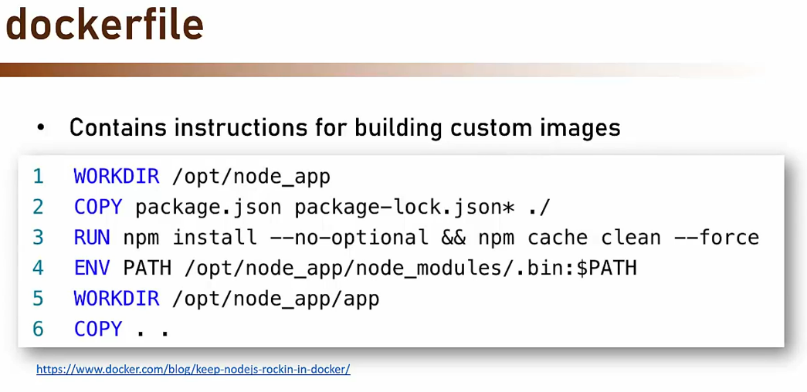

Here is an example of such file. As you can see, it's quite easy to understand what's going on. The file instructs Docker to copy some files then RUN npm install, set environment variable, and copy some more files. This is a classic example of a dockerfile and most files look quite similar to this one. Now, we said before, Docker is the most popular container platform in the world and that shows in the great support it has in values platforms.

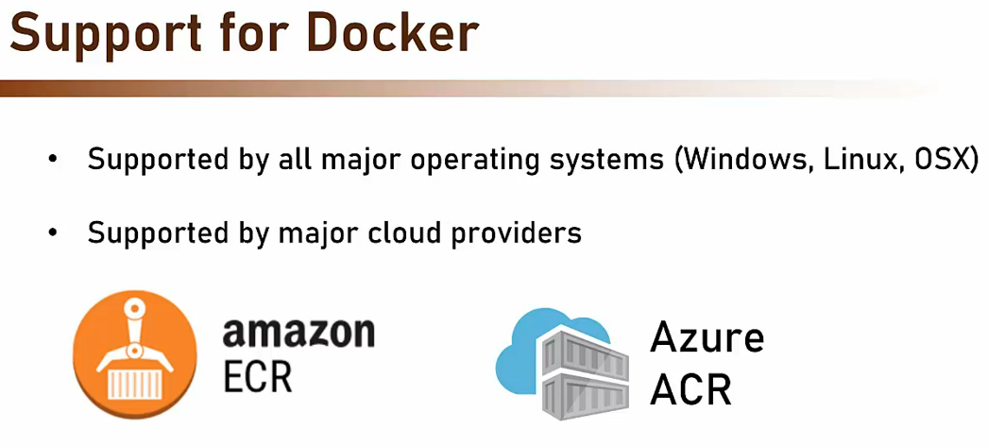

First, it's supported by all major operating systems, Windows, Linux, and OSX. And more important, it's supported by the major cloud providers. That means you can deploy Docker to the cloud and it simply runs. And even more, the cloud providers have their own container registry you can use for your images. Amazon has ECR, Elastic Container Registry. And Azure has ACR, Azure Container Registry And that makes Docker even more attractive. Using it means you can develop on your own development machine and then simply package the code in Docker, push it to the cloud, and it will just run. And this is another reason to use Docker and another reason why it became so popular.

### Container Management

Containers are a great deployment mechanism. It's easy, widely supported and predictable. No wonder it gained popularity quite rapidly. However, what happens when there are just too many of them? Take a look at this application. We have in this application alone, six containers.

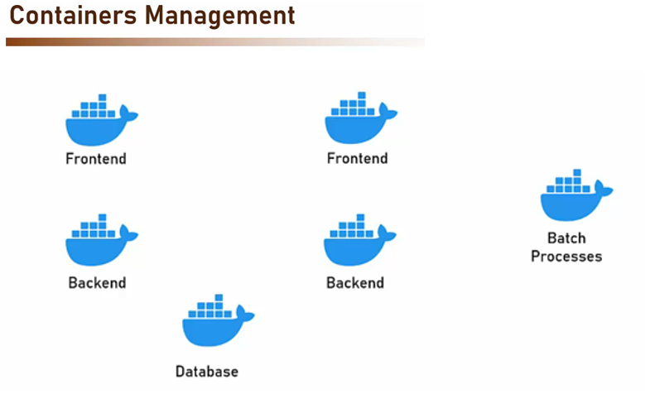

Two for the front end, two for the backend, one for batch processing, and another one for the database. And that's quite a small system. When the number of containers begins to grow, we find out we have problem managing this number of containers. The major problems are deployment. We have a lot of containers to deploy to and doing it manually can be tiresome and error-prone. Scalability. If the containers are loaded, we need to be able to scale them or add more containers to distribute the load more effectively.

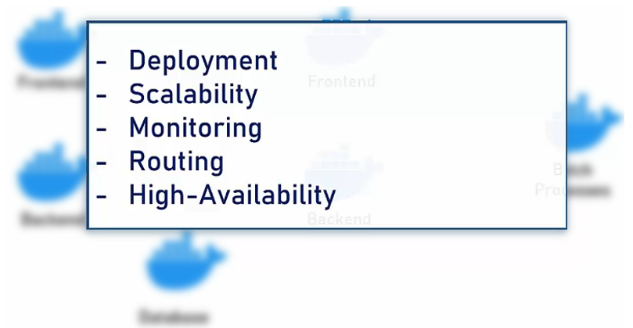

Monitoring. What happens when a container goes down? Someone has to know that, but when having a lot of them, doing it manually is not feasible. Routing. If we have more than one instance of a container, we need a routing mechanism similar to load balancer to route the request to the container instance. And high availability. How to make sure our container-based system can deal with crashes and errors? Now, this list might look familiar to you and it's not a coincidence. When using virtual machines, we face the same problems. With virtual machines, these problems are solved by the traditional host managers and load balances. But how do we do that with containers? Well, exactly for that, containers management tools were designed and let's meet the most popular one. Search course content Start a new search To find captions, lectures or resources

### Kubernetes

Kubernetes is the most popular container management platform by a wide margin. It is currently the de-facto standard for container management, and it was released by Google in 2014.

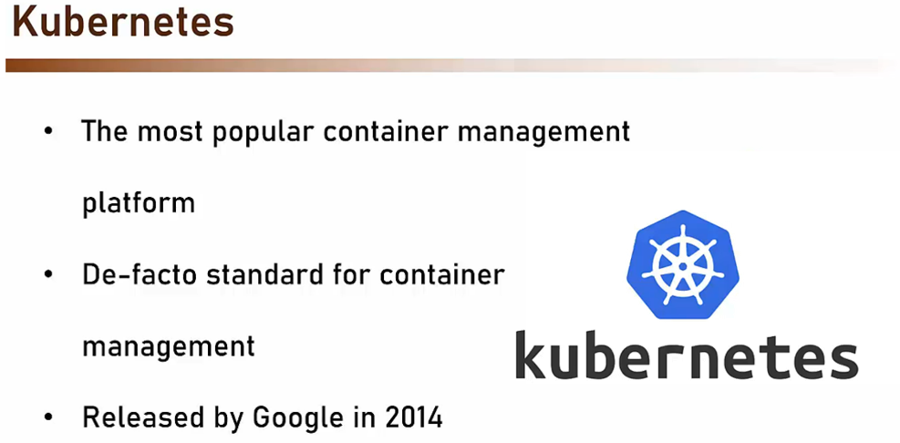

Kubernetes provides all aspects of container management: routing, scaling, high-availability, automated deployment, configuration management, and lots more.

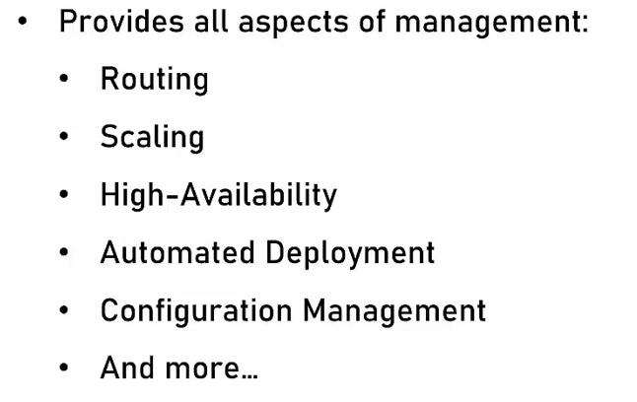

Now, I don't want to deep dive into Kubernetes architecture. You are not expected to know that, but there are some elements you do need to know.

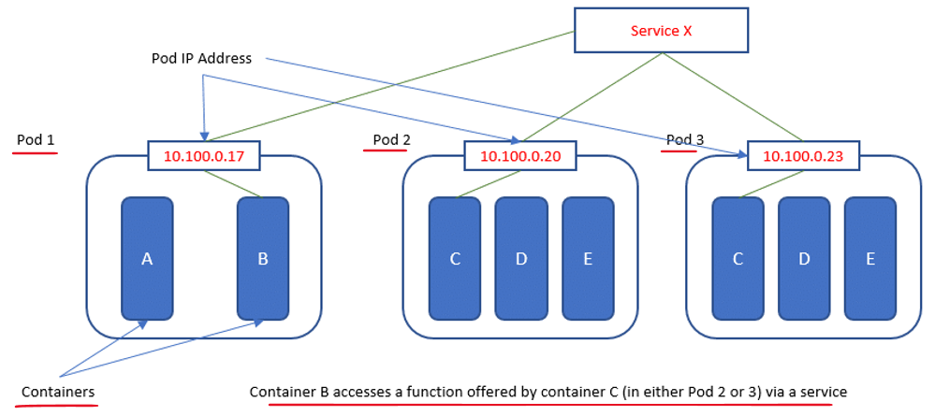

First, as you can see in this diagram, the basic building block in Kubernetes is the pod. Pod is the atomic unit in Kubernetes and it is the one Kubernetes manages. You can think of pod as a container of containers. In other words, the Docker container lives inside a pod and the pod functions as a wrapper around it, provides connectivity and monitoring. Now, in the diagram, you see there can be more than one Docker container inside a pod. That's true, but rarely happens. Usually, there is one Docker container inside one pod. As you can see, the pod exposes an IP address, which is how the Kubernetes communicates with the container. The containers are accessible to the public network using service. Service is the mechanism used by Kubernetes to expose functionality to the outside world and it masks the inner containers. The service provides not just public IP, but also load balancing, monitoring, high-availability, and more. Now, of course, there is a lot more in Kubernetes, but the pods and the service are the most important part of it. Search course content Start a new search To find captions, lectures or resources

Working with Azure Container Registry

In the next video we're going to create and use Azure Container Registry.

Due to a recent change Microsoft implemented in ACR, you need to have specific permissions to access its repositories. If you don't have these permissions, you might encounter the following error when trying to access the repositories

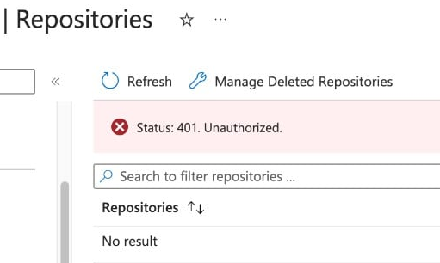

In order to avoid this error please follow these steps:

1. In the menu on the left click Access control (IAM)

2. Click + Add -> Add role assignment

3. Switch to the Privileged administrator roles tab

4. Select the Contributor role and click Next

5. Click + Select members and select your user from the list

6. Click Select, Review + assign, Review + assign again, and after assignment is complete go again to Repositories, and this time you won't see the error.

Azure CLI command to build the Docker image

In the next lecture we're going to build Docker image in Azure using the Docker extension in VS Code.

This extension has some issues, and it won't always show the registry we created in Azure.

You can build the image in Azure using Azure CLI instead of the extension, which also makes the process a lot shorter. To do that, after creating the registry in the portal, go back to VS Code (~8:40 in the video) and run the following command in VS Code terminal:

az acr build --image cart:v1 --registry <REGISTRY NAME> --file Dockerfile .

Make sure to replace the <REGISTRY NAME> placeholder with the actual registry name you created.

This will build the image in the registry and add a repository to it.

You can then jump to the ~11:40 mark in the video, and continue from there.

Note: Due to a recent bug in Azure, you might get the following error if you're using a trial account:

Error: ACR Tasks requests for the registry acrname and xxx-xxx-xxx are not permitted. Please file an Azure support request at http://aka.ms/azuresupport for assistance.

In this case, you have the following options:

1. Upgrade your account to a pay-as-you-go account, and the error will go away. Note that if you complete the course quickly, and delete the App GW (discussed later) right after using it, the costs will be negligible.

2. Download and install Docker Desktop locally on your computer from here: https://www.docker.com/products/docker-desktop/, and then build the image locally on your computer. After that you'll just need to push the image to ACR, and not build it in ACR, which is allowed in trial accounts.

### Working with Containers

We would first need to install something on our computer, which is Azure CLI. Now, we already used Azure CLI as part of Cloud Shell, and we used it to perform various actions in the cloud. However, now we need to use it locally, and that's because it provides access to values commands that we are going to run locally, especially the command that will deploy our Docker image into AKS. So, let's do that. Open another browser tab and navigate to this address.

<https://learn.microsoft.com/en-us/cli/azure/>

So hit enter, and now we are going to install the Azure CLI. So pick your operating system. In my case, that would be Windows. So click it and scroll down. And latest release of the Azure CLI. So click it also. And now it's downloading.

<https://learn.microsoft.com/en-us/cli/azure/install-azure-cli-windows?pivots=winget>

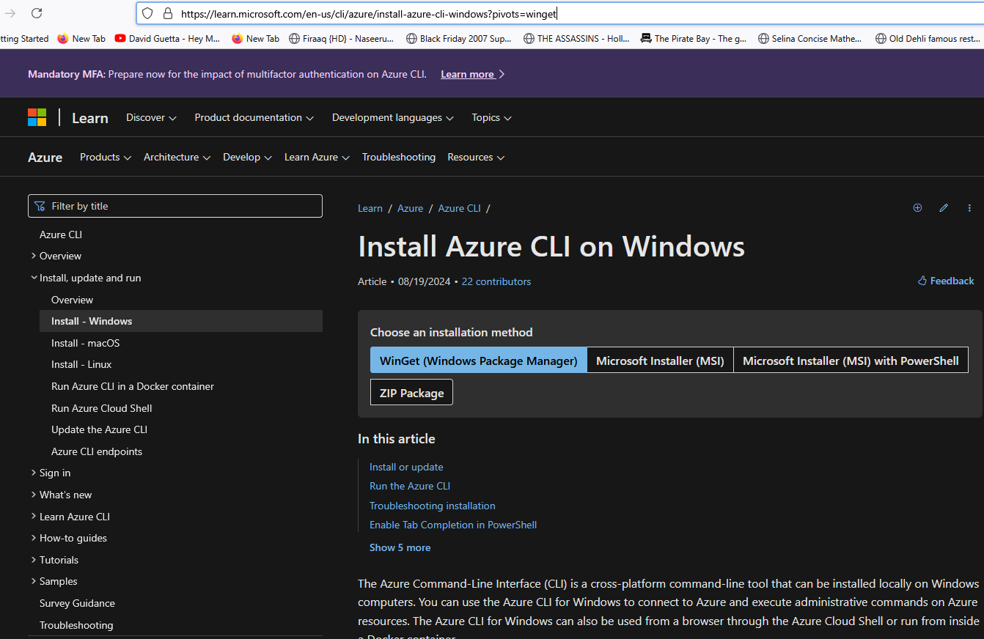

Let's wait for the download to complete. Great, and click it. And it might take a few seconds for it to compute the space requirements. Okay, and accept the terms of license agreement and install. And let's wait for the install to complete. Great, and setup is complete. So click Finish, and now let's just make sure that the CLI is indeed installed. So let's open the command line from here and simply type az like that. And it looks like our computer is familiar with the az command, and yes indeed it can run it, so it is installed and available for us.

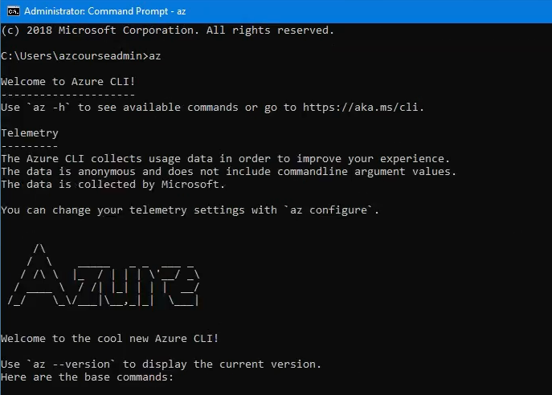

So now download from the resources of this lecture, the current baseline zero one zip file and extract it to our readit folder. So in my case, I will simply copy it to this folder, to the readit folder. And this code is basically the shopping cart of our readit store. So, here is this folder, look at cart, so browse into it, and this is our app, and it contains the code to run this shopping cart. So first, let's see if it runs locally. So let's open this up in VS Code. So as usual, go to here and CMD and code space dot, and it opens in VS Code.

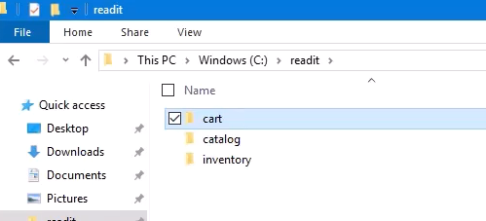

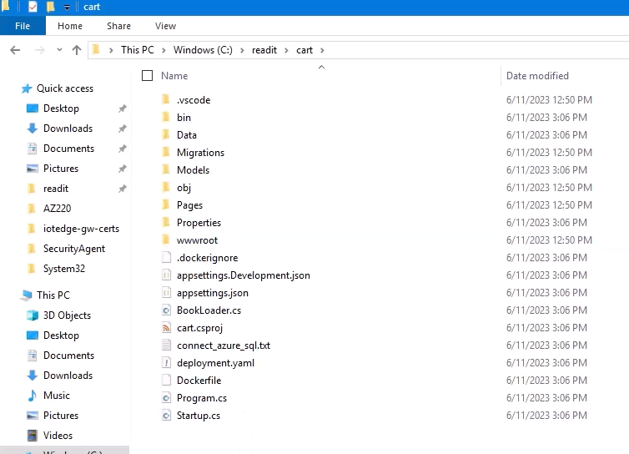

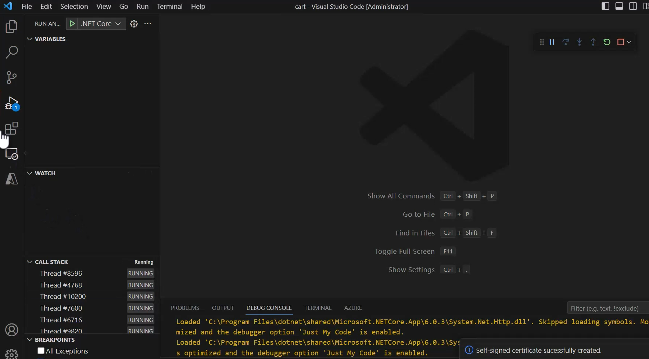

So simply without making any changes, just hit a F5 and let's see what happens. So hit a five, and the code is building. And here is our shopping cart, which is naturally empty right now.

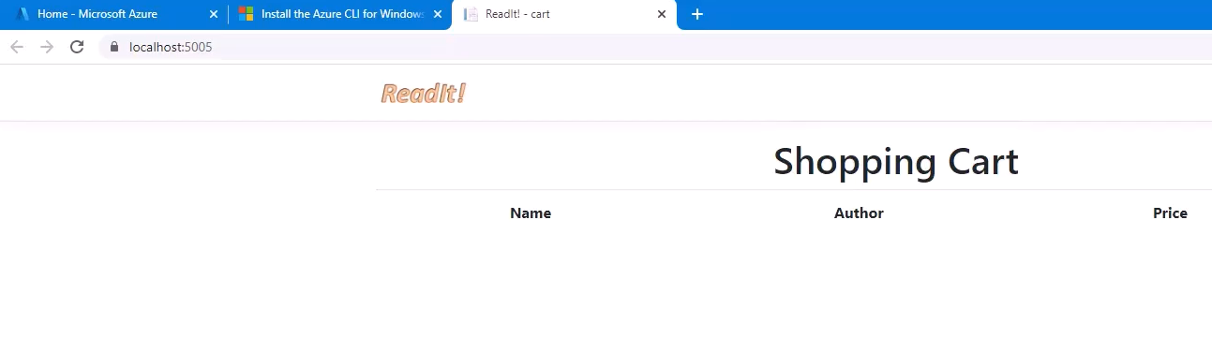

So the code actually runs in our local computer, and that's good. But again, what we really want to do is to run it in AKS. So the first step in doing that is to build a Docker image based on this code and publish this image or push this image into a container registry in the cloud. And for working with Docker in VS Code, we first need to install the Docker extension. Now previously we installed various extensions in this code, mainly to work with Azure, and now we are going to install another one. So go back to VS Code and go to extensions right here, and here in the search bar, look for Docker like this, and pick the first suggested extension, which is this one created by Microsoft. So click it and install. Let's wait for this to install, and installation is complete.

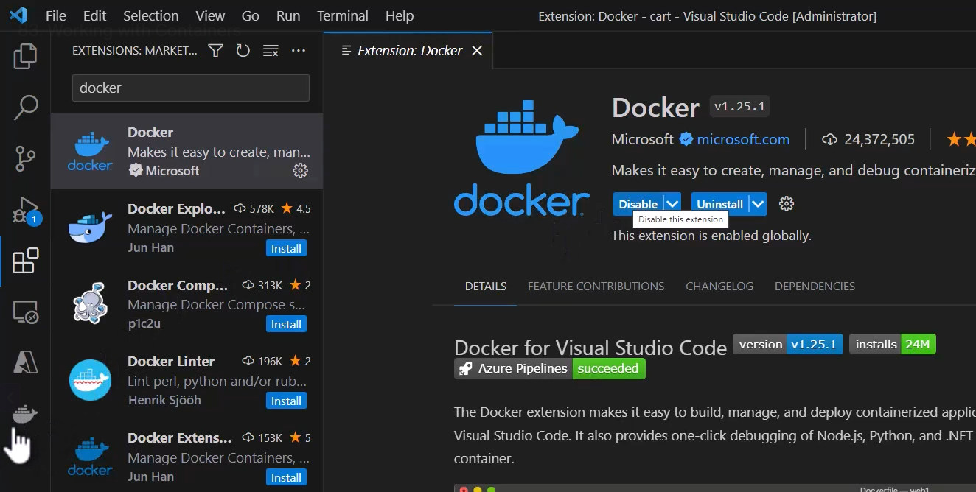



And you can see this new extension right here. Now if you click it, then you can see that using this extension we can manage the containers, the images, and the registries.

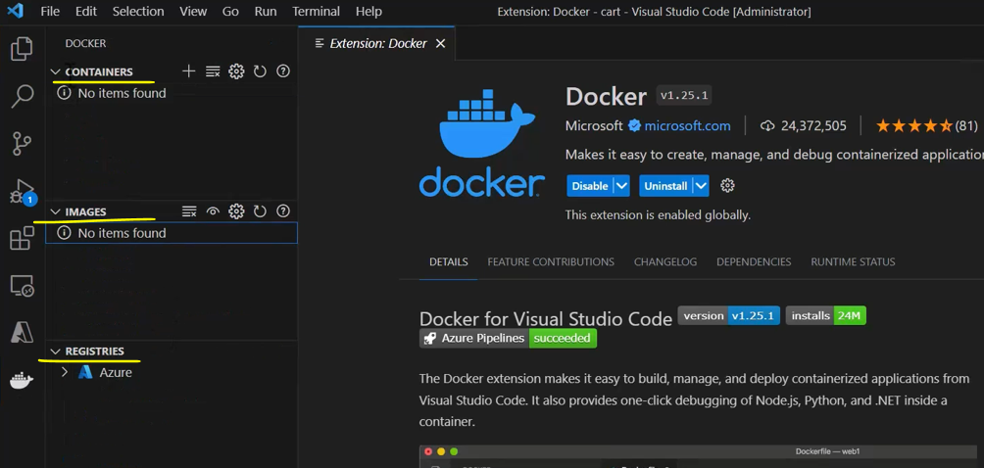

Great, so we have this extension, and we can now start working with Docker. And if you remember, one of the most important building blocks when working with Docker is the docker file. And here it is. So click it. And this Docker file basically defines how we are going to build our Docker image or what are its components.

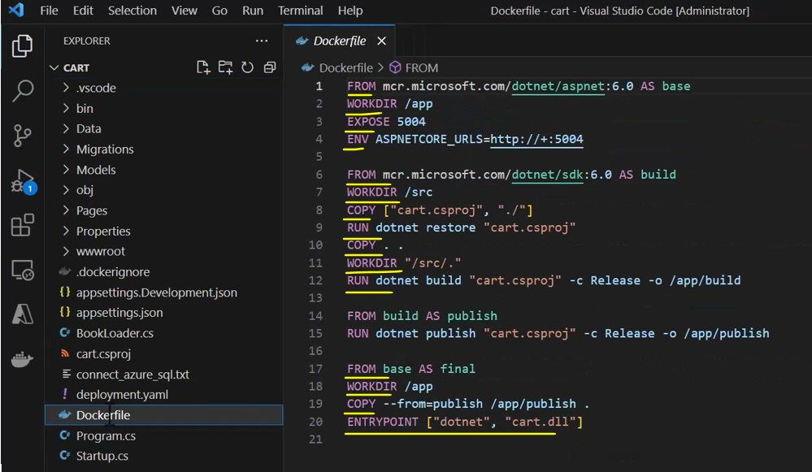

So you can see that we are going to base our image on dotnet 6.0, which is our version of the .NET platform that we are using. And we are going to publish it and do some more actions to our code. Again, we are not going to deeply explain each line here, but, again, the main important things here that we are going to base it on is this image taken from the Microsoft Container Registry, and then grab the code and build it and publish it. Now, we are not going to build the Docker on our local computer because that will make us install Docker Desktop, which is quite complicated and can cause a lot of problems. We are going to build the Docker image in Azure Container Registry, which is also one of the capabilities that it offers, to build the Docker image and not only to store it. So of course for that we need to create one, and currently we don't have any Azure container registry that we can use. So let's build one. So for that, let's go to the portal, and here type registries, and click container registries, and let's create one.

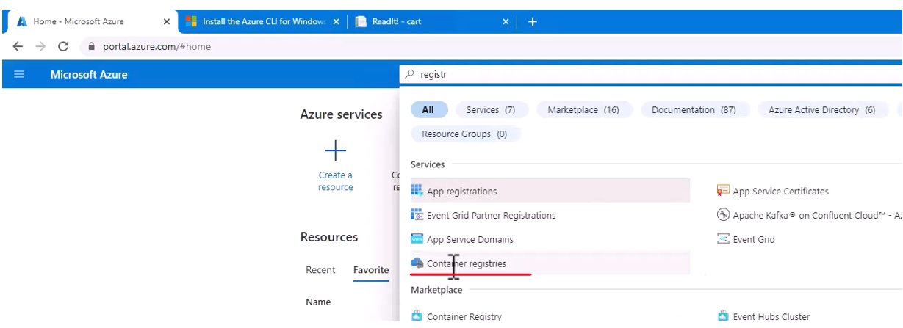

So hit Create and select the readit resource group, and the name of the container registry in my case is going to be readitmemiacr, ACR, as in Azure Container Registry. And note that this name should be unique, which means you won't be able to use it, so pick another one. Probably replace maybe with your own name.

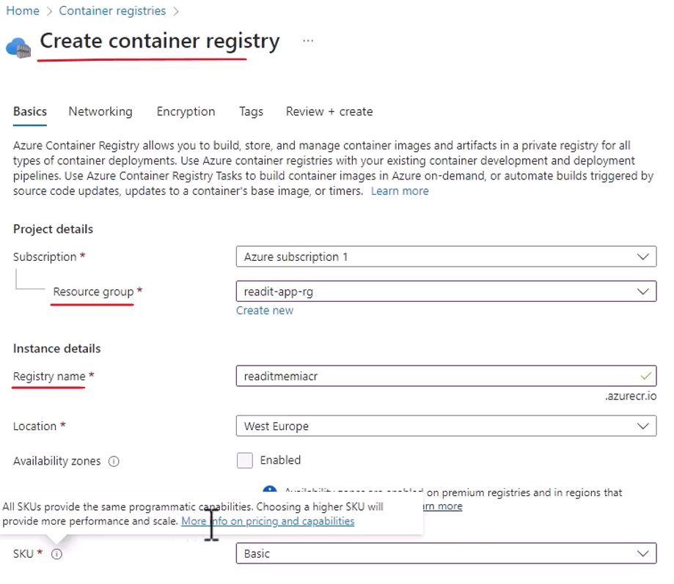

The location is your regular location and about the SKU, we are not going to use the standard tier, but the basic one, and the basic one offers less storage than the standard one, but it's still more than enough for what we need, and of course it's much cheaper. In fact, if you will click this icon and click the more info on pricing and capabilities, then scroll down here, and you can see the differences in the pricing between basic, standard, and premium, and the pricing differences are quite substantial.

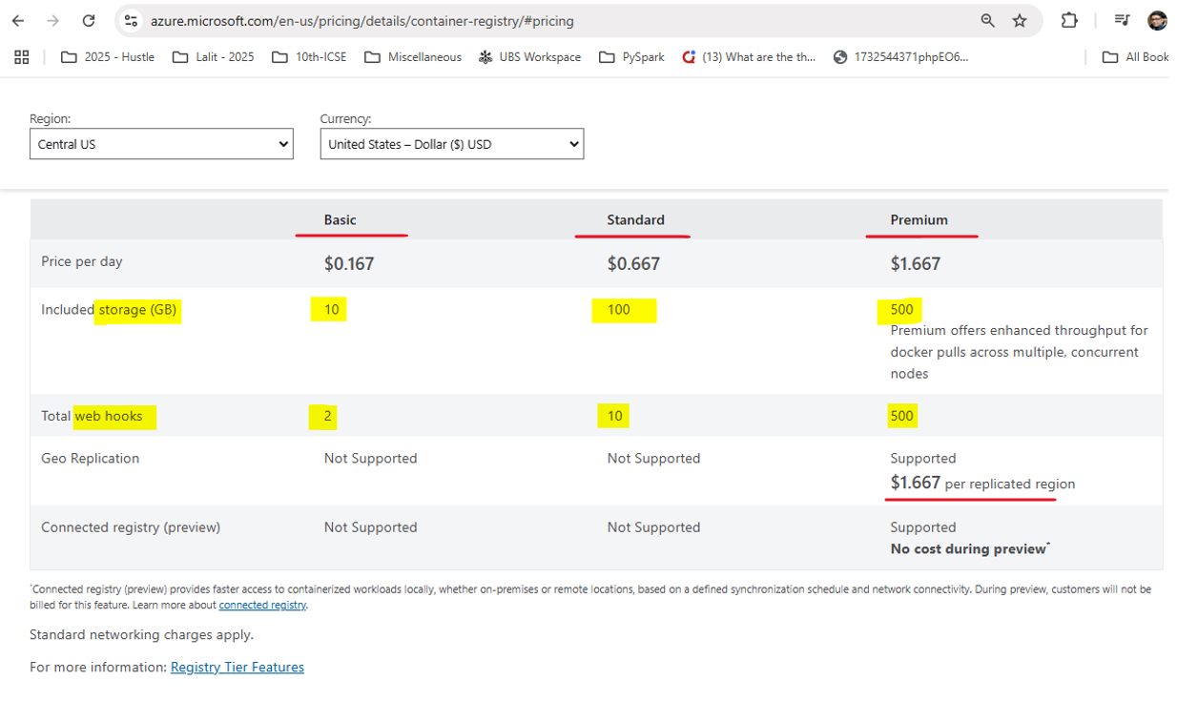

And you can see that the major difference is that the storage included in each tier is different. And in our case, we have 10 gigabyte of storage, which is of course much more than we actually need.

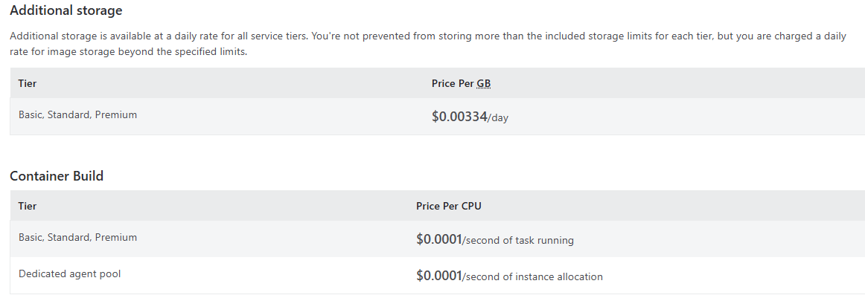

So let's go back to the portal, and again make sure that the basic tier is selected and Review plus create. And Create. And now Azure is deploying the Azure Container Registry for us. It might take a few minutes, so let's wait. And deployment is complete. So let's go to it. Click Go to resource.

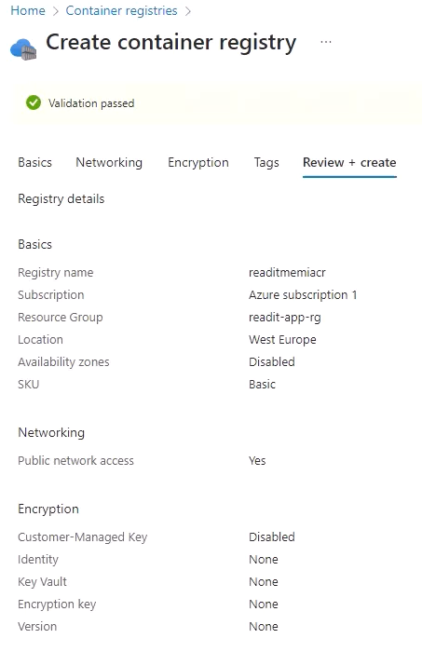

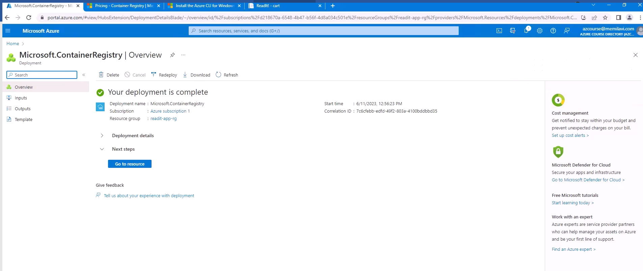

And here is our ACR, or container registry.

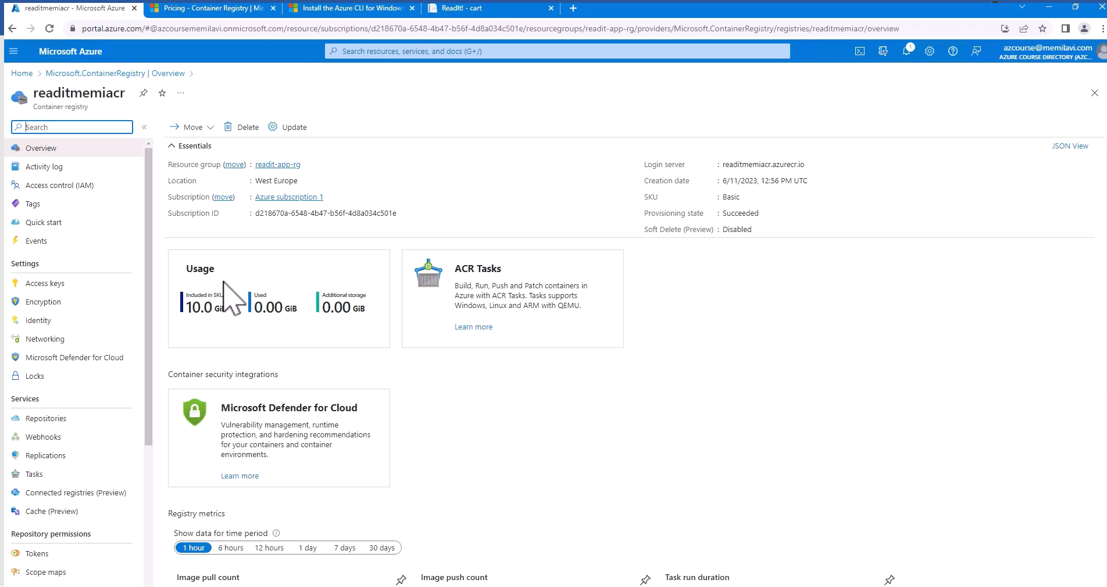



So you can see that we have 10 gigabytes available for storage, and naturally we didn't use anything yet. And of course our SKU is basic, the provisioning has succeeded, and just make sure that the location is in fact the location that you indicated. Now go to access keys and enable admin user right here.

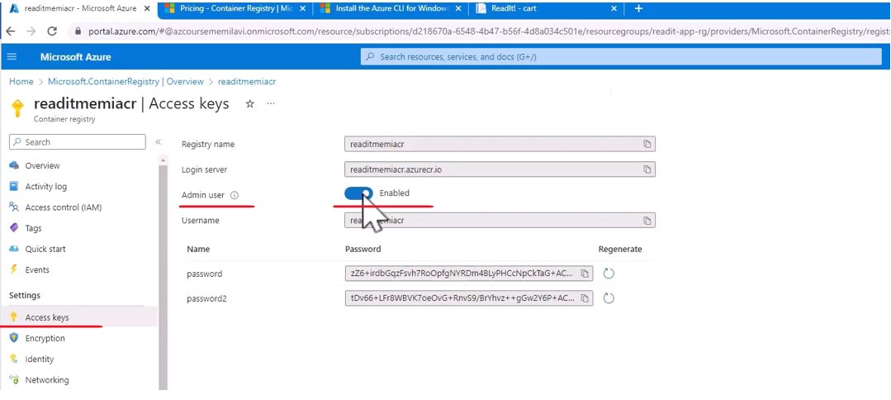

And this will help VS Code accessing the ACR and pushing code into it. Great, so we have container registry up and running, and now we can use it to build and store our Docker image. Go back to VS Code and go to the Docker extension. And under Registries, you have Azure here. So click the little arrow at the left of it and select your subscription. In my case, that would be it. And here is our container registry, the one that we just created. So now we know that VS Code is familiar with this container registry, which is great because we are now going to push this image or this code to the registry and ask him to build this code for us and store the resulting image.

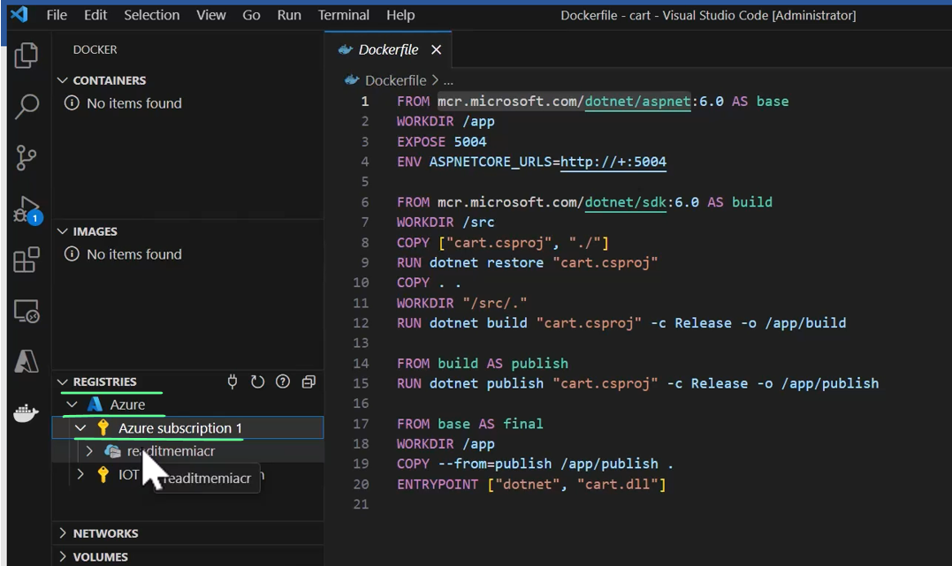

And for that, go back to the Explorer and right click on the Docker file and select build image in Azure. And make sure not to select just build image because this will use a locally installed Docker, which we don't have.

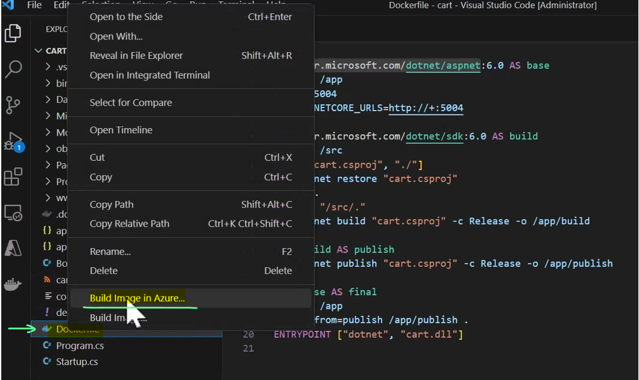

So select the Build Image in Azure. And now we need to name the Docker that we want to create, and we are going to name it cartlatest, like this, and hit enter.

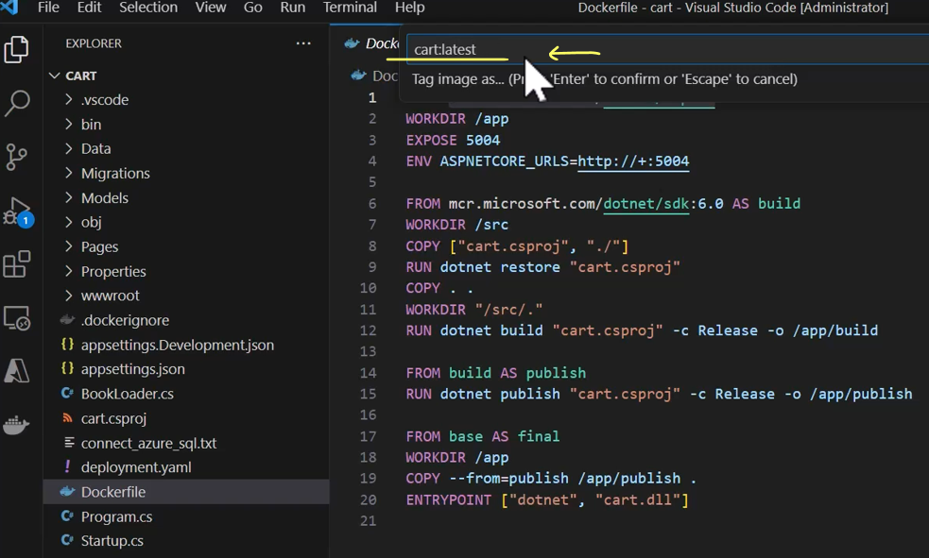

And the subscription is this one.

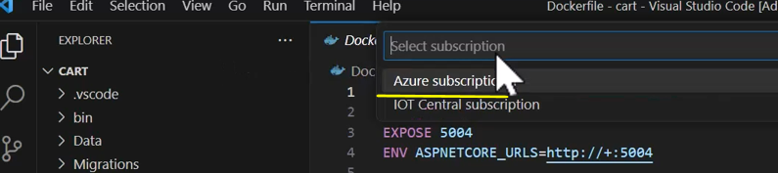

And select the registries that we want to use for the build end store, which is this one.

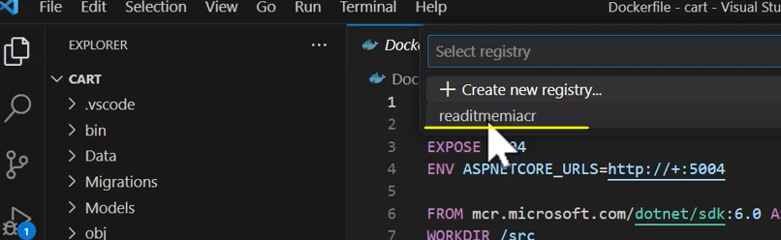

And the operating system we are going to use is Linux.

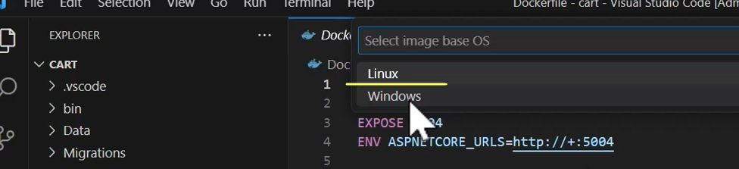

And now we are beginning the process of uploading the code, building it, and storing it. Now if you see this error, and let's resize it, if you see this error, cb1 or some other number failed after two seconds, failed to download the context, please check if the URL is incorrect and so on, well, in this case that happens due to a problem with our login.

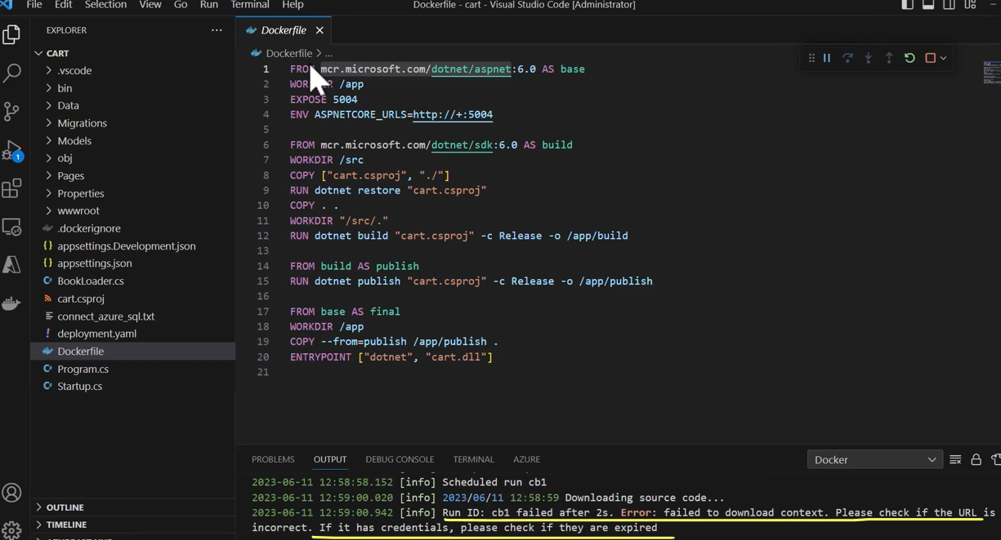

So simply go to the terminal right here, hit enter, and if it closes, then go back to the terminal menu and New Terminal. And then after the terminal opens, type az login, oops, login, and hit enter.

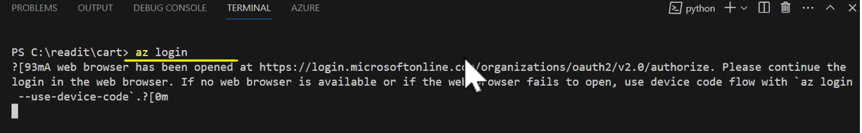

And now the browser opens and simply select your account, which is signed into Azure, and we are now logged into Azure.

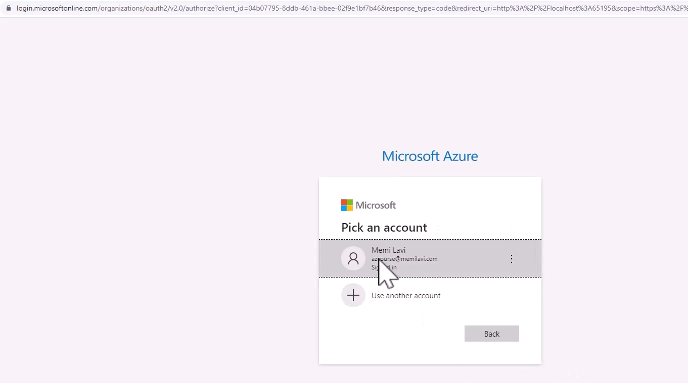

So you can close this and go back to VS Code, and you can see that we are indeed logged into Azure.

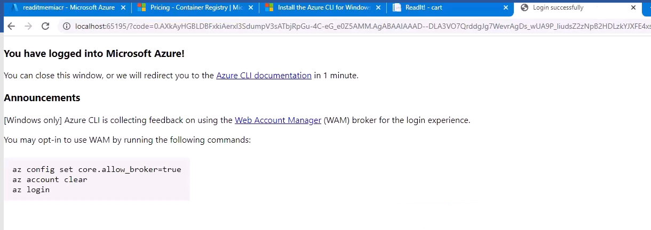

And after doing that, go back to the Docker file and again Build Image in Azure, and cartlatest,

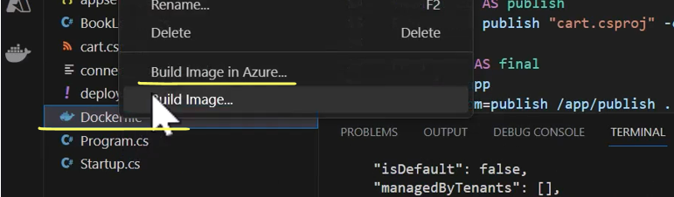

and select your subscription and your ACR and the operating system.

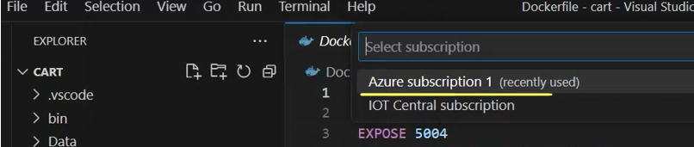

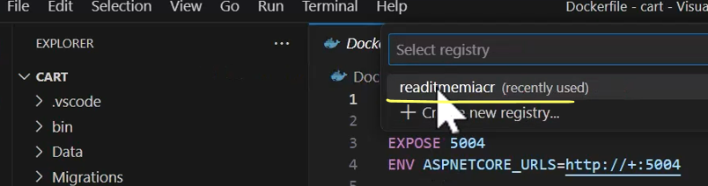

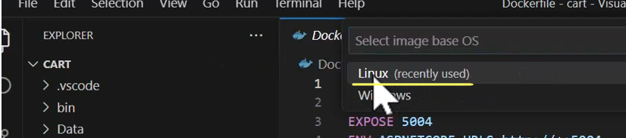

And let's wait again for the code to upload build and store. So now it looks like it's working. Let's wait for that to complete.

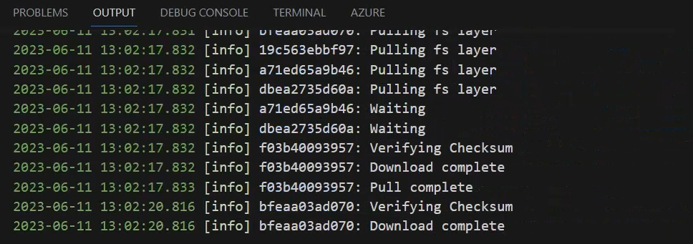

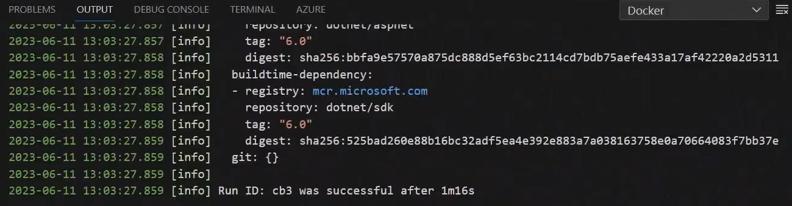

And the process was complete, and it looks like it was successful. Let's just take a look at the container registry and make sure that everything runs as expected. So here in the menu under Services, go to Repositories, and we see here indeed our cart project. So click it, and we see that we have one version, which is the latest one.

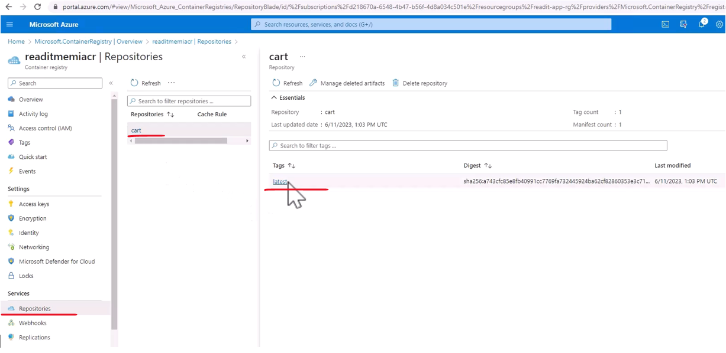

And if you will click it, then this is a manifest used by the container registry to upload and store our Docker image. And you can see also the operating system that was used in the process.

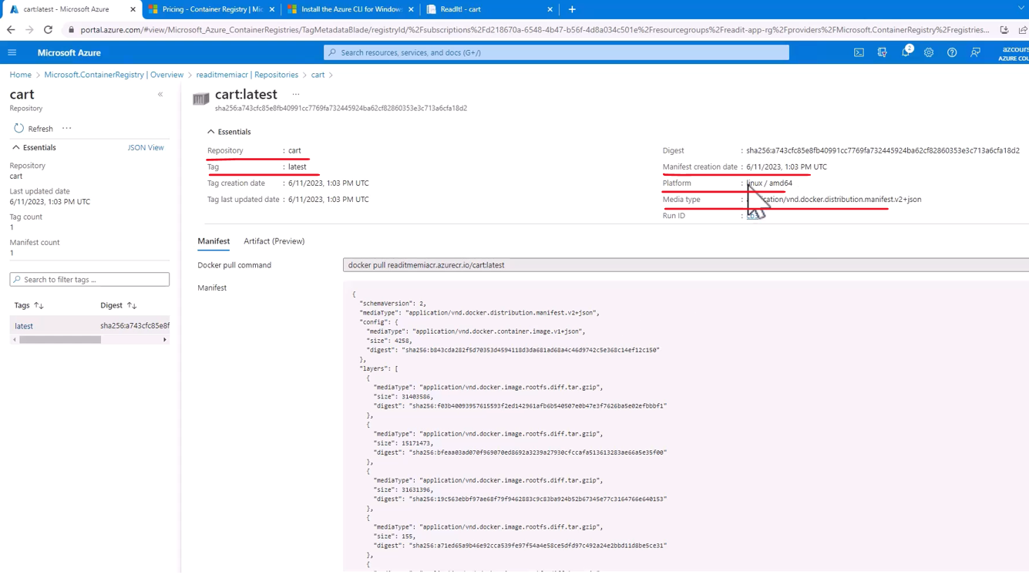

So we have the Docker built and stored in the container registry, and the next step is to create the AKS cluster and attach it to the ACR, and let's do that in the next lecture.

### Working with AKS Cluster

So let's see how to work with Azure Kubernetes Services. So in the search bar, type AKS and click Kubernetes services. And naturally, currently we don't have any Kubernetes services in our Azure, so let's create one.

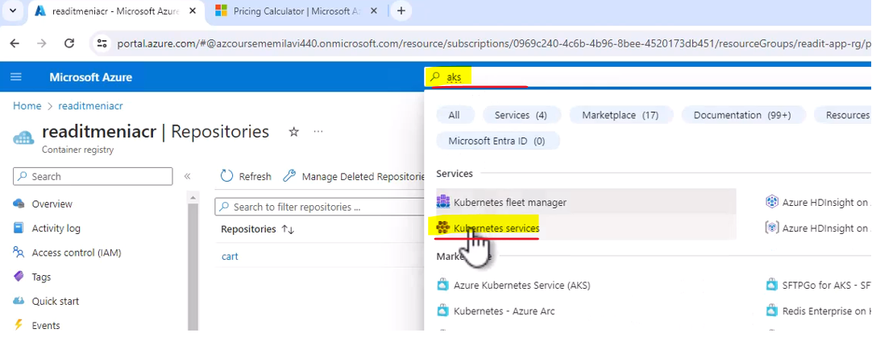

So click create and select create Kubernetes cluster because this is what we are going to create, a new cluster. And for the resource group, pick the regular one, they readit-app-rg.

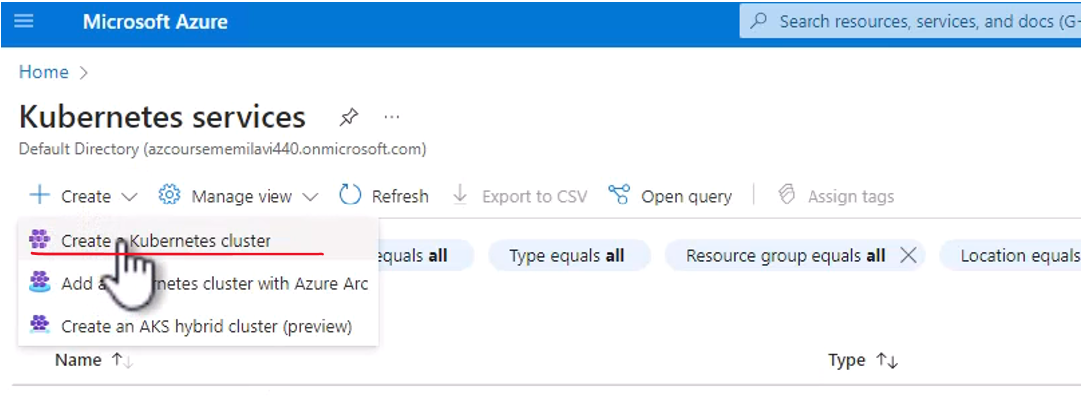

And for the configuration we are going to use the dev test configuration, which uses the least amount of resources and therefore, will cost the minimum possible. If you will open this list, you can see the various configurations that are offered to you.

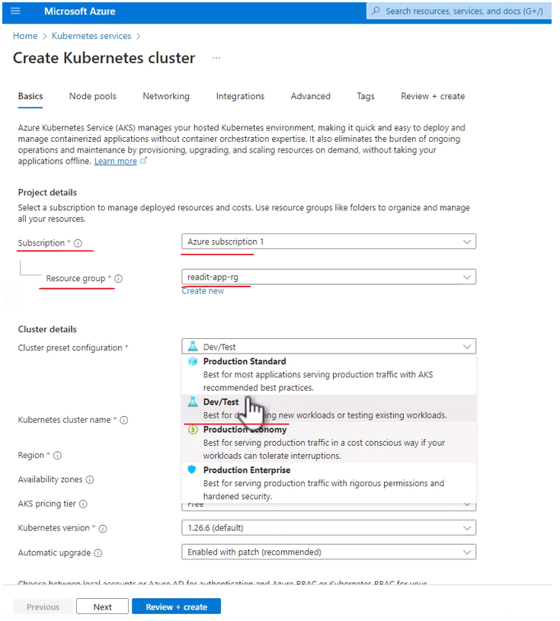

So we have production standard, which is great for most applications. Again, in production environment of course, we have the dev test, which we are going to use. We have the production economy, which is still good for production, however uses less resources and production enterprise, which is great for serving production traffic with a lot of permissions and hardened security and resources. But again, we are going to stick to the dev test configuration. The cluster name that we are going to create is going to be cart-aks, like that, pick your region, I will go as usual, with Europe. And for the pricing tier, go for free. However, note that the free tier is not entirely free. It means that the Kubernetes is free. However, all the underlying infrastructure such as the virtual machine, the storage, and the networking are still going to incur costs. But we'll go with the free. Pick the default version that is offered to you, and let's talk a little bit about the automatic upgrade that we can select. So there are various options of how exactly Azure is going to upgrade the Kubernetes version that we are going to use. And by default, the selected option is enabled with patch, meaning patches that are within the minor version are going to be updated.

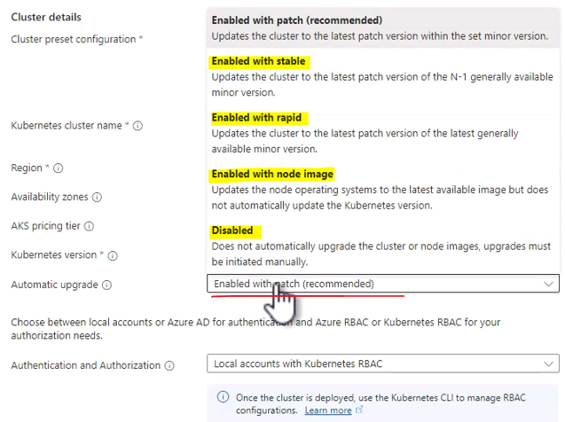

Again, this is the default one, but there isn't going to be any major update to the Kubernetes version. The other options are enabled with stable, meaning update to the one version before the most updated one or N minus one, as it called here. And that ensures that the version is stable and as bug free as possible. That is also enabled with Rapid, which will update to the latest version the moment it is released. There is also enabled with node image, which means that the operating system of the nodes is going to be updated. However, the Kubernetes version itself will not get updated. And also the disabled option, which as you can guess means that no update will occur whatsoever. We will stick to the default one, enabled with patch, great. So that's the basic configuration. Now scroll up and navigate to the integrations tab right here. And here we are going to select the Azure Container Registry that this cluster will integrate with, or in other words, the ACR that AKS is going to pull the images from. So in the container registry list, open it and select the ACR, the container registry that we created earlier. Great, so now we have the integration in place. So review plus create, and let's wait for the validation to complete.

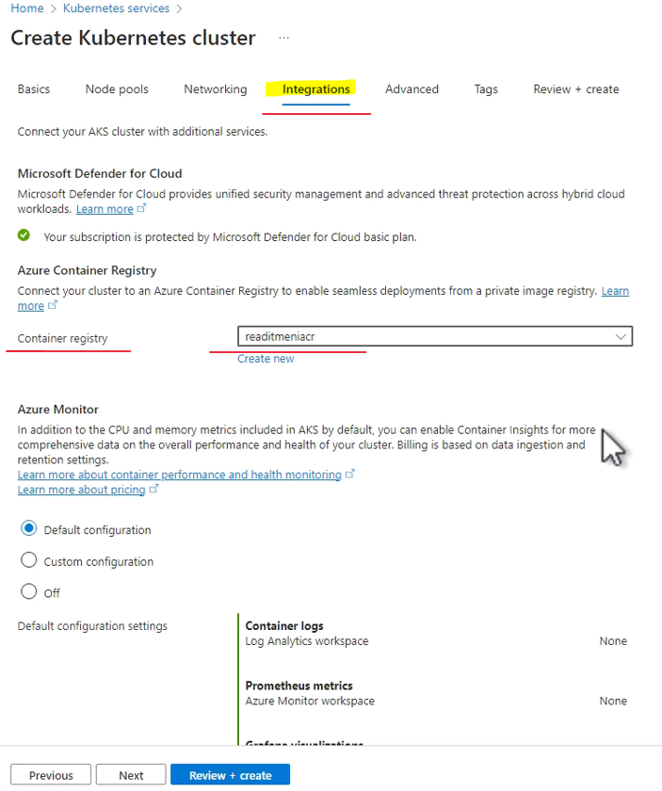

Create. And Azure will now deploy AKS cluster for us so that we can deploy images on this cluster, and note that cluster creation can take a few minutes. So let's wait for that to complete. So deployment is complete. Let's go to the resource that we created

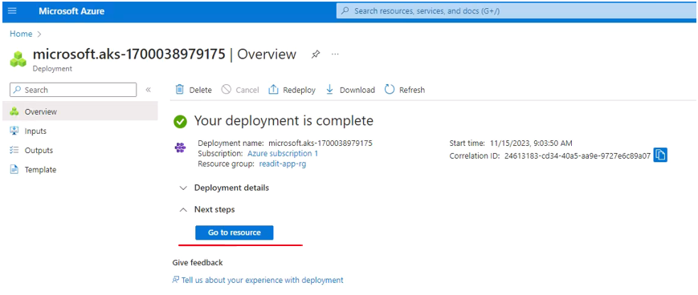

The AKS cluster just to make sure that everything looks fine. And yes, it is deployed and it is running.

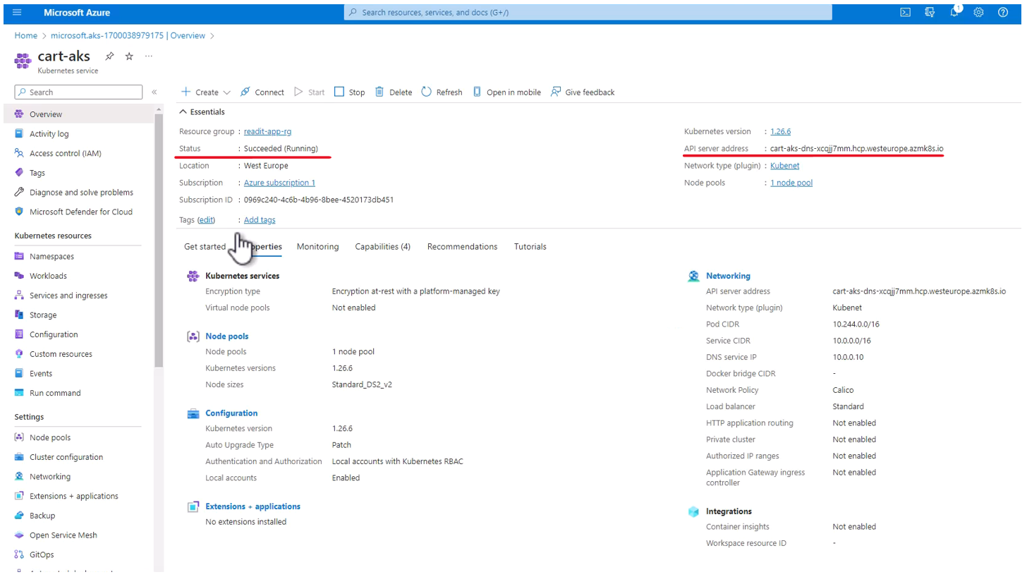

And of course, the next thing we want to do is to deploy our cart container to AKS and we are going to do that from VS Code. So open the cart project in VS Code, and we are going to run some commands in VS code to configure it for deploying containers to AKS. Now, you can follow me in typing the commands or you can download the akscommands.txt file from the resources of this lecture and run the commands that you see there, so whatever you choose.

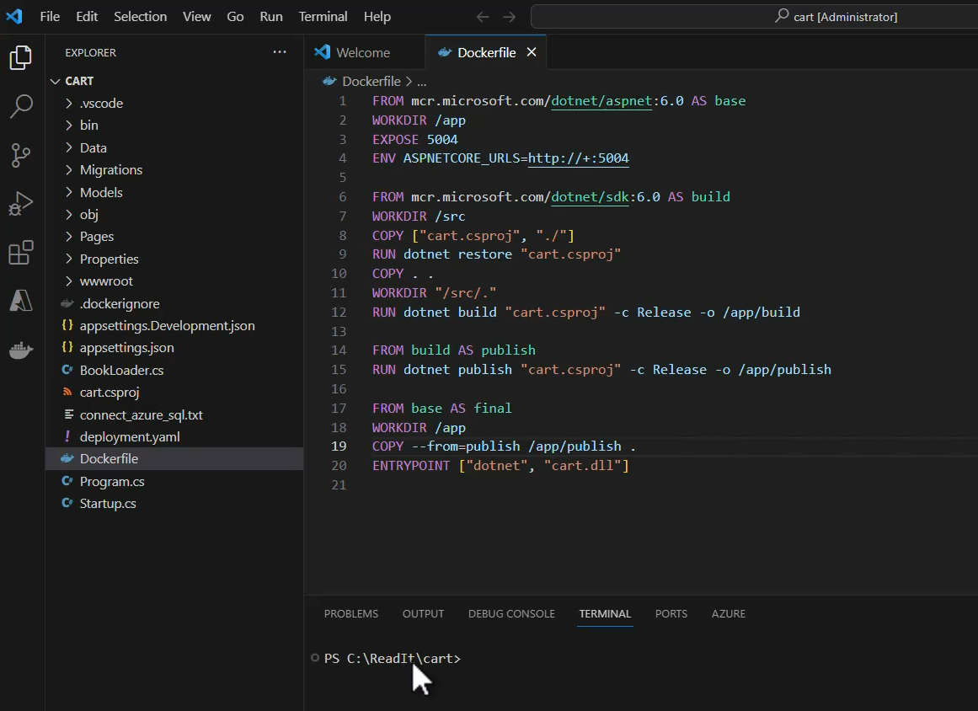

**aks-commands.txt**

az aks install-cli

Set PATH

az login

az aks get-credentials --resource-group readit-app-rg --name cart-aks

kubectl get nodes

kubectl apply –f deployment.yaml

Now the third thing we need to do is to download and install the AKS CLI. AKS has its own CLI, which is basically Kubernetes CLI and we need to download and install it so that we can use it in VS Code terminal. So let's run the first command to do that, az aks install-cli. And now the AZ CLI or the Azure CLI will download and install the AKS CLI. Let's wait for that to complete.

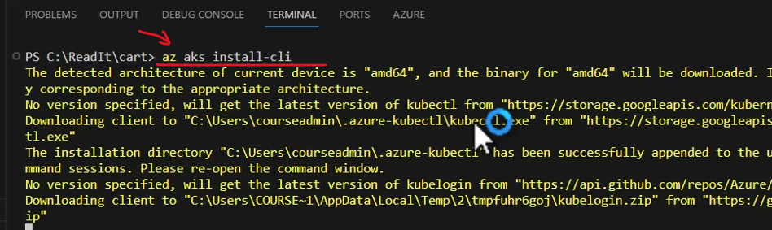

Now next we need to make sure that the new CLI is in the path of our computer so that we can actually run it, and note what VS Code is telling us here.

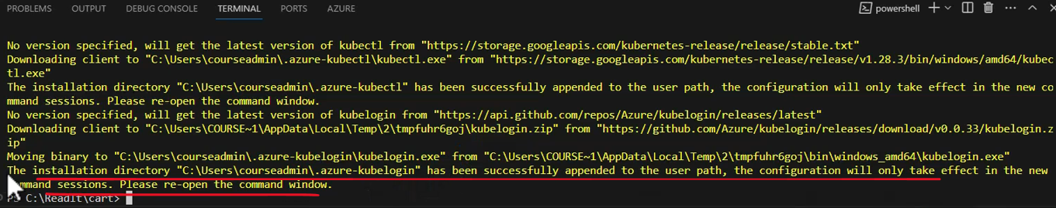

The installation directory and the directory where the CLI was installed has been successfully appended to the user pass. But the configuration will only take effect in the new command sessions. So please reopen the command window. In other words, if we want to be able to access this CLI, then we need to restart VS Code. So let's do that, close VS Code and open it again. Great, and now we should be able to access it. Now if for any reason you won't be able to access the CLI because it is still not in the path, then add this path.

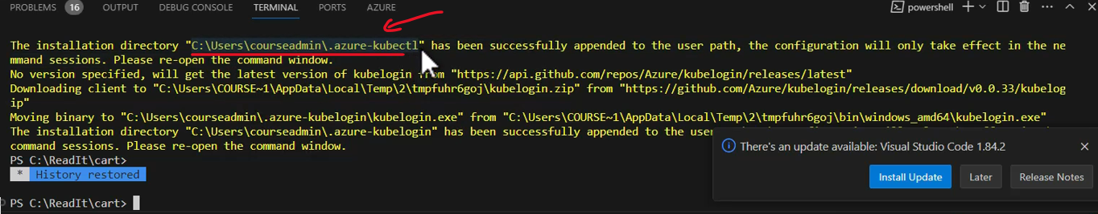

And of course, in your case, the path will be different to the path of your machine. But again, now we should be okay. So now we are going to connect to the AKS cluster and get the credentials and just to make sure that everything is fine. Then let's run AZ login again just to make sure that we are logged into Azure CLI. You probably don't really need it, but this is only a safety measure.





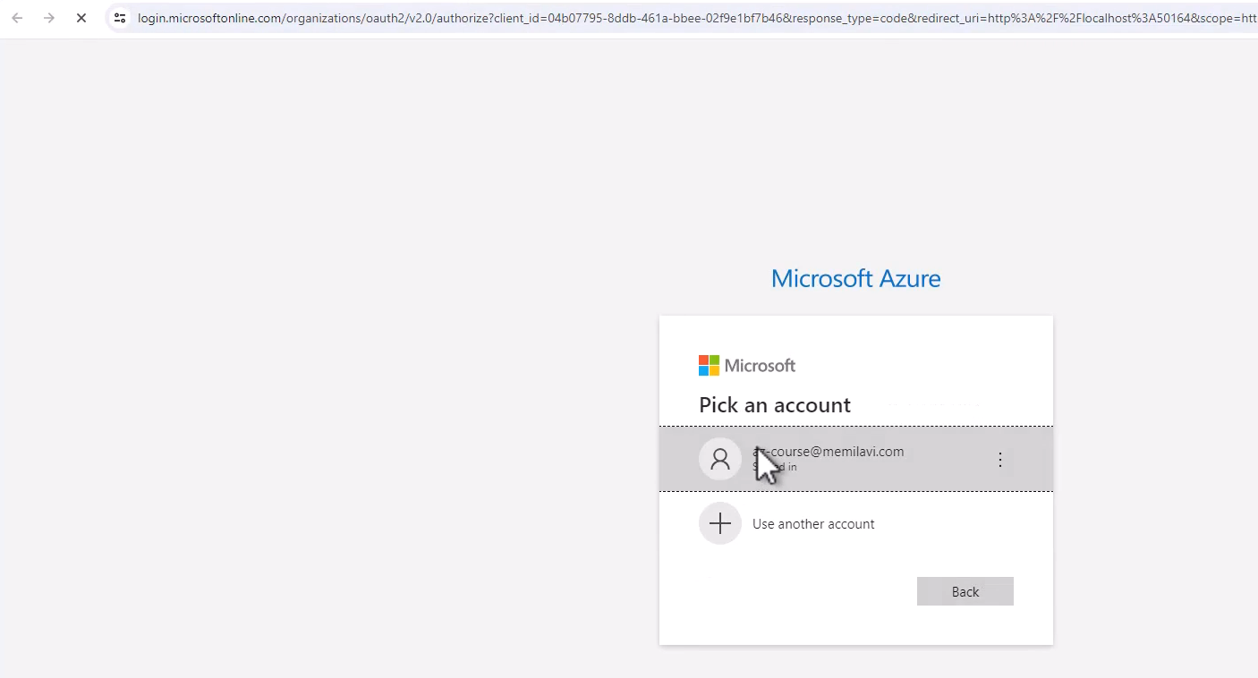

So hit enter and sign in to your account, to your Azure account. And that's it. Basically we are now logged in to the Azure CLI. You can see the username that you are currently using, great.

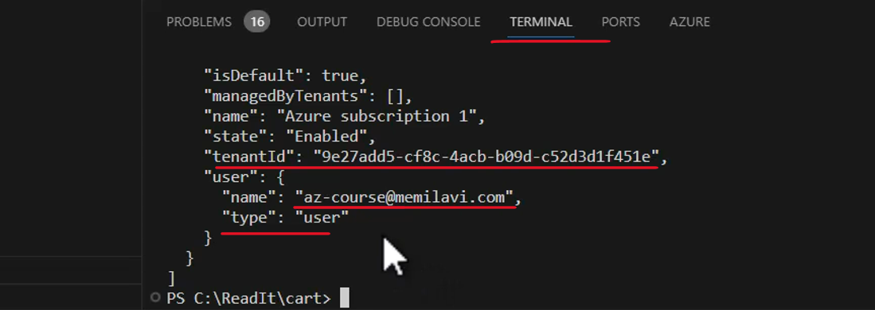

Now next as we said we are going to connect to the AKS cluster and get the credentials. We need that so that the cubed CTL command, which is the main command that Kubernetes uses, will have the credentials to connect and work with the cluster that we created. So you can copy the command from the file, from the resource file. So copy the command and paste it here.

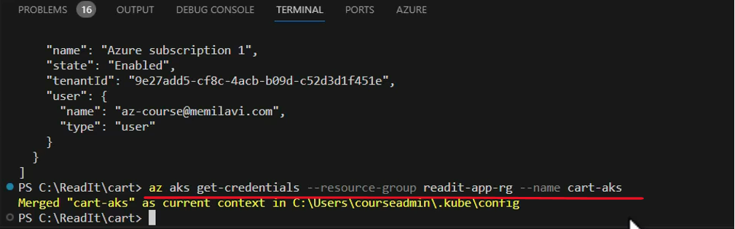

And this is a command, AZ AKS, great. Get credentials for resource group, readit-app-rg, and for cluster name cart-aks. Of course, if you used other names, then fix the command accordingly. So this is a command we are going to run and hit enter. Great, and the credentials were merged with the cube CTL.

Now let's take a look at the cluster just to make sure we can connect to it. So run the following command cubectl get nodes, and let's see whether we can access it. And yes, we see that currently there are two nodes in our cluster and both of them are ready, which is really the status that we want to see.

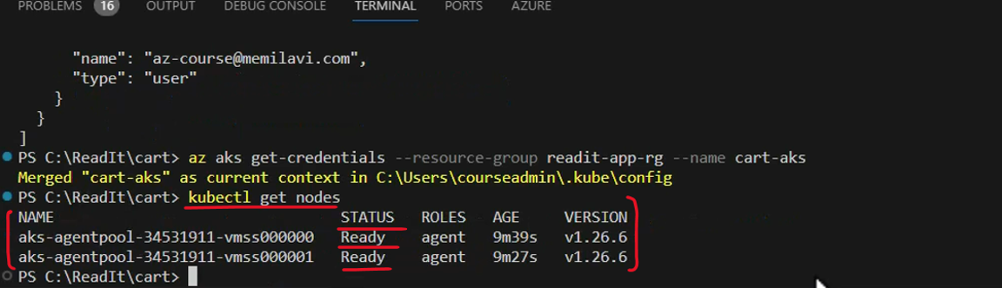

Now note that the exact number of nodes that are ready for us is determined by AKS and this number might go up and down as needed. Okay, so now we are configured to deploy our container. And for that, let's take a look at this file, the deployment.yaml file.

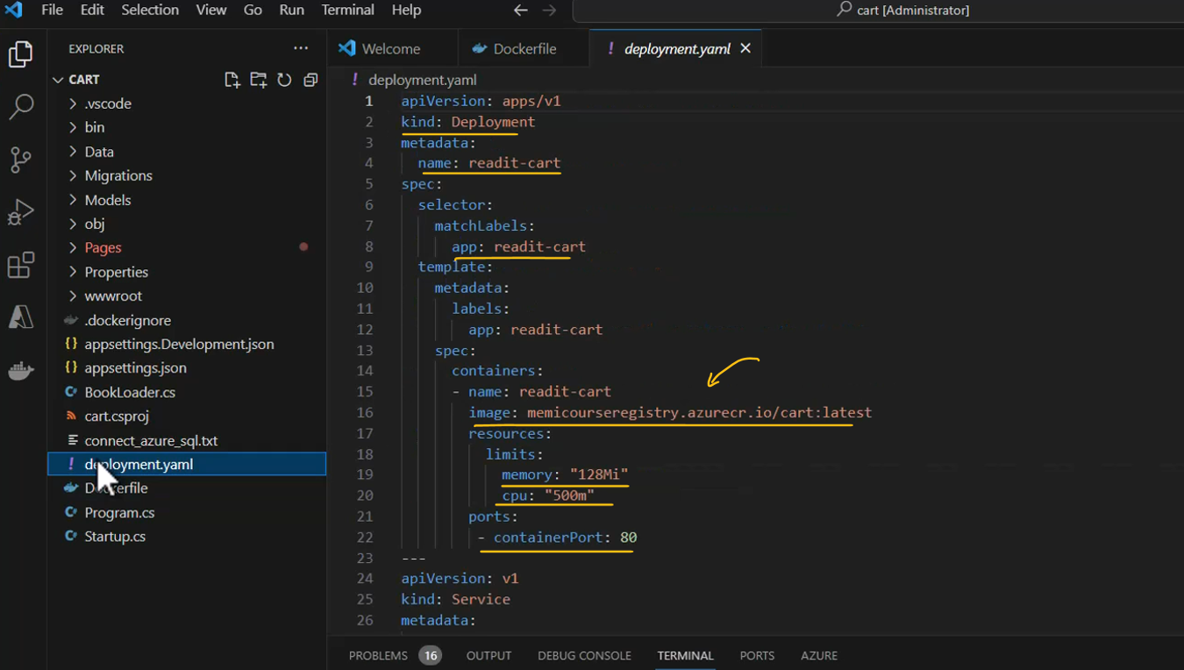

And this file is basically the configuration file that Kubernetes uses when deploying workloads to a cluster. And it contains quite a lot of data. But the thing that is really interesting for us is the one pointing to the ACR or to the container registry that we want to pull the image from. So here on this line, change the container registry to the name of your registry, the one that you created. And if you are not sure what is the name of this registry, you can go to the portal and let's duplicate this page. And go here in the search bar to container registries. And this is the name that you should put there.

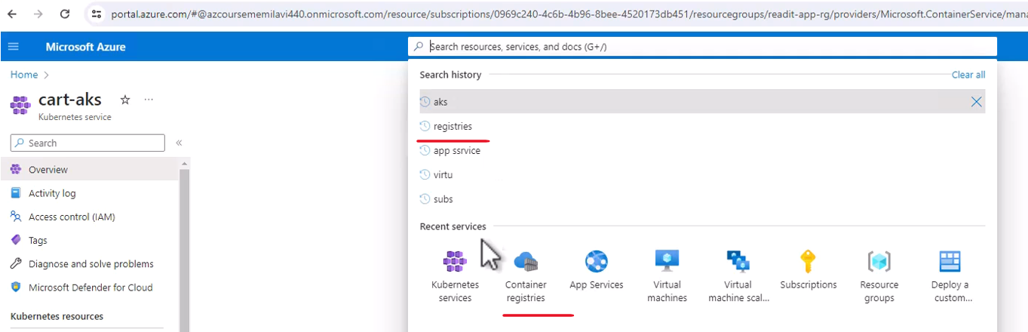

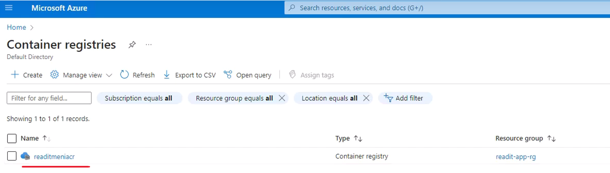

So let's go back to VS Code and change the name accordingly. So in my case that would be this name. Great, and save the deployment.yaml file.

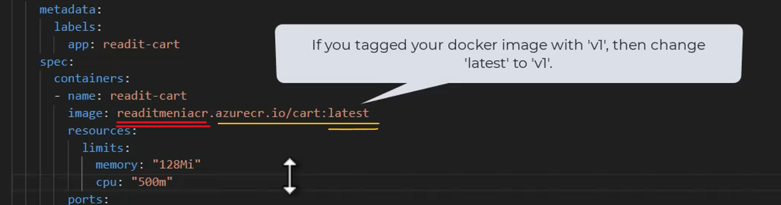

And now we are ready to deploy. So for that, run the last command in the file or type it manually. And the command goes like this, cuubectl apply -f, and the name of the YAML file we want the deployment to be based on. So that would be deployment.yaml. Okay, this is the main command you will use when deploying to Kubernetes, then cubectl apply, and hit enter. And let's wait for the deployment to complete. And it was quite quick.

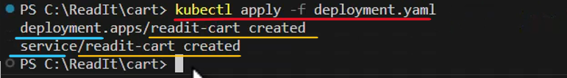

So as you can see, two things were created here. The deployment was created, which means the pods were created for our cart container and also a new service was created.

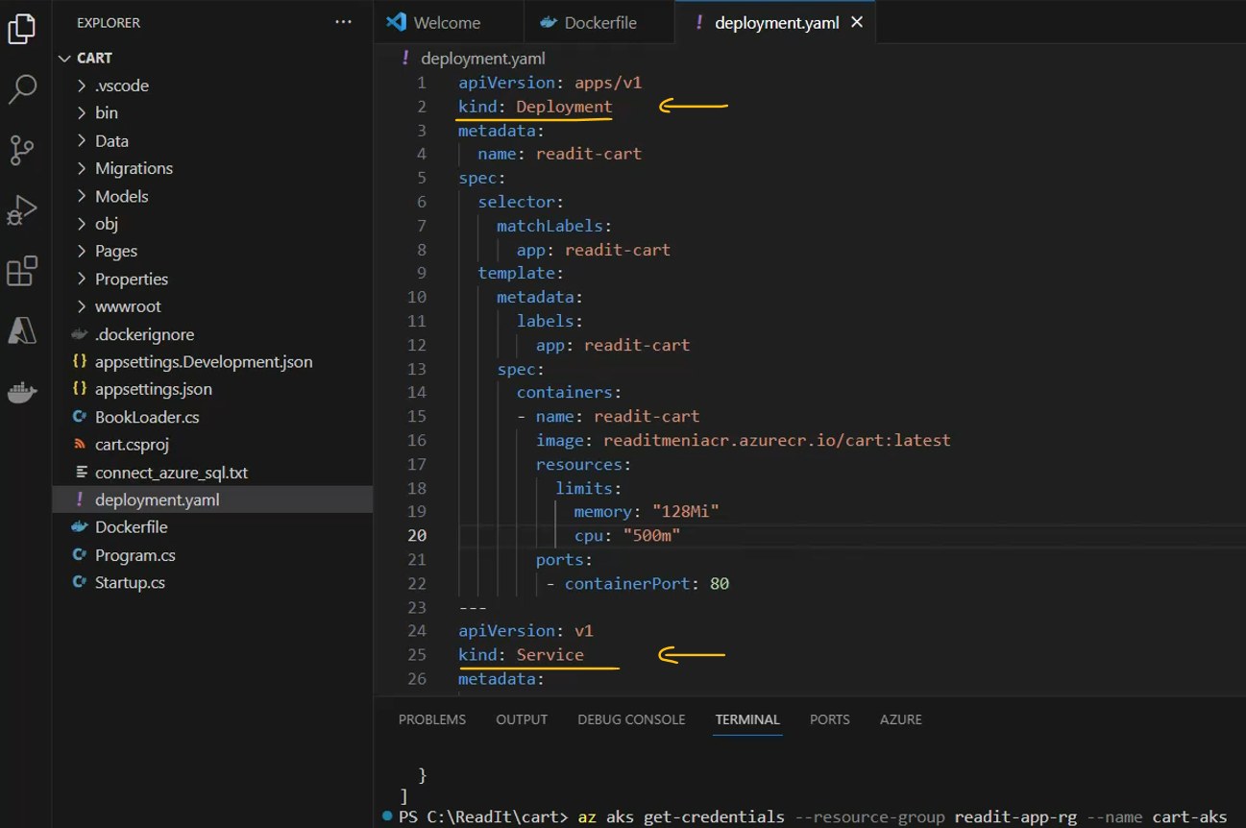

Remember that service is basically a public endpoint that allows access to pods within AKS. Let's see whether we indeed have this deployment & service and whether we can work with it. So go to portal, and go back to AKS page and click services and ingresses. So there is a list of services here, most of them are built in into the AKS. However, note the last one, readit-cart.

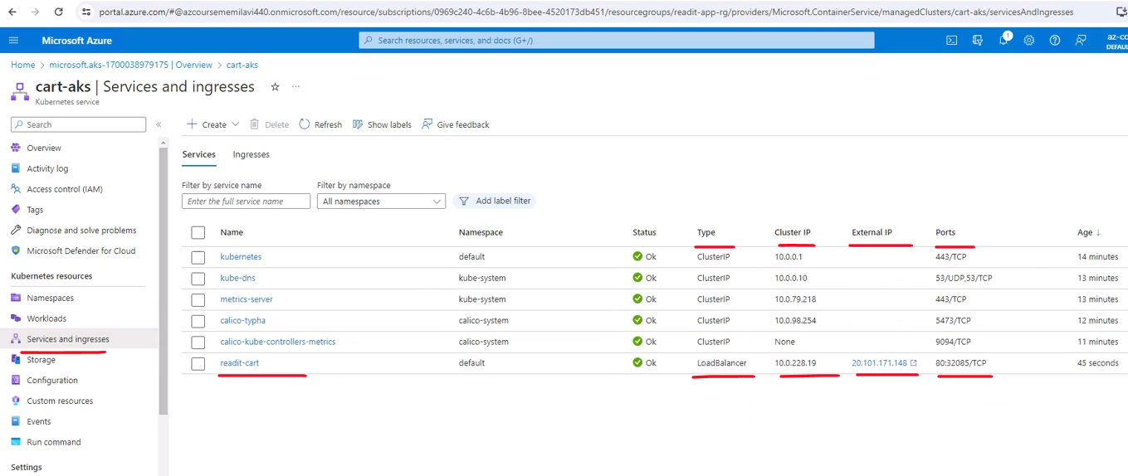

This is a service that was created right now based on our deployment. And note that the status is okay, the type is load balancer, meaning it is externally available. The other types, the cluster IPs are for internal access by some monitoring and other internal resources in Azure. But this is the only load balancer, meaning it can be accessed externally, great. This is the external IP address of the service using which we can actually access it. But before clicking it, click the service name right here. Let's wait for it to load. Now let's take a look at the pods of the service to navigate to the pods tab here. And currently there is one pod right here and its status is running.

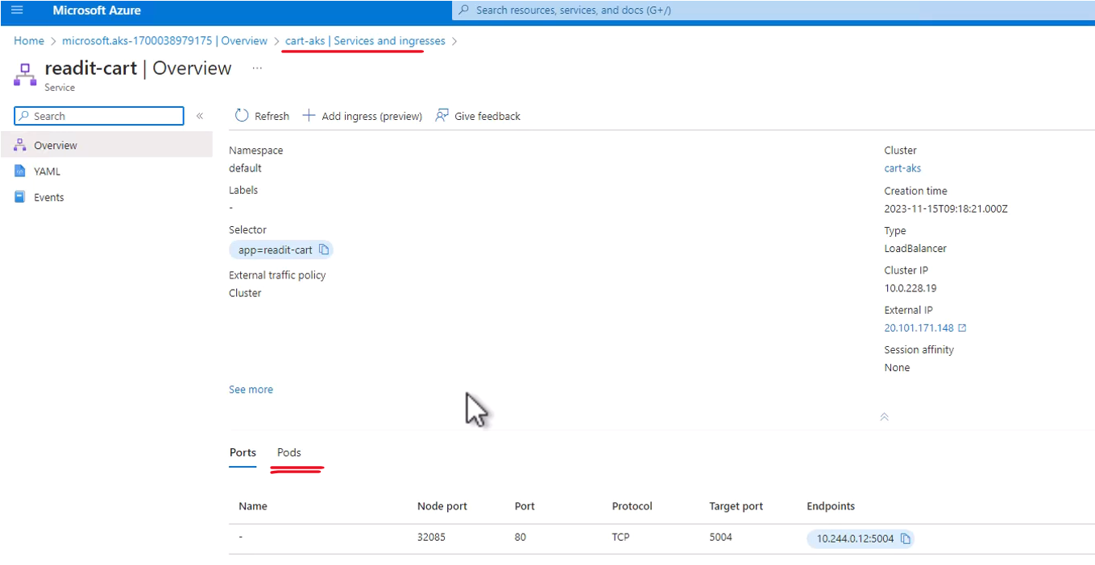

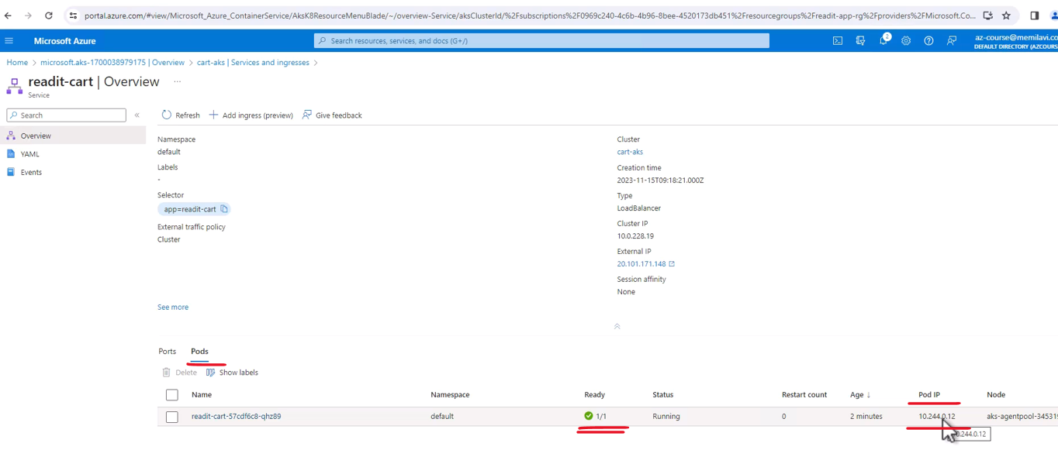

And note that there is a single pod right here and this is its private IP, which frankly we will never use. Great, now let's see whether we can actually access this service and the pod, and of course, the cart. So click the external IP of this service right here.

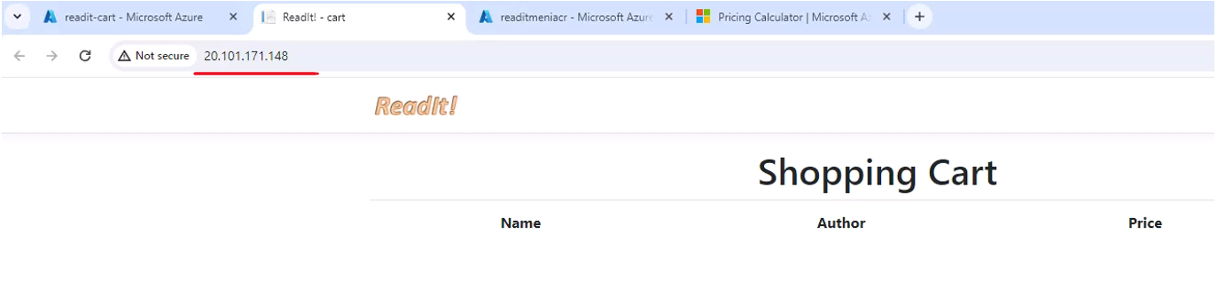

And here is our shopping cart currently running on AKS with the service and the pod that we created. So this is how you deploy container images from VS Code to AKS after of course, creating an AKS cluster.

### Current Architecture

|  |  |
| --- | --- |
| So we have the two VMs, one for Catalog and one for the Weather API.  We have the App Service, which is for the Inventory App. And now we also have the AKS, the Azure Kubernetes Services, which hosts the Cart App.  And this AKS talks to the ACR, to Azure Container Registry. This registry hosts the Cart Docker image, and AKS pulls that image, builds the container, and runs it under the service. |  |

## Technology Choices ( WIP )

See all sections under

<https://learn.microsoft.com/en-us/azure/architecture/guide/technology-choices/technology-choices-overview>

## Azure Functions

|  |  |
| --- | --- |
| So these are small, focused functions running usually as a result of an event. These functions are great for event-driven systems when you must do something as a response to something else that has happened in your system.  These functions are automatically managed by Azure which means that Azure can start, stop, and autoscale them, which frees you, the developer, from handling all this stuff. In addition, Azure functions have flexible pricing plans, as you'll see in just a minute.  And also, they are serverless. |  |

Now, you might have heard about serverless before, but let's deep dive into it and see what exactly is serverless.

|  |  |
| --- | --- |
| So serverless is a cloud resource that is completely managed by the cloud. That mean that the users do not need to think about virtual machines, CPU, memory, et cetera. So all the aspects of handling underlying infrastructure which we saw is relevant for virtual machines as well as app services.  And even with AKS, when we were aware of the actual virtual machine instances, well, all this does not exist with Azure functions.  What's nice about Azure functions is that it just works. |  |

But remember, even when we talk about serverless, it still runs on actual servers and there are some aspects of serverless that are affected by this fact as we will see later.

Remember – Serverless too runs on Servers – it just doesn’t require you to do anything for it.

Now, here is a typical example of an Azure function. So as you can see, it is in fact a function. It's a single function called run. And as any well-written function is quite short. Now, the really interesting things about this code is the HTTP trigger and the Event Grid that define the received parameters. And let's discuss those.

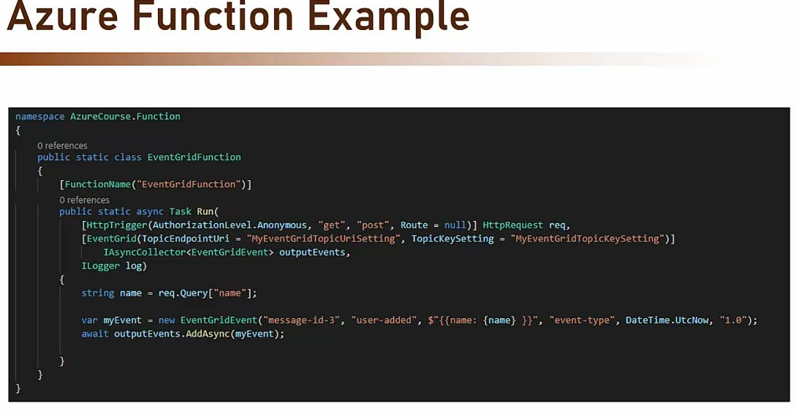

So when talking about Azure function, we must understand the concept of triggers and bindings.



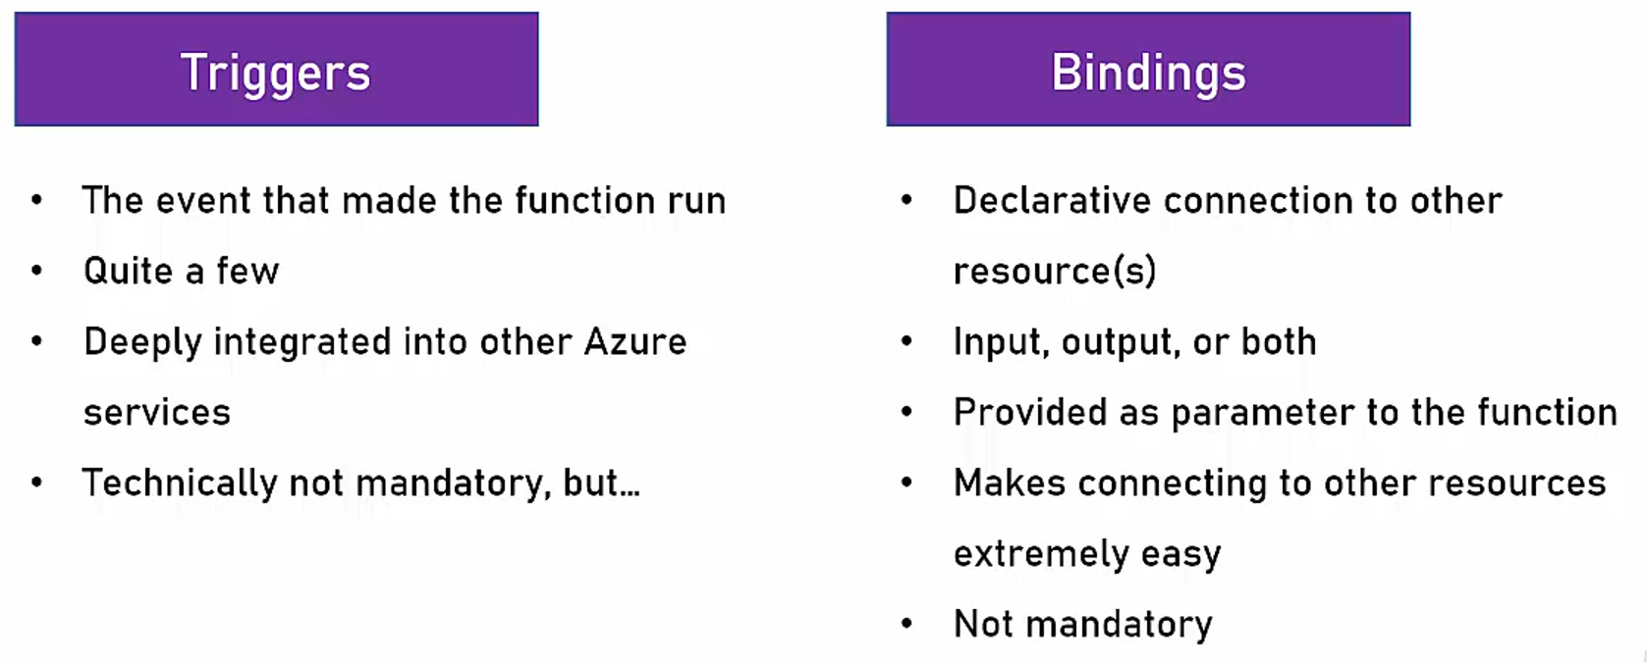

So let's see what they are. And let's begin with triggers. So triggers are the events that made the function run. So as we said before, an Azure function runs as a response to some kind of event. So the trigger is this event definition. Now there are quite a few triggers and we will see later the full list of triggers that Azure function can subscribe to. And these triggers are deeply integrated into other Azure services. Now, technically, triggers are not mandatory, and you can create an Azure function which does not have any trigger. But you really need a very good reason for that. So that's triggers. And what are bindings? So bindings are declarative connection to other resources. So using binding, you can set up a connection between the Azure function and another resource in the cloud so that you can read or write value to these resources, whether as input, output or both. Now these bindings are provided as parameter to the function and they make connecting to other resources extremely easy. Now, bindings as triggers are also not mandatory, but usually you would want to use them. Now since a lot of times functions read and write data from and into Azure resources, then the bindings concept is extremely convenient and really helps us develop functions much faster.

<https://learn.microsoft.com/en-us/samples/azure-samples/azure-functions-samples-java/azure-functions-java/>

package com.functions;

import com.microsoft.azure.functions.ExecutionContext;

import com.microsoft.azure.functions.HttpMethod;

import com.microsoft.azure.functions.HttpRequestMessage;

import com.microsoft.azure.functions.HttpResponseMessage;

import com.microsoft.azure.functions.HttpStatus;

import com.microsoft.azure.functions.annotation.AuthorizationLevel;

import com.microsoft.azure.functions.annotation.FixedDelayRetry;

import com.microsoft.azure.functions.annotation.FunctionName;

import com.microsoft.azure.functions.annotation.HttpTrigger;

import java.io.File;

import java.nio.file.Files;

import java.util.Optional;

/**

* Azure Functions with HTTP Trigger.

*/

public class Function {

/**

* This function listens at endpoint "/api/HttpExample". Two ways to invoke it using

* "curl" command in bash:

* 1. curl -d "HTTP Body" {your host}/api/HttpExample

* 2. curl "{your host}/api/HttpExample?name=HTTP%20Query"

*/

@FunctionName("HttpExample")

public HttpResponseMessage run(

@HttpTrigger(

name = "req",

methods = {HttpMethod.GET, HttpMethod.POST},

authLevel = AuthorizationLevel.ANONYMOUS)

HttpRequestMessage<Optional<String>> request,

final ExecutionContext context) {

context.getLogger().info("Java HTTP trigger processed a request.");

// Parse query parameter

final String query = request.getQueryParameters().get("name");

final String name = request.getBody().orElse(query);

if (name == null) {

return request.createResponseBuilder(HttpStatus.BAD_REQUEST)

.body("Please pass a name on the query string or in

the request body").build();

} else {

return request.createResponseBuilder(HttpStatus.OK).body("Hello, " + name).build();

}

}

public static int count = 1;

/**

* This function listens at endpoint "/api/HttpExampleRetry".

* The function is re-executed in case of errors until the maximum number of retries occur.

* Retry policies: <https://docs.microsoft.com/en-us/azure/azure-functions/>

* functions-bindings-error-pages?tabs=java

*/

@FunctionName("HttpExampleRetry")

@FixedDelayRetry(maxRetryCount = 3, delayInterval = "00:00:05")

public HttpResponseMessage HttpExampleRetry(

@HttpTrigger(

name = "req",

methods = {HttpMethod.GET, HttpMethod.POST},

authLevel = AuthorizationLevel.ANONYMOUS)

HttpRequestMessage<Optional<String>> request,

final ExecutionContext context) throws Exception {

context.getLogger().info("Java HTTP trigger processed a request.");

if(count<3) {

count ++;

throw new Exception("error");

}

// Parse query parameter

final String query = request.getQueryParameters().get("name");

final String name = request.getBody().orElse(query);

if (name == null) {

return request.createResponseBuilder(HttpStatus.BAD_REQUEST)

.body("Please pass a name on the query string or in

the request body").build();

} else {

return request.createResponseBuilder(HttpStatus.OK).body(name).build();

}

}

/**

* This function listens at endpoint "/api/HttpTriggerJavaVersion".

* It can be used to verify Java Home & java version currently in use in ur Azure function

*/

@FunctionName("HttpTriggerJavaVersion")

public static HttpResponseMessage HttpTriggerJavaVersion(

@HttpTrigger(

name = "req",

methods = {HttpMethod.GET, HttpMethod.POST},

authLevel = AuthorizationLevel.ANONYMOUS)

HttpRequestMessage<Optional<String>> request,

final ExecutionContext context) {

context.getLogger().info("Java HTTP trigger processed a request.");

final String javaVersion = getJavaVersion();

context.getLogger().info("Function - HttpTriggerJavaVersion" + javaVersion);

return request.createResponseBuilder(HttpStatus.OK)

.body("HttpTriggerJavaVersion").build();

}

public static String getJavaVersion() {

return String.join(" - ", System.getProperty("java.home"),

System.getProperty("java.version"));

}

/**

* This function listens at endpoint "/api/StaticWebPage".

* It can be used to read and serve a static web page.

* Note: Read the file from the right location for local machine and azure portal usage.

*/

@FunctionName("StaticWebPage")

public HttpResponseMessage getStaticWebPage(

@HttpTrigger(

name = "req",

methods = {HttpMethod.GET, HttpMethod.POST},

authLevel = AuthorizationLevel.ANONYMOUS)

HttpRequestMessage<Optional<String>> request,

final ExecutionContext context) {

context.getLogger().info("Java HTTP trigger processed a request.");

File htmlFile = new File("index.html");

try{

byte[] fileContent = Files.readAllBytes(htmlFile.toPath());

return request.createResponseBuilder(HttpStatus.OK).body(fileContent).build();

}catch (Exception e){

context.getLogger().info("Error reading file.");

return request.createResponseBuilder(HttpStatus.INTERNAL_SERVER_ERROR).build();

}

}

}

So let's go back to the code example that we just saw. And let's see. So the first line, the HTTP trigger is, as you can guess, a trigger. And this trigger is, well triggered as a result of an HTTP call. So you can see that the trigger here is defined for get and post verbs and that it does not require any authentication. So anonymous users can also use this function.

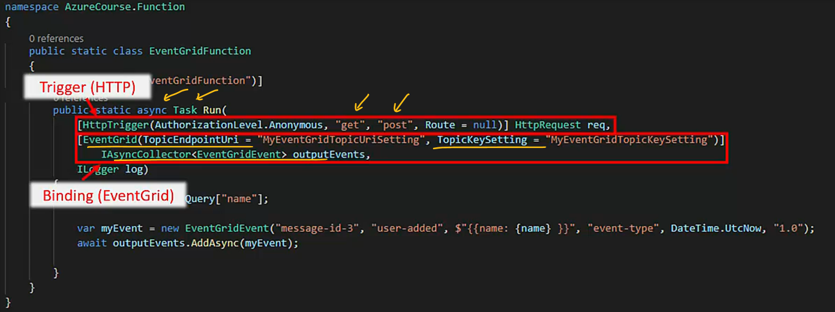

The second line, the Event Grid is the binding. That's a binding definition for Event Grid, which we didn't discuss yet, and we will do it later in this course. And basically what it says is that the result of this function is going to be written into the Event Grid. So here is the list of supported trigger types in Azure functions.



So as you can see, there are a lot of event types that can trigger a function such as Blob Storage, Cosmos DB, Dapr, Event Grid, HTTP request, Timer, RabbitMQ, Kafka, and lots more.

And if you think that this list is long, then here is the list of the binding types, whether input or output. So you see that functions can have bindings to a lot of resource types such as, again, Blob Storage, Cosmos DB, Event Grid, SendGrid, SignalR, HTTP request, and so on. So let's see some examples for triggers and bindings.

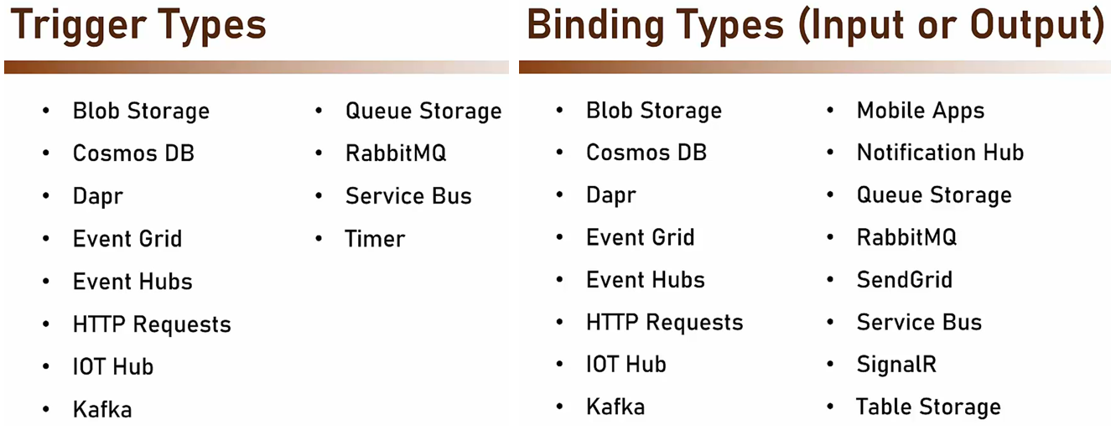



So the first example is a function that runs every five minutes using the timer trigger and then calculates the sum of a column in a DB. Now if the sum is above 115, then send an event in Event Grid, which is the binding. So the trigger here is the timer trigger and the output binding is Event Grid.

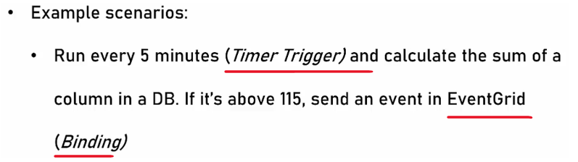

Another example, a function that when a message arrives in the orders queue using the queue trigger is activated. And then saves the message in Cosmos DB, which is again, the output binding for future handling. So we have the Queue trigger and we have the output binding of Cosmos DB.

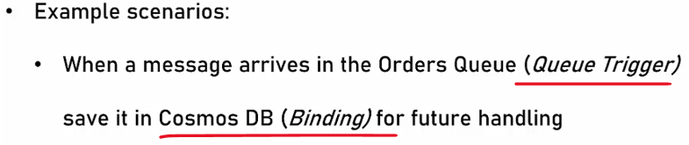

Last example is this one, receive HTTP request. And for this, we are going to use the HTTP trigger. And this request should contain four numbers and return the smallest one of them. So this function is going to do some basic calculation and return a number. Now note that in this example, there is no binding. The function is activated by the HTTP trigger but it does not connect with any other Azure resource for the output of the function. It simply returns a result and that is completely legitimate.

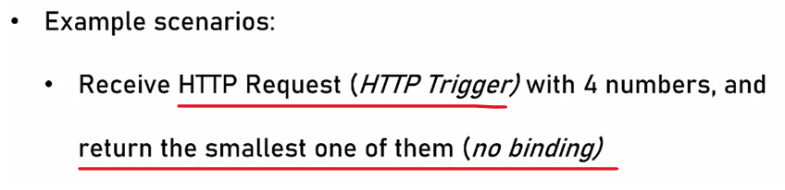

Now Azure functions support a long list of languages that you can use when writing them. The list includes C#, JavaScript, which is basically Node.js, Java, Python, PowerShell, and F#. And the list is growing all the time.

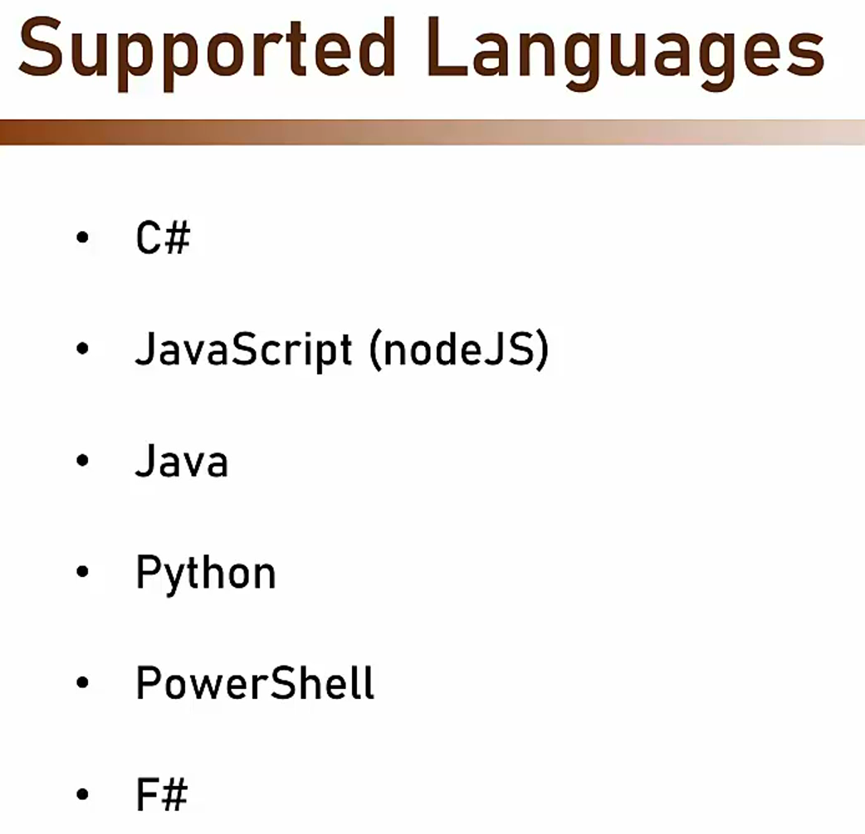 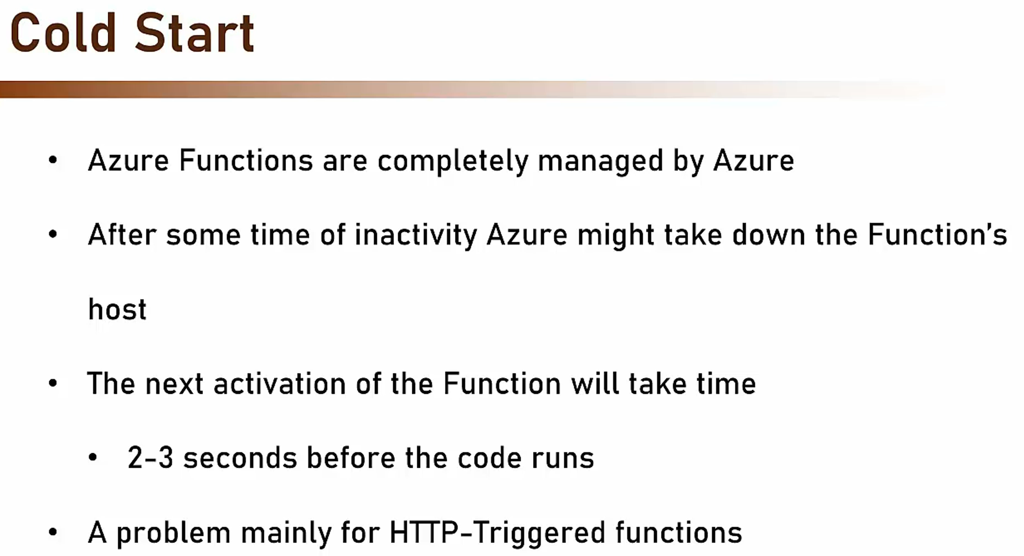



Now one of the important issues with Azure functions is cold start. And this is something you must be aware of. So what does it mean? Azure functions, as we discussed, are completely managed by Azure. And that means that after some time of inactivity, Azure might take down the functions host because if it will see that the compute power is not used, then it will bring it down. And that means that the next activation of the function will take time because the underlying infrastructure, the underlying host, needs to be powered up.

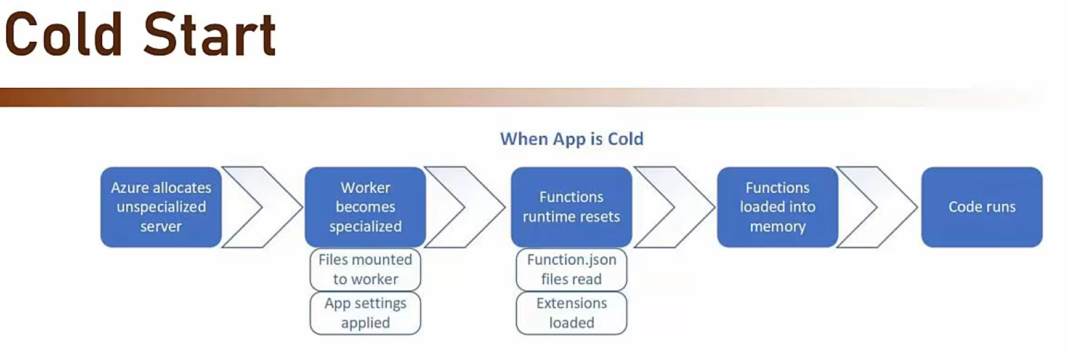

And that means that this activation can take up to two or three seconds before the code runs, and that's a delay that you must be aware of. Now in most types of functions, this is not a problem, especially in the async triggers such as queues, timers, and so on. But with HTTP-triggered functions, this is going to be a problem because HTTP calls are synchronous and the calling party expects a quick response. And if the function just starting up, then this is gonna take time. So this is basically what happens with cold start. So when the app is called, meaning the host is powered on, then when the function should be activated, then first Azure allocates unspecialized server, then the worker becomes specialized. Meaning, it prepares itself for the function activation, then the function runtime resets or reloads. The functions themselves are loaded into memory and only then the code runs. So all those four steps before the actual activation of the code can take time. Again, usually between two and three seconds. Now when the app is warm, then when the function should be activated, the only step Azure has to do is to actually run the code.

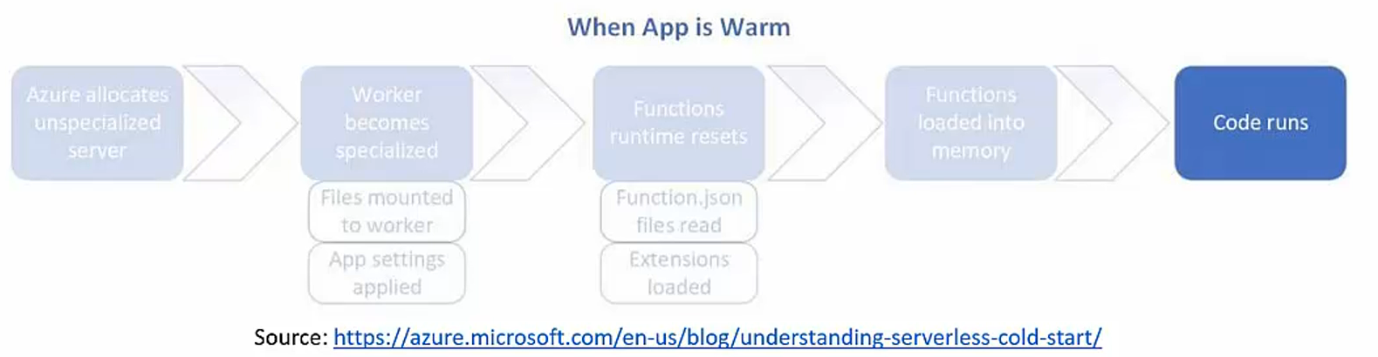

And then of course, the response time will be much better. So cold start is something that you must be aware of. And of course, the question is, "How to avoid it?" And the answer for that is to select the right hosting plan.

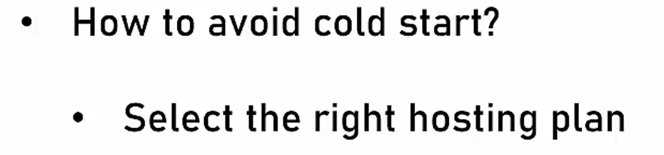



So let's discuss Azure functions hosting plans.

<https://azure.microsoft.com/en-us/blog/understanding-serverless-cold-start/>

### Azure Functions – Hosting Plans

When we create a new Azure Functions app, we need to select the hosting plan of this function app. And there are three of those.

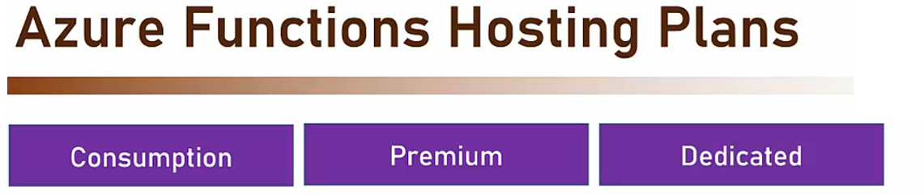

#### Consumption Plan

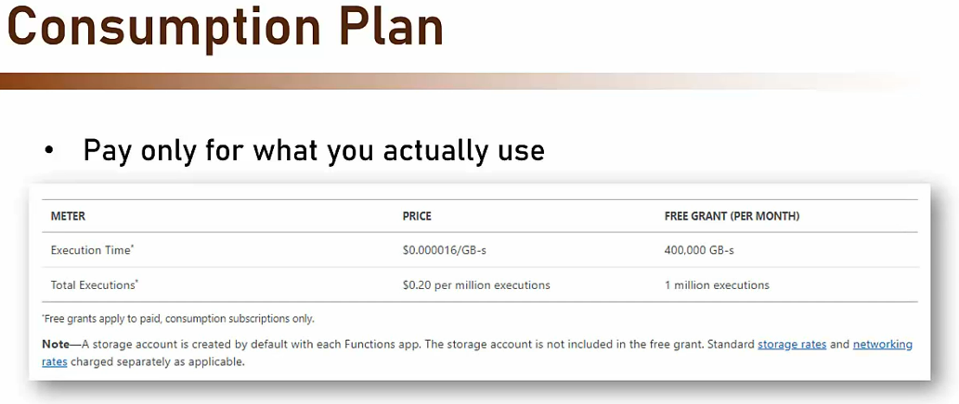

The first one is consumption, then premium, and the last one is dedicated. So let's go through these plans and explain what they are. And let's begin with consumption plan, which is the most popular plan. With consumption plan, you pay only for what you actually use. So this is what the pricing in consumption plan looks like. So as you can see, you basically pay for two things. You pay for the actual gigabytes you consumed and you pay for the actual function executions. Now the price calculation is a consumption plan is actually quite complicated and we'll do an actual example in just a minute. But before that, something important to note, in consumption plan there is a limit of 1.5 gigabyte RAM. So your function cannot consume more than this amount of RAM. If you need more than that then go to one of the other hosting plans. So let's see a calculation example for the consumption plan.

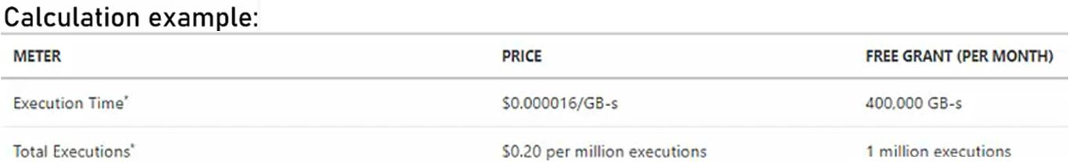



So as a reminder, this is the pricing scheme for the consumption plan. So basically with this scheme, we pay first $0.000016 gigabyte per second. And we have the first 400,000 gigabyte per second for free. And in addition, we are paying 20 cents for every million executions per month, of course, and we have the first 1 million for free.

So let's take an example.

Let's say we have a function that is executed 9 million times per month. And for every such execution, we consumed an average 800 megabytes. In addition, the average duration of such execution is 1.5 second. So these are the raw details.

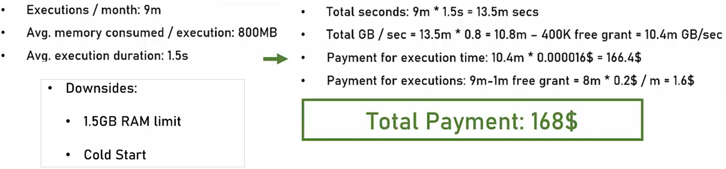

And now let's see how we calculate the actual monthly cost based on these details. So first, our total seconds are 9 million times 1.5 second which gives us 13.5 million seconds a month.

Now if you will take this number and use it in the gigabyte per second formula, then we see that we get 10.8 million gigabyte per second. From this, we subtract the 400,000 free grant and we end up with 10.4 million gigabytes per second. And that means that for the execution time or for the first line in the pricing scheme, we are going to pay $166.40.

In addition to that, we are going to pay also for the total executions, and this number is 9 million minus 1 million free grant, which gives us 8 million, and if we will multiply that with $0.20 a month, we will get a quite funny price of $1.60 a month, which gives us a total payment per month of $168.

So make sure you fully understand this calculation because you will need it if you are going to use the consumption plan. Now, what are the downsides of the consumption plan? Well, first, as we mentioned, there is the 1.5 gigabyte RAM limit. So you can't use a function that consumes more than that. And of course, the cold start that we mentioned earlier. So with the consumption plan, a cold start is a real problem and you must be aware of it. Now, if it is a problem for you then you can definitely go with a premium plan

#### Premium Plan



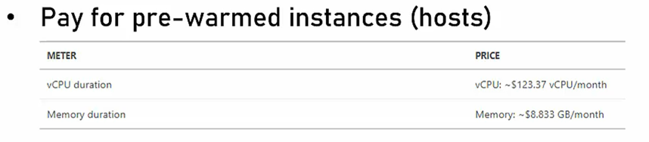

Now with premium plan, you pay for pre-warmed instances or hosts, and this is a pricing scheme for the premium plan. So basically we pay here for two things for the vCPU duration or in other word, we pay a fixed price per CPU that is reserved for us. And in addition, we also pay a fixed price for every gigabyte of memory that is reserved for us.

Now, when going for the premium plan, we can select from the instance size and these are the available instances at least at the time of this recording. So you can see that there are instances with one cores and 3.5 gigabyte RAM, two cores and seven gigabyte RAM, and four cores and 14 gigabyte RAM. You can also pay for scale-out instances. So if you set up a scale-out in the premium plan then of course when new instances are added, you are going to pay for them.

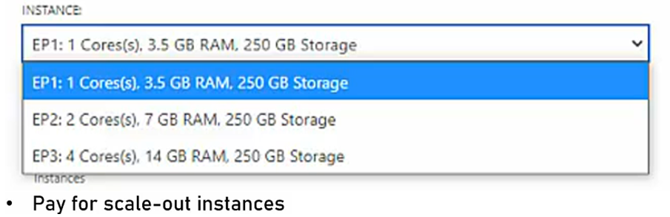

|  |  |
| --- | --- |
| Now with premium plan what you get is no cold starts, which is great and you get this no cold start because the host instances of the functions are always warmed up.  In addition, there is no memory limit, of course, up to the host RAM because if the host has, let's say, seven gigabyte RAM of memory then this is your limit.  And as a result of all this, you get better performance. In addition, with premium plan, you get also VNet integration. |  |

Now, we didn't talk about networking yet and we will do that in the next section, but a VNet integration is a quite useful security feature that you might want to use. In addition with premium plan, you get also predictable price because you know upfront how much you are going to pay and there aren't any surprises with a premium plan. So let's demonstrate the calculation example with premium plan.

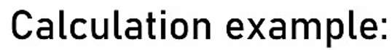

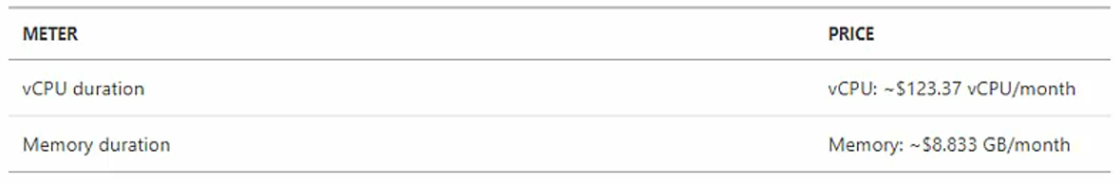

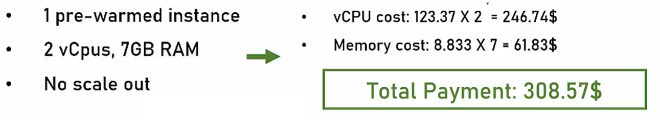

So again, as a refresher, this is a pricing scheme for the premium plan. And let's say that we reserved one pre-warmed instance, which has two vCPUs and seven gigabyte RAM, and we don't want any scale-out. So again, these are the raw details, and let's see what we get. So for the vCPU, we are going to pay $246.74, which is basically the base price of vCPU multiplied by two because we have two vCPUs, and for the memory, we are going to pay $61.83, which again is the base price of one gigabyte multiplied by seven, which is the number of gigabytes we have in our host. And that makes the total monthly payment to be $308.57.

Now note, this number is much higher than the consumption plans number, but, of course, this number depends on a lot of factors. And remember that with the premium plan, you get no memory limit and no cold start, which might be very important in your case. But what are the downsides of the premium plan? Well, of course it is more expensive and this is definitely something you need to factor in. But to be honest, other than that, there are no really downsides for the premium plan.

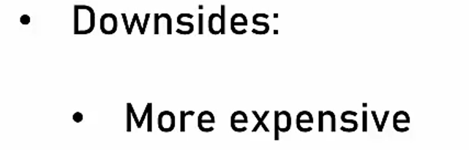

#### Dedicated Plan

The last hosting plan I want to discuss is a dedicated plan. Now with dedicated plan, the functions run on an existing app service. So that means that you can use the dedicated plan only if you have an app and running App Service somewhere else in your subscription. And this is great if the server hosting the App Service is underutilized because then you can use the remaining compute power for the function app. And because it uses a host that you are already paying for then there are no additional costs for the dedicated plan.

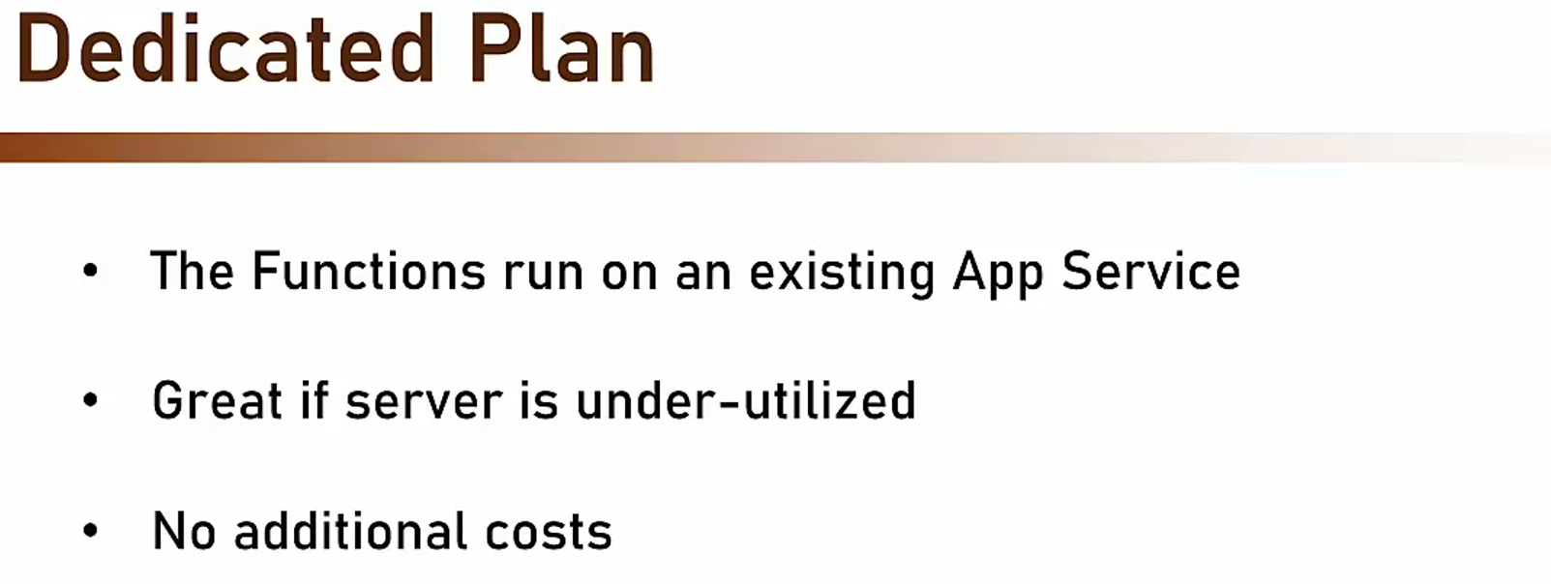

Now, one important thing to note about the dedicated plan is that in the settings of the App Service, make sure the Always On setting is activated to avoid disabling the functions. So this setting should be set to On.

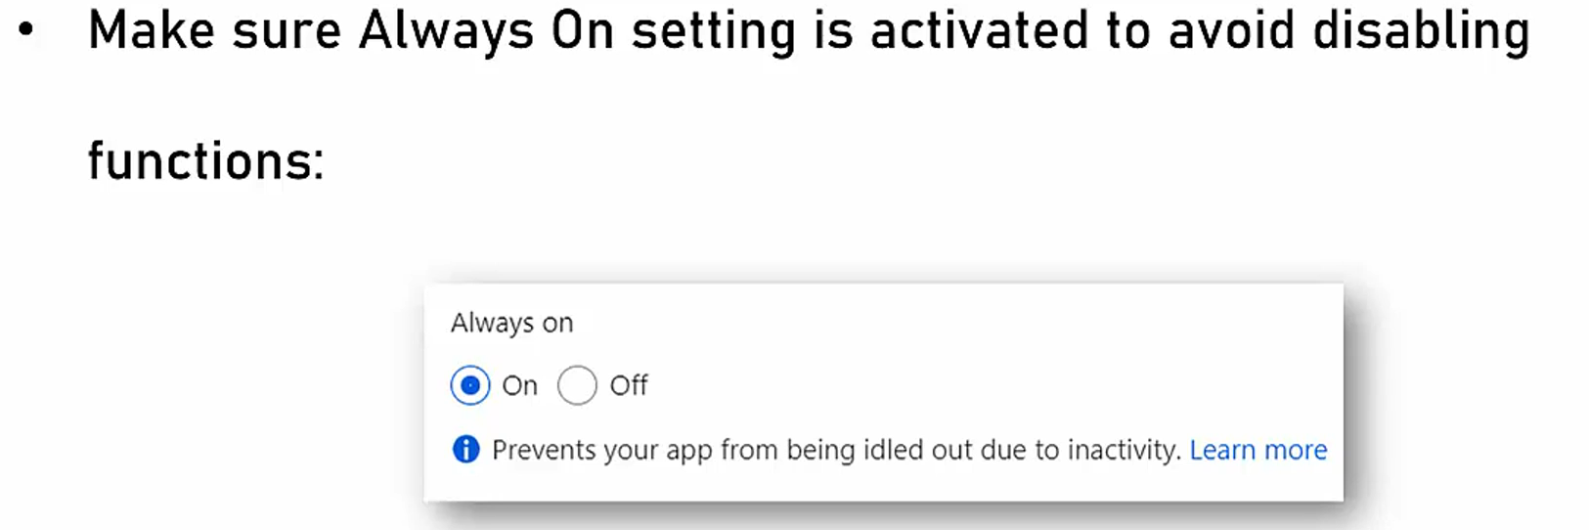

It appears on the configuration page of the App Service. If this setting is off, then the functions might be disabled by the App Service when it will see that they are not used. And what are the downsides of the dedicated plan? Well, actually there is only one, and this is that with dedicated plan, there is no Auto-Scale support.

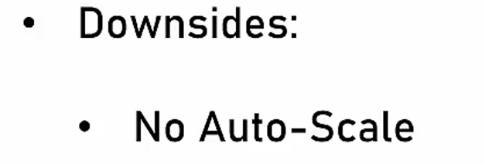

So if Auto-scale is extremely important for you then don't go for the dedicated plan. So these were the three hosting plans, consumption, premium and dedicated. And I hope that by now you can make an informed decision about which one to pick.

### Durable Functions

With Azure functions, there is a specialized type of functions called durable functions. Durable functions are stateful functions that interact with external resources and keep track of flow. Now, this might sound quite complicated, but as you will see in a minute, it's actually quite simple, and these functions offer very simple syntax and they hide all the complexities of managing state retries, et cetera

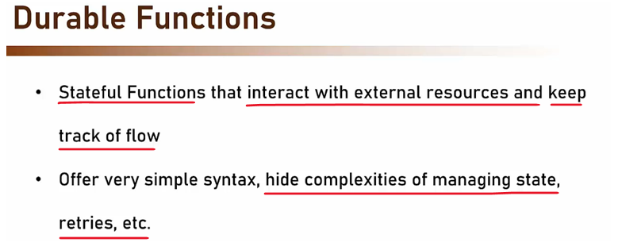

and for example, durable functions are extremely useful for function chaining. With function chaining, we call values functions sequentially and apply the output of each function to the next one.

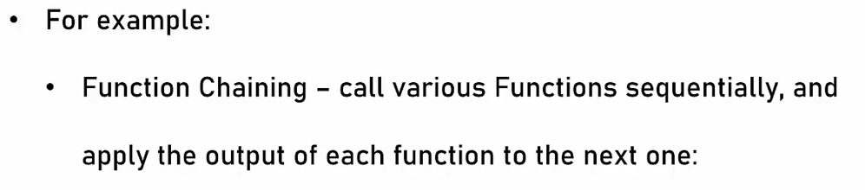

So it might look like this. So we have a function that calls some resource, and then another function is called, which calls some resource, and so on and so forth. In this example, there are four such functions.

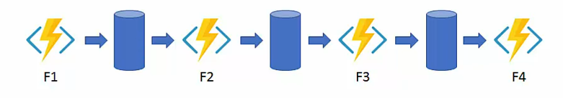

Now, each of those functions have its own state, its own process, and runs in its own time, so managing all this flow can be quite complicated, but with durable functions, it becomes so much simpler. So this is how the exact flow we just discussed will look like with durable functions.

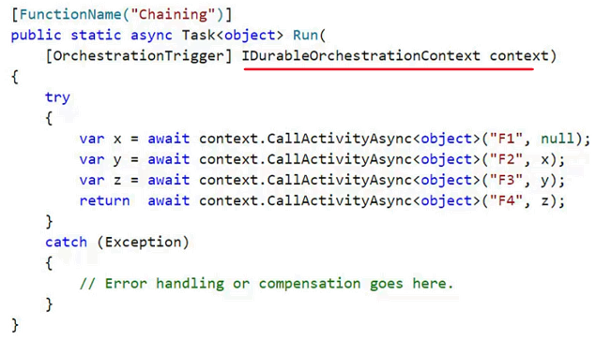

So you can see here that there are basically five lines of code, and each such line uses the CallActivityAsync and specifies the name of the function to be called. Now, behind the scenes, the durable function manages all the state of this flow. So when it calls, let's say the F1 function, it will go to sleep until the F1 function completes, it gets the return value from it, and then activates itself and calls the next function, but all this flow and state management is completely transparent for you, the developer, and you just need to define that this function is a durable one, and you do that by specifying this parameter, the IDurableOrchestrationContext parameter, and then, using the CallActivityAsync, you run and manage this flow. So these are durable functions. So we talked a lot about functions, and now, let's see them in action.

### Running Functions Locally

We are going to create a function that will handle the orders that are received in our Readit app. And this order will be triggered when a user clicks the place order button in the shopping cart. And let's see what are the steps that are required for doing that?

<https://learn.microsoft.com/en-us/azure/azure-functions/functions-develop-local>

So first, we need to install something on our computer, which is something that is called Azure Functions Core Tools.

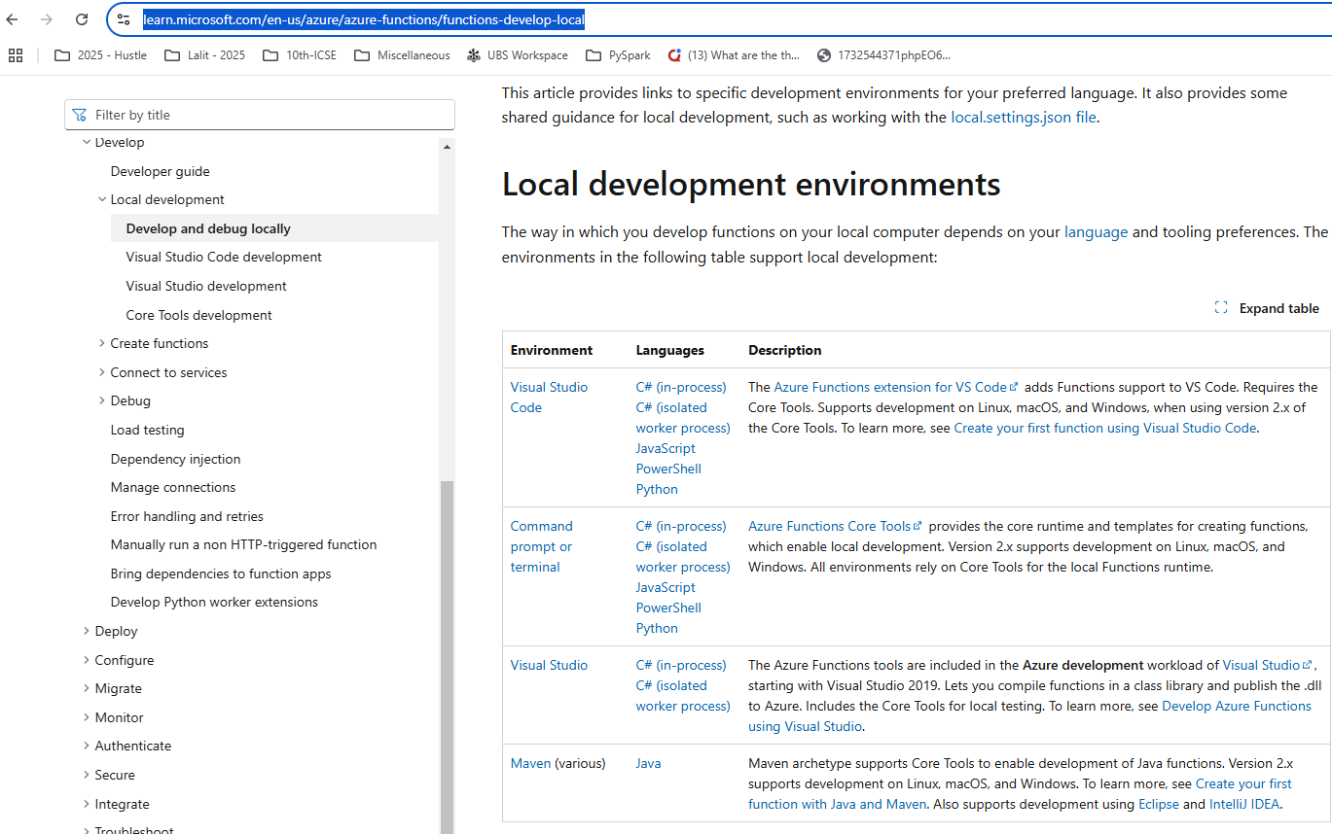

**Maven (various) - Java**

Maven archetype supports Core Tools to enable development of Java functions. Version 2.x supports development on Linux, macOS, and Windows. To learn more, see Create your first function with Java and Maven. Also supports development using Eclipse and IntelliJ IDEA.

Read this page - <https://learn.microsoft.com/en-us/azure/azure-functions/functions-develop-local>

And this allows us to run the Azure functions locally on our machine because naturally, we refuse to want to make sure that the code runs fine on our computer before deploying it to the cloud. So for that, open a new browser tab and navigate to the following URL. You can also find this URL in the resources of this lecture. And basically we are going to learnmicrosoft.com/ azure/azure-functions/functions-run-local. So go to this URL and here we are downloading the Azure Functions Core Tools. So click the install the Azure functions core tools right here. And based on your operating system, download the version that is compatible with what you are running. In my case, that would be the V4 of the Windows 64 bit. So click that and it downloads and download complete. So click it and click next. And of course, we accept the terms and next again and again and install. And now the Azure Functions Core Tools are installing and it might take a few seconds so let's wait for that to complete. Great, so installation is complete.

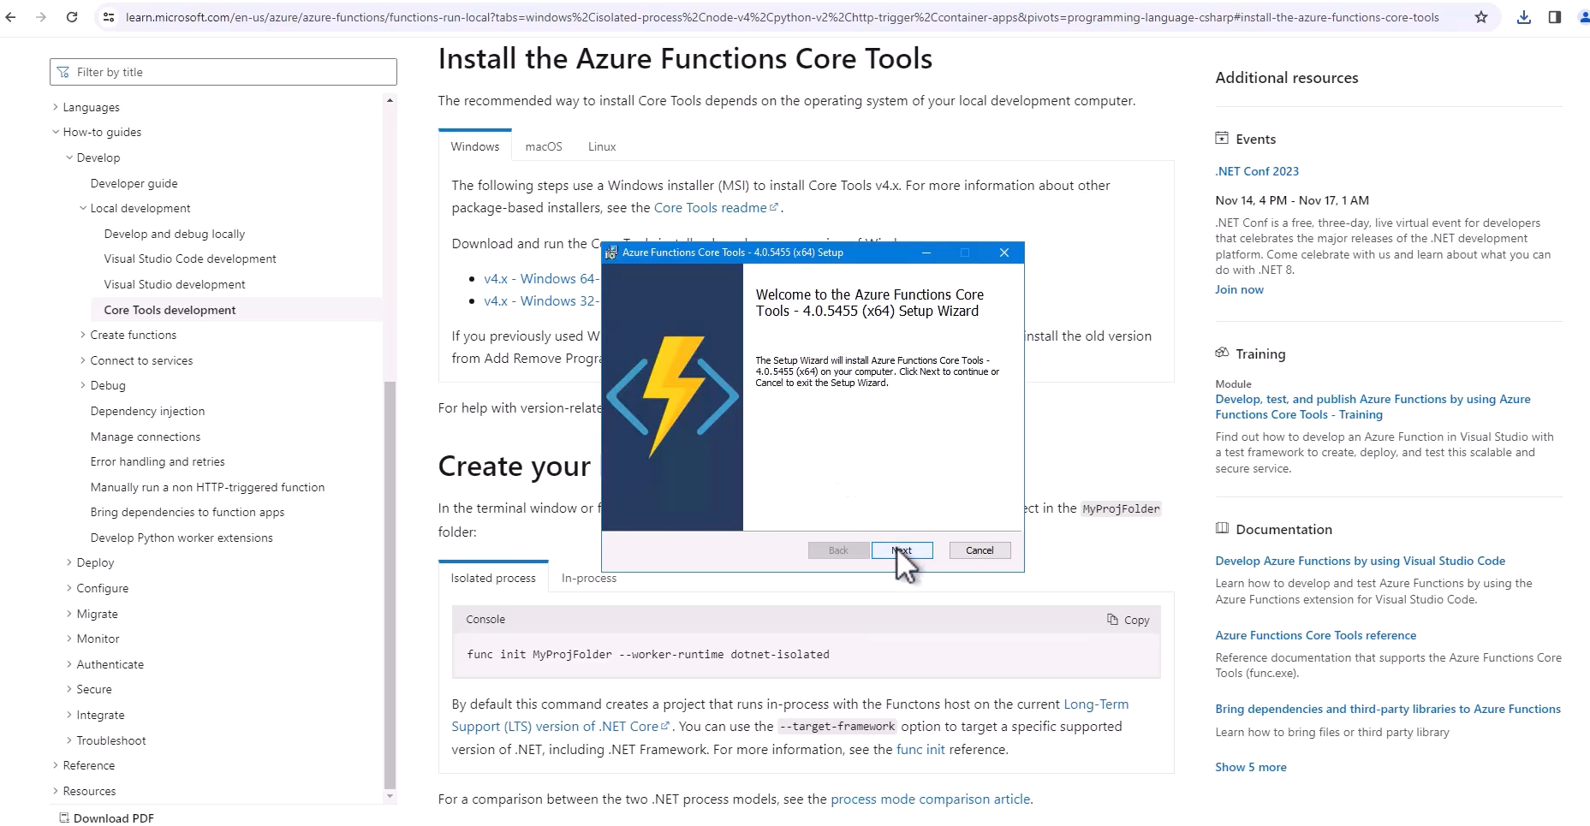

Now, next, download the order baseline-01.zip file from the resources of this lecture and extract it into the Readit folder that we already used. So here is the zip file and let's copy the folder in it, the order folder and I will place it in the Readit folder. This is a baseline code for the Azure function that we are going to work with.

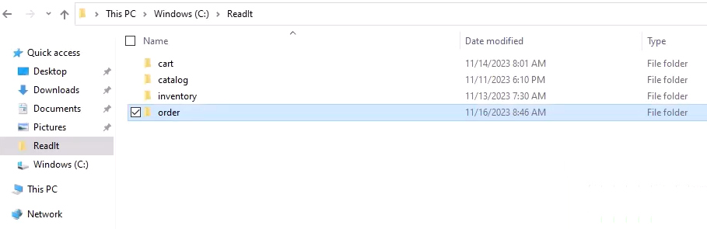

So navigate into the order folder and right click and open it in VS Code. And here is the project. Now first, before running it, I want to go through some files in this project and explain what exactly is going on.

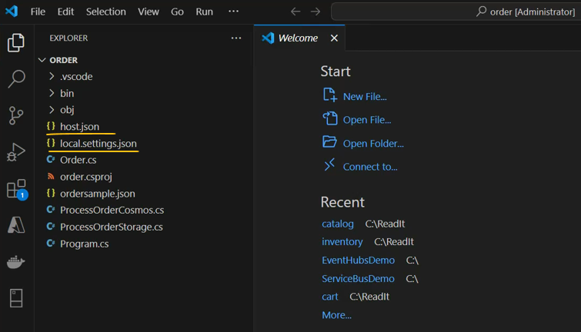

And the most important files in this project are these two, the ProcessOrderCosmos and the ProcessOrderStorage. And these two files are basically the two functions that are going to be part of our function app. And one of them is going to process the orders and store them in the Cosmos DB. And the second one is going to store them in storage account. Now, by now we didn't learn yet about Cosmos DB and storage accounts and of course we will do that later. And I included these two functions so that you'll be able to see how to work with both. And let's begin with ProcessOrderStorage and we will see how a function looks generally.

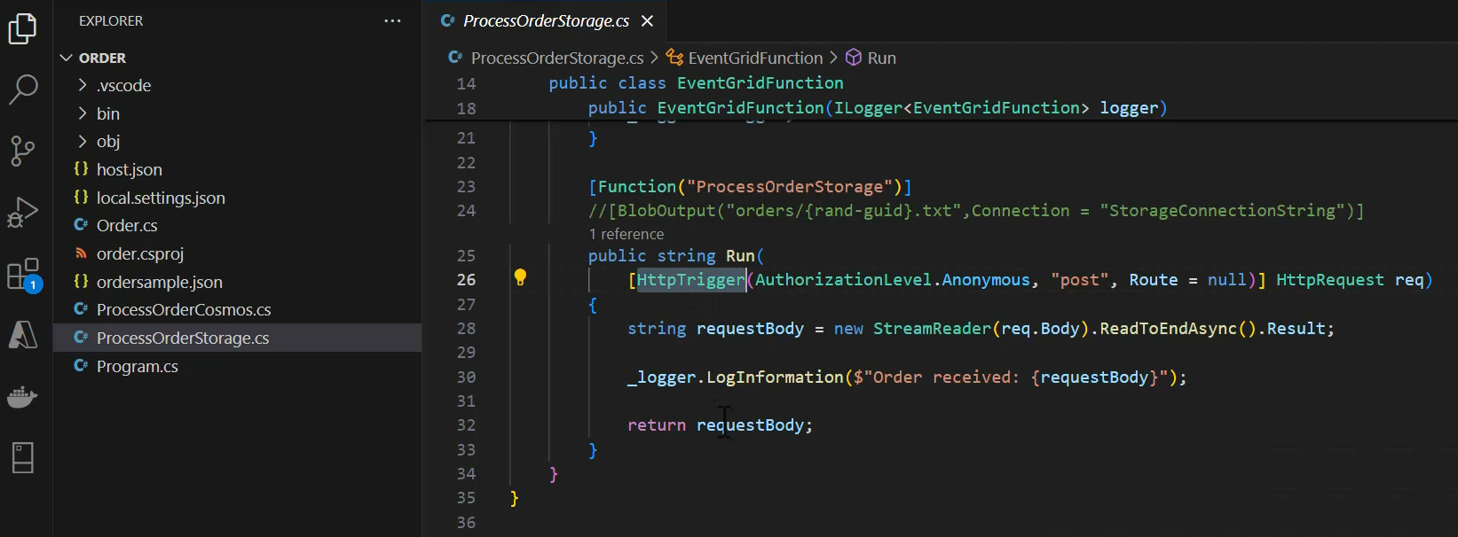



So this is a function file and you can see here the function attribute telling what's going to be the function name in Azure. So in Azure we will see the name, ProcessOrderStorage. We have some initialization for the logger, and the function itself is right here in the Run method. And let's see what we have here. So first we can see that the function is going to be triggered by HTTPTrigger. And denote that this is a parameter of the run method and the type of this parameter is HTTPRequest. And the name of the parameter is going to be rec, which we will use later. And we are going to trigger this function using HTTPTrigger and the POST verb. So after running the function, we read the content of the request into a requestBody variable and then we log the contents of this variable to the console and then return the requestBody. So it looks like the function doesn't do much. However, take a look at this line, the BlobOutput line, which is currently commented out. And what this line indicates for us is that we want to store the output of this function in a blob in storage account. And these are the configuration parameters of the storage account. We'll discuss them later. Currently, it is commented out because we didn't define it, the storage account and therefore the function simply returns the requestBody after of course logging it. So this is a ProcessOrderStorage.

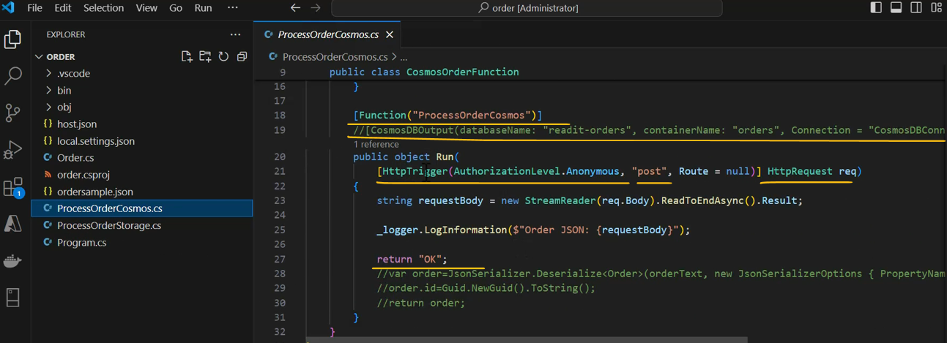

Next, let's take a look at the ProcessOrderCosmos right here. It is quite similar actually. Here also we have the HTTPTrigger. We read the content of the request and log it and then we return an OK. In the note, they commented out lines.



And what happens here is that we serialize the JSON into an order object. We set an ID to this order and then we return the order object. And what are we going to do with that? Well, similar to what we saw before with the storage account here we have a CosmosDBOutput again commented out right now.



And here we configure what are the parameters of the Cosmos DBs that we want to store the order in. Again, currently it is commented out, we'll configure it later. So these are the function files. Now I want to also take a look at this file, ordersample. This is a simple JSON file that demonstrates how an order looks. So we have an ID of the order and note that in our code, we are going to generate a new random ID for the order.

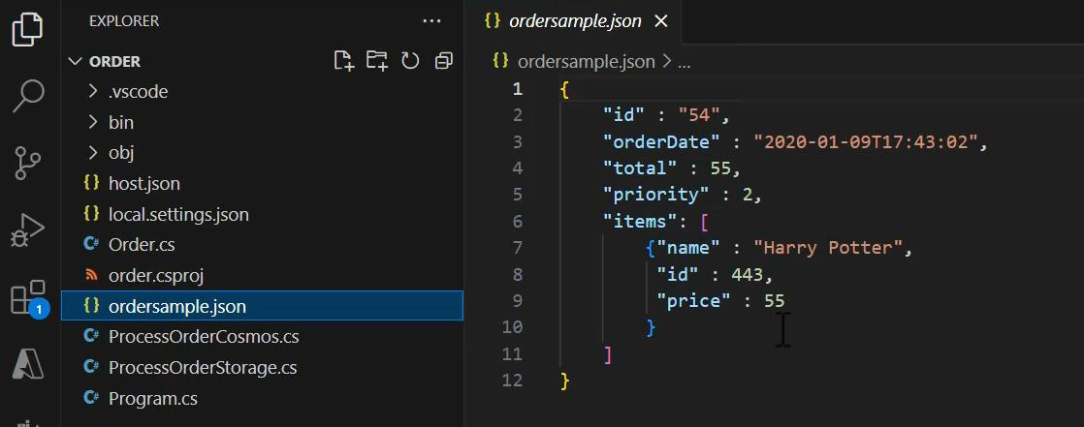



We have the order date, the total amount to pay, priority of the order, and the list of items in the order itself. So we will use this ordersample when testing the function. Next, let's take a look at the order cs file, which is basically a class representing the order. And you can see here, the exact same fields as we saw in the ordersample JSON.

|  |  |
| --- | --- |
|  |  |

So we have the ID, the orderDate, the total, priority and the list of items. And here we can initialize this order and also take a look at the order item class, again, similar to what we saw in the ordersample. Lastly, let's take a look at these files, the local settings JSON. This is a configuration file that we'll use to configure the connection to the Cosmos DB and to the storage account.

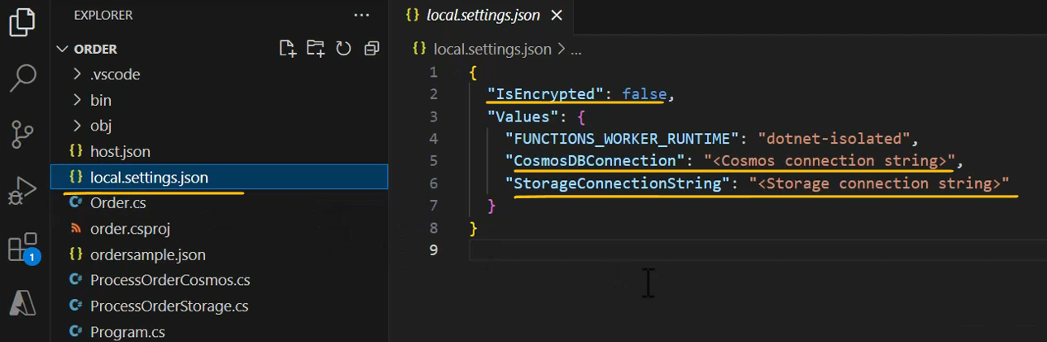

Currently, we only have placeholders here, but later in the course, we are going to configure these connections and we'll start working with the actual Cosmos DB and storage account. Great, so these are the files that are going to be part of our project. Now I want to take a look at the Azure extension and see how we are going to work with these functions. So note that the workspace pane right here, we have a local project folder. So expand it and in it we have a functions item. Let's expand that also and note the message we see here. Start debugging to update this list. So after we'll run our functions, we will be able to see the names of the functions right here and we will be able to handle them right from the extension.

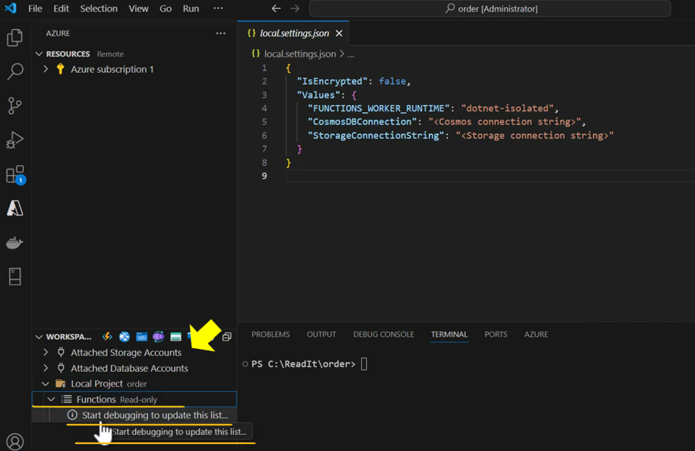

So now it's time to run the functions and let's see whether they work. So simply hit a 5 and let's wait for the functions to build and the note that the first run might take a few minutes. So let's wait for it to complete.

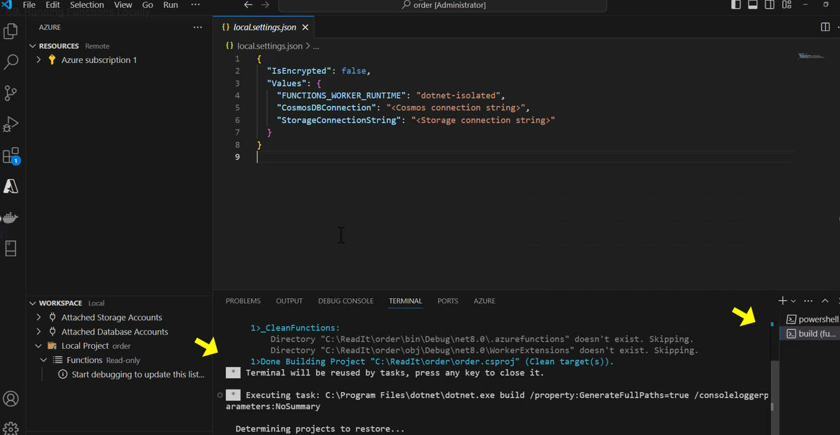

So build is complete. And now the functions are running and the note that as opposed to websites, we don't have a browser opening up after building the project in that because in order to use functions, we call their URL.

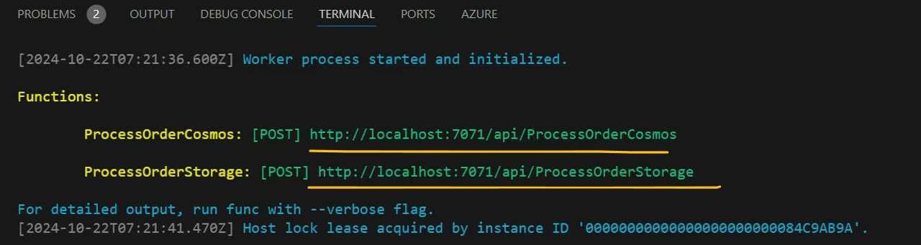

And the notes that here we have two URLs. We have URL for the ProcessOrderCosmos function. And this is a URL. Note that this is a local URL. Currently the functions are running locally and here is the URL for the ProcessOrderStorage function. Great, so again, we are going to test these functions by calling the URL and we are going to do that using Postman. Now we already use Postman before when calling the metadata service of Azure VM, but we didn't install it yet on our local computer. So let's do that now . Let's go to the browser and type here, download Postman and click this link and click your operating system. And now Postman is downloading, let's wait for that to complete. Great. And Postman was downloaded. Let's open it and the postman is installing. Great. You can click the Open Lightweight API Client. Great, so here we have Postman and now we can use it to test our function. So to do that, let's go back to VS Code. And for example, let's test the process orders storage function. So simply copy this URL and let's go back to postman, paste it right here and change the HTTP verb to POST. This is the verb that the functions are using. And now go to body right here and go to row and change the type from text to JSON. And here we are going to paste the order that we want to send. So let's go back to VS Code and open in the explorer, the ordersample file and simply copy its content and let's paste it right here and send and let's see what we'll get. So we can see that the response was 200 OK, meaning the request was successful.

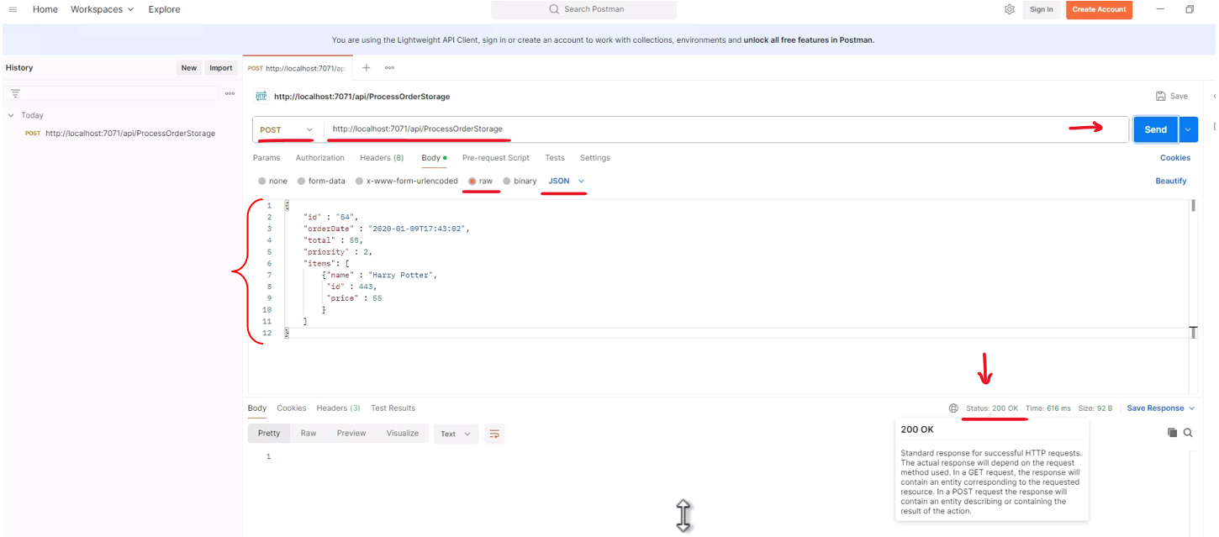

And now let's go back to VS code and we can see that something happened here.

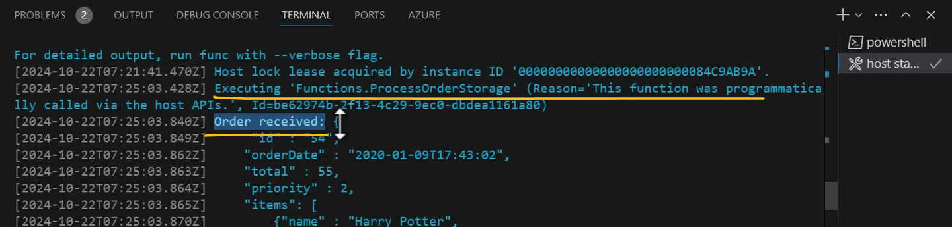

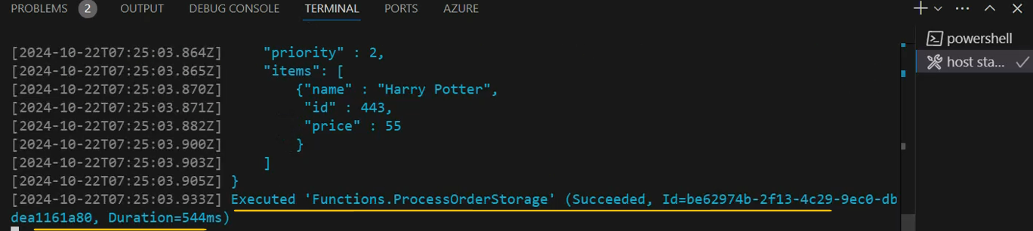

And if we'll take a look here, we can see that an order was received and here are the details of this order, which are the exact same details as here. And if we will take a look again at the code of the ProcessOrderStorage, then we can see that this log record is basically what we see here. So the function was activated and the order was received and the log was able to record the order that was received by the function. And that means that our functions are up and running locally and now it's time to publish it to Azure.

Changing the default log source in Azure Functios

In the next lecture you're going to upload and run the function in Azure.

On 7:35, you're going to open the log console which you'll use to view the logs created by the function.

Recently, an update was made in the Azure Function page in the portal, which makes the default log to be streamed to App Insights, and so it's not displayed in the log console.

When you open the log console, take a look at this button:

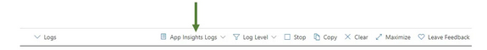

If its says App Insights Logs, as in the image, click it and switch to Filesystem Logs (and approve the notification that will be displayed).

After that, logs will be streamed to the console as shown in the video.

### Running Functions on Azure

So our functions are running locally and now it's time to deploy them in Azure. First, we need to create a function app in Azure and let's do that. So let's go to the portal and in the search bar, type function app and click function app.

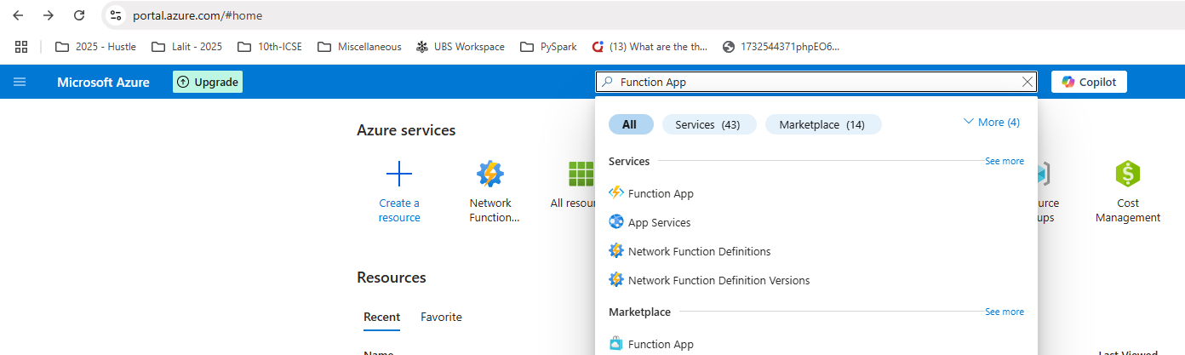



And naturally we don't have any function app yet. And let's create one. So click create function app. And the third thing we need to do is to select the hosting option of the function app we want to create. And these are the hosting options that are available for us.

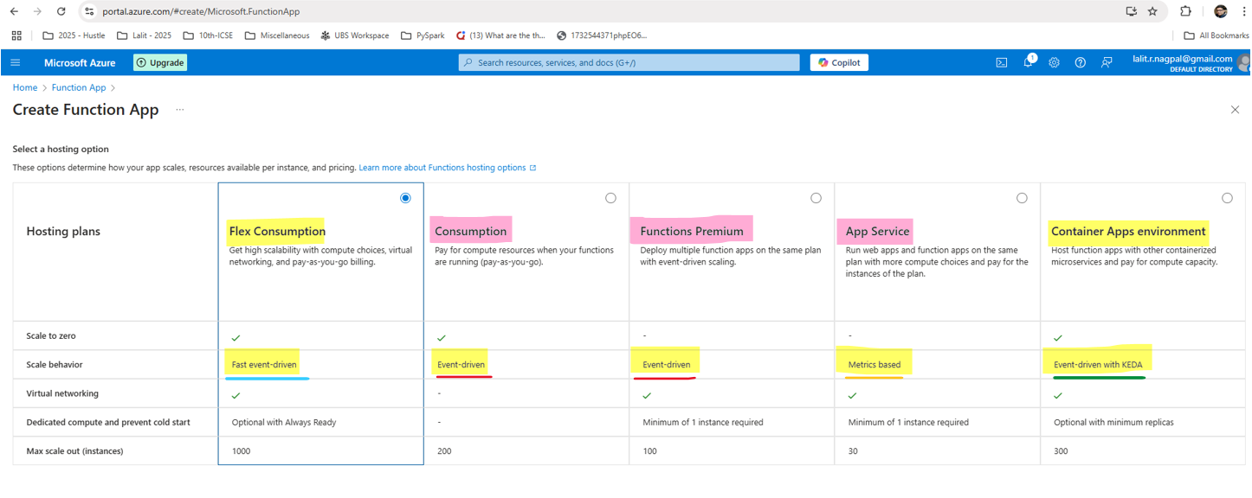

We already discussed them and we are going to stick with the Consumption hosting option. So make sure it is selected and click select. And now let's configure our function app. So for the resource group, of course we are going to go with the readit-app-rg. And now let's name our function app and remember that name of a function app should be unique across Azure and that means that the name I will pick will not be available for you. So pick another one. I will go with memiorderfunction like that.

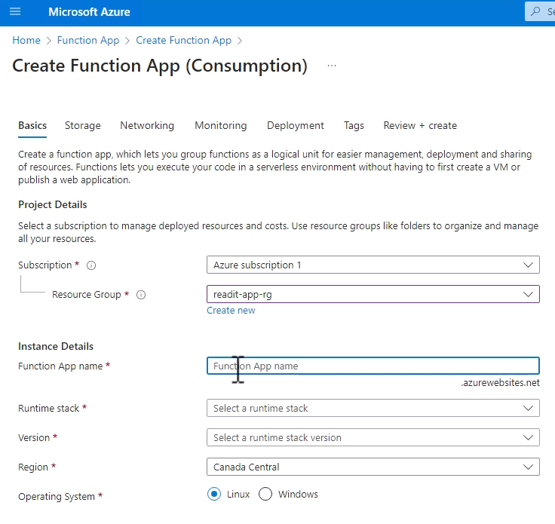

Great, now let's select the runtime stack, which is going to be .NET and the version is going to be 8. And make sure to select 8 isolated worker model. This is a new model that function apps are running under.

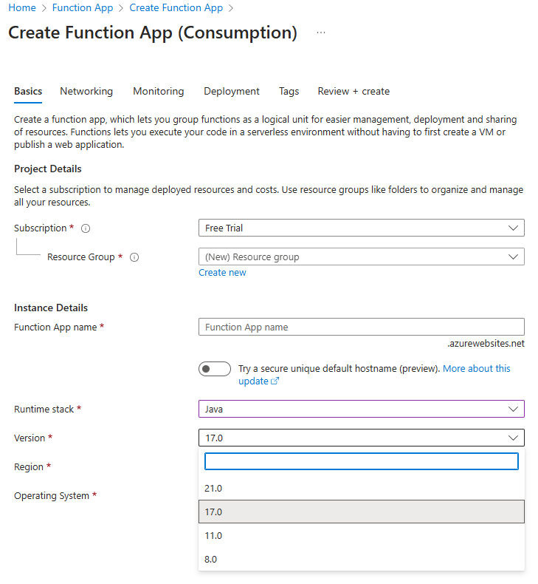

And select your region, again, in my case, that would be West Europe and the operating system as before is going to be Windows. Great. Now click Next Storage. And what we want to do now is to configure the storage account that will be used for the function.

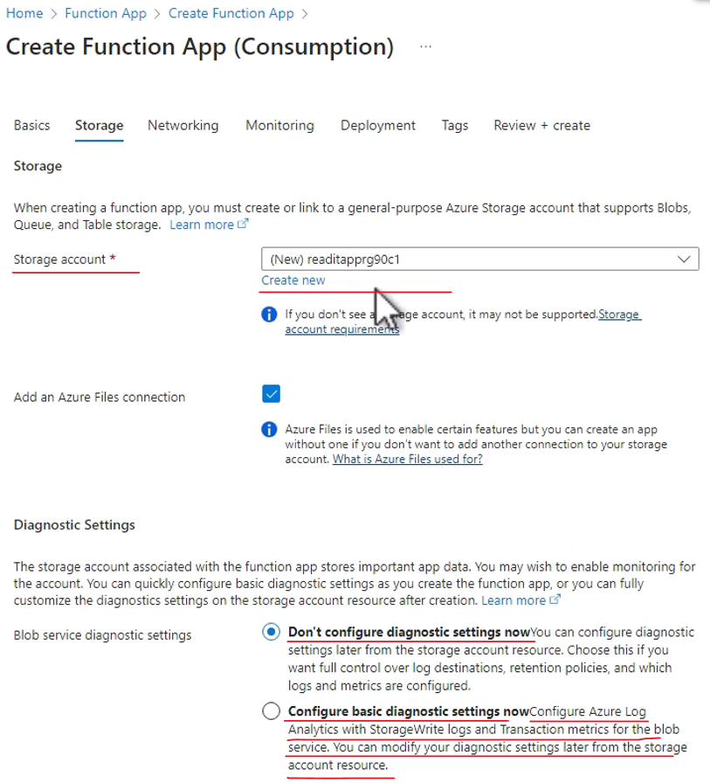

And basically every function app requires a storage account to store the function and its parameters. So it's important to have a storage account and note that Azure offers us a default name for the new storage account, but we'll use another one. So click create new and I will name the new storage account, memireaditfuncstorage. So I will use this name and note that the name, again, should be unique across Azure. So this name will not be available for you. Of course, feel free to use a default name offered by Azure.

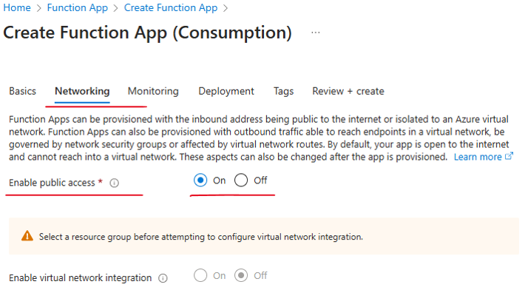 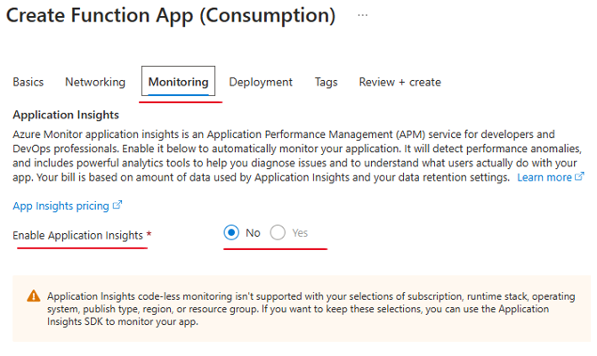

|  |  |
| --- | --- |
|  |  |

Review + Create. Let's wait for the validation to complete. Here it is and create. And now Azure is creating a function up for us and let's wait for that to complete. And deployment is complete and our function app is up and running. So let's take a look at it.

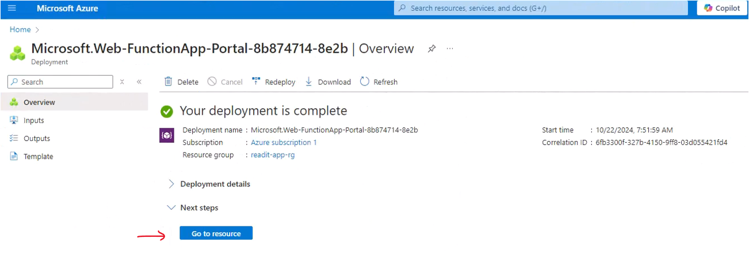

Click go to resource and here is our function app.

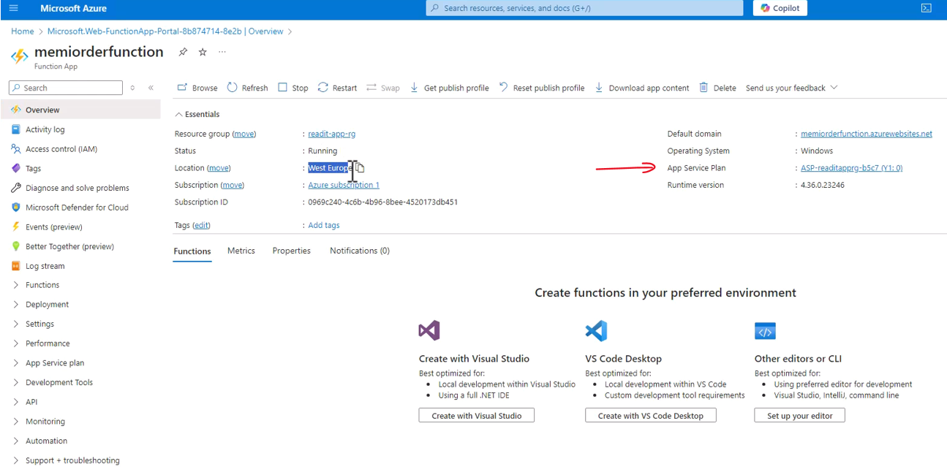

So we can see that it is running and it is deployed in the location that we asked for. And now let's click the app service plan right here. And again, remember that service plan is basically the infrastructure that the function app is running on and in it, click properties right here.

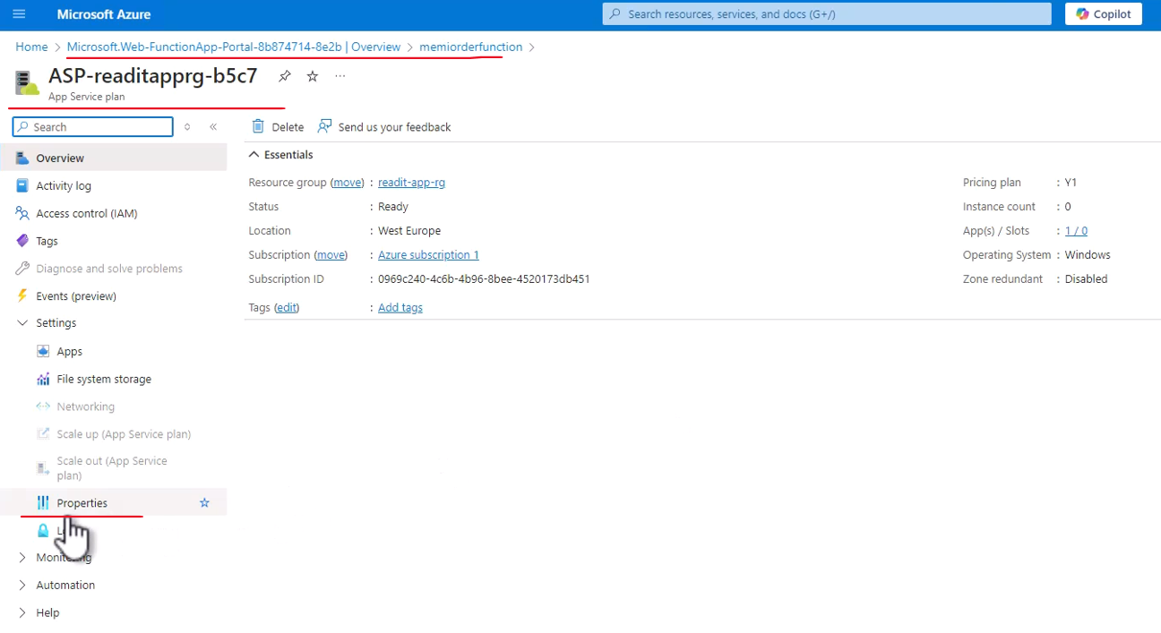

And you can see the pricing tier, which is Consumption. And indeed this is the tier that we asked for when creating this function app.

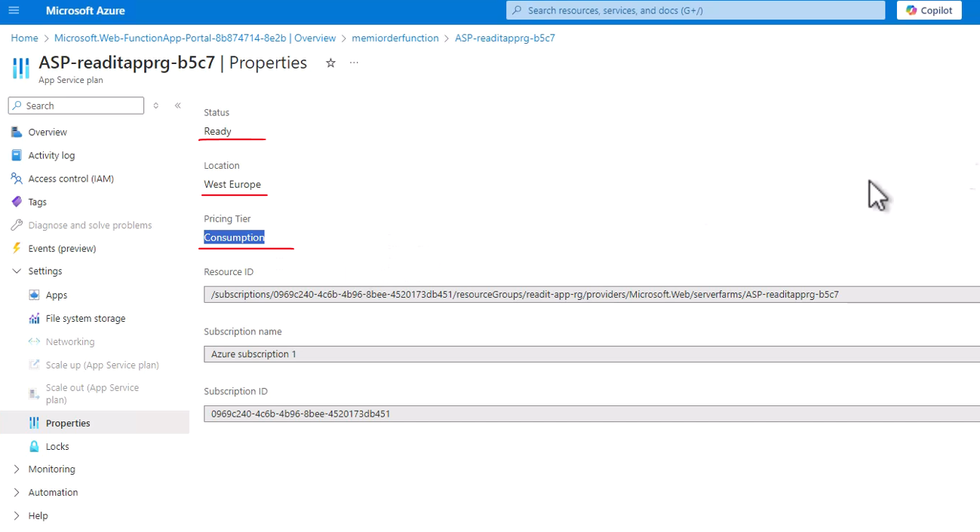

So let's close that and go back to the function app. And as you can see under these tabs the functions, there aren't any functions in this function app which will make sense since we just deployed it.

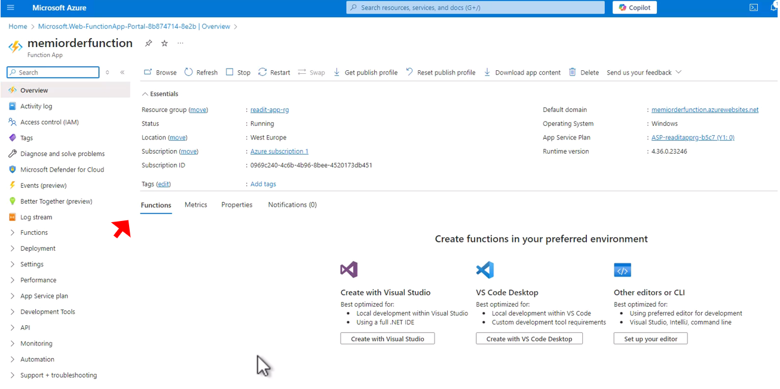

So now we are going to deploy our functions to this function app. So let's go back to VS Code and go to the Azure extension. And first note that under the local project right here, we have the two functions that we created, the ProcessOrderCosmos and the ProcessOrderStorage. Great, now in the resources pane, expand the Azure subscription and underneath it, you will find Function app. So expand this and if you don't see anything in it, then click refresh. And here is our function app.

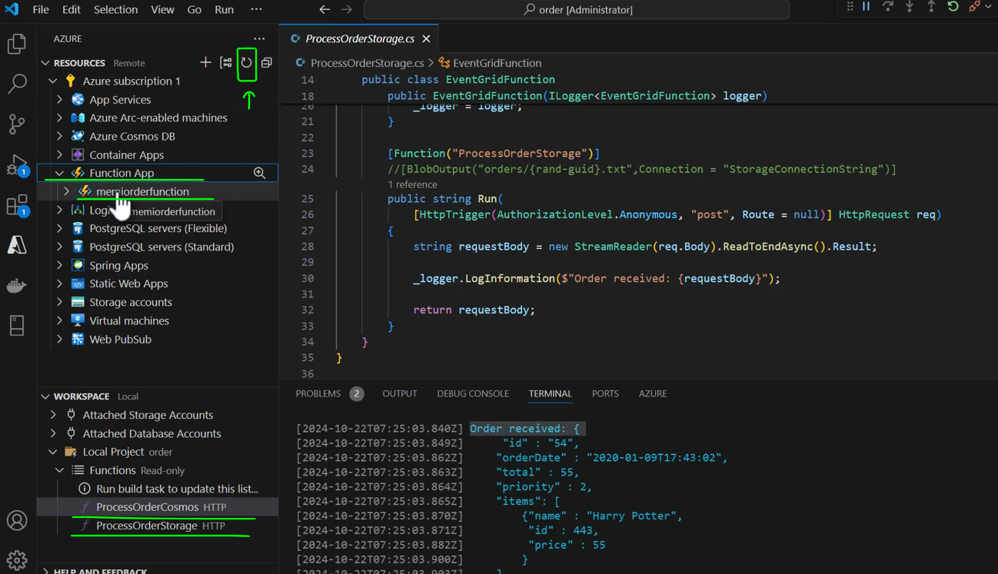

So that means that VS Code is familiar with the function app that we just deployed in Azure and we can now deploy functions into it. So let's do that. In the workspace pane, click this icon, the Azure functions and select deploy to Azure. And now we need to select the function app to which we want to deploy our functions.

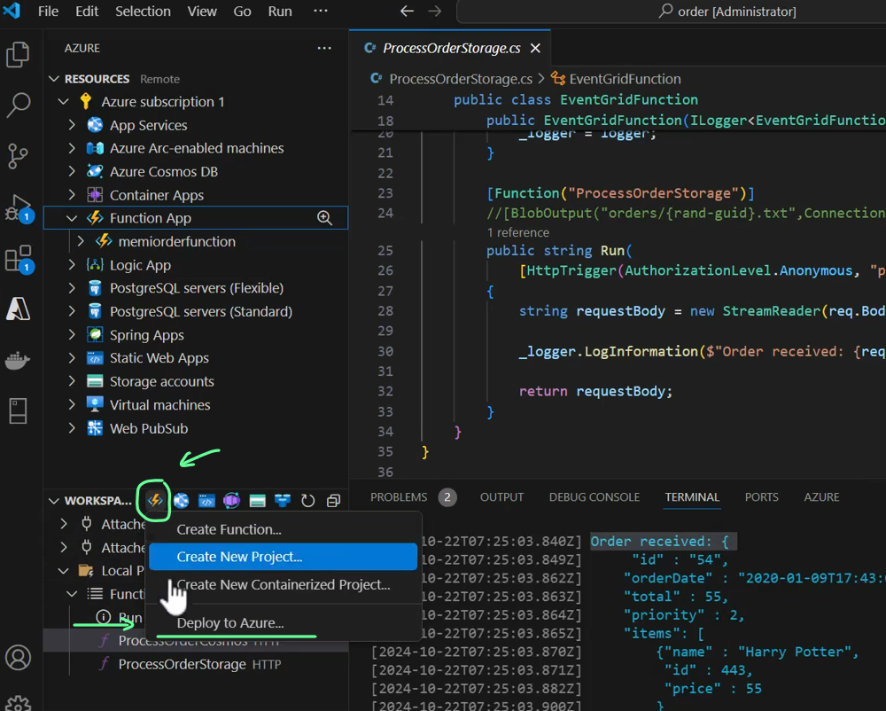

So select the function up we just created. So click it. And now VS Code asks us whether we want to deploy our functions to memiorderfunction, which is a function app we created.

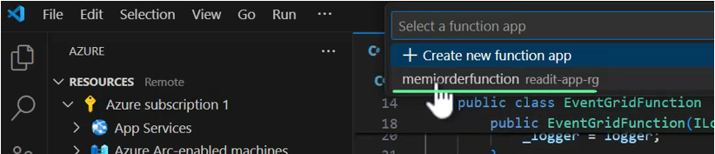

Of course, in your case the name will be different. So yes, we want to deploy our functions to this function app.

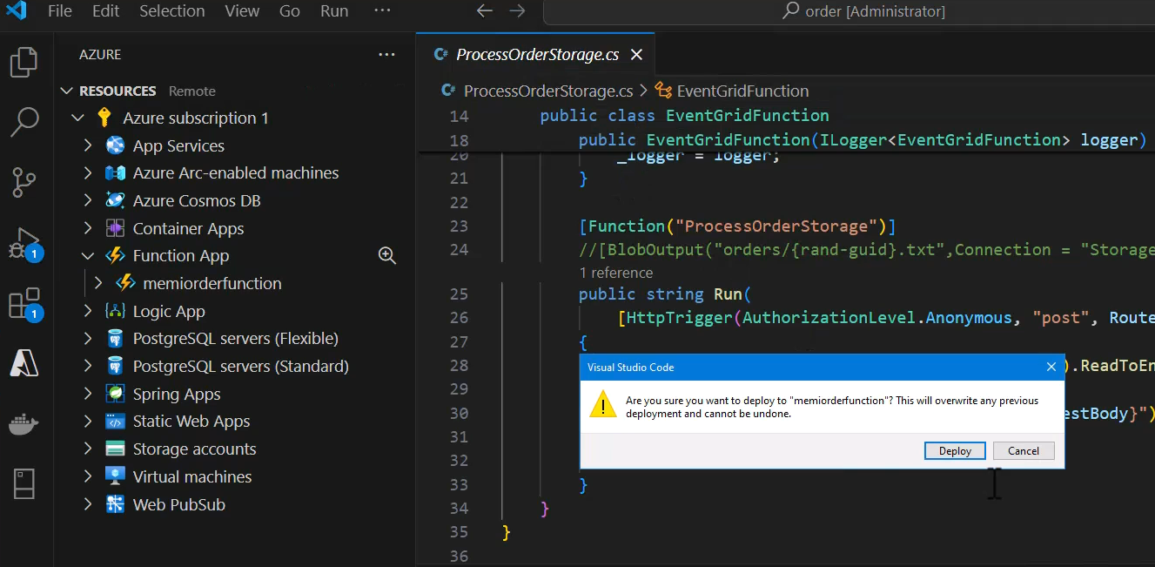

So click deploy, and now deployment begins. And the third step is to build the functions. So this is what happens now. Let's wait for that to complete. Great. And now deploying begins.

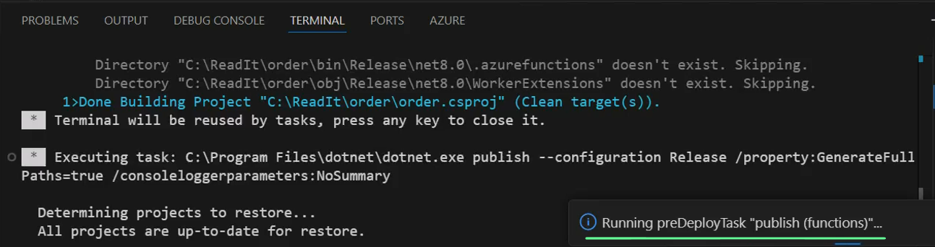

Let's click the output window link to see what exactly is going on so we can see the value steps of the actual deployment.

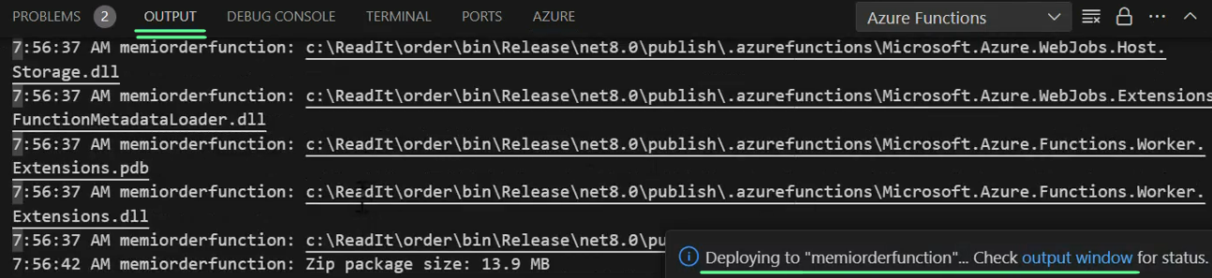

It might take a few seconds, so let's wait for that. Great. And the deployment completed. Now make sure to click the upload settings button right here, which basically uploads the contents of the local settings file to the function app.

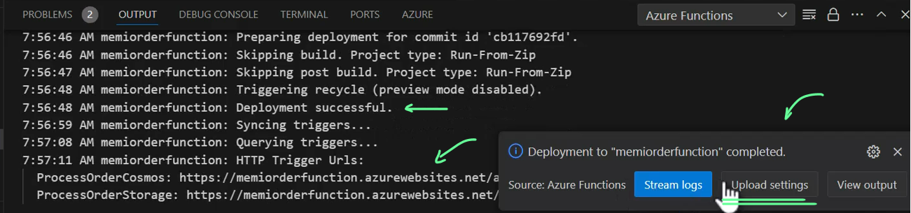

Currently, there isn't anything in this file, but we will use it later. So the settings were uploaded successfully and now we have our functions deployed in the function app.

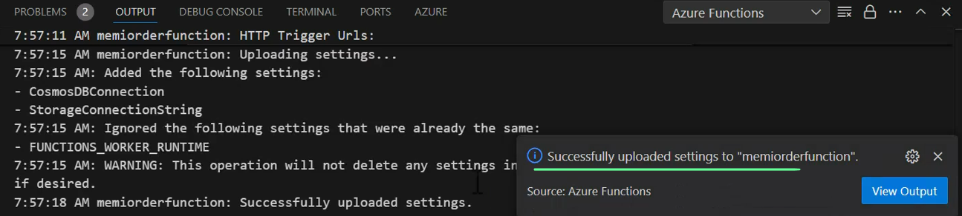

And let's make sure this is indeed the case. So let's go back to our function app page and hit refresh. And here are our two functions, the ProcessOrderCosmos and the ProcessOrderStorage.

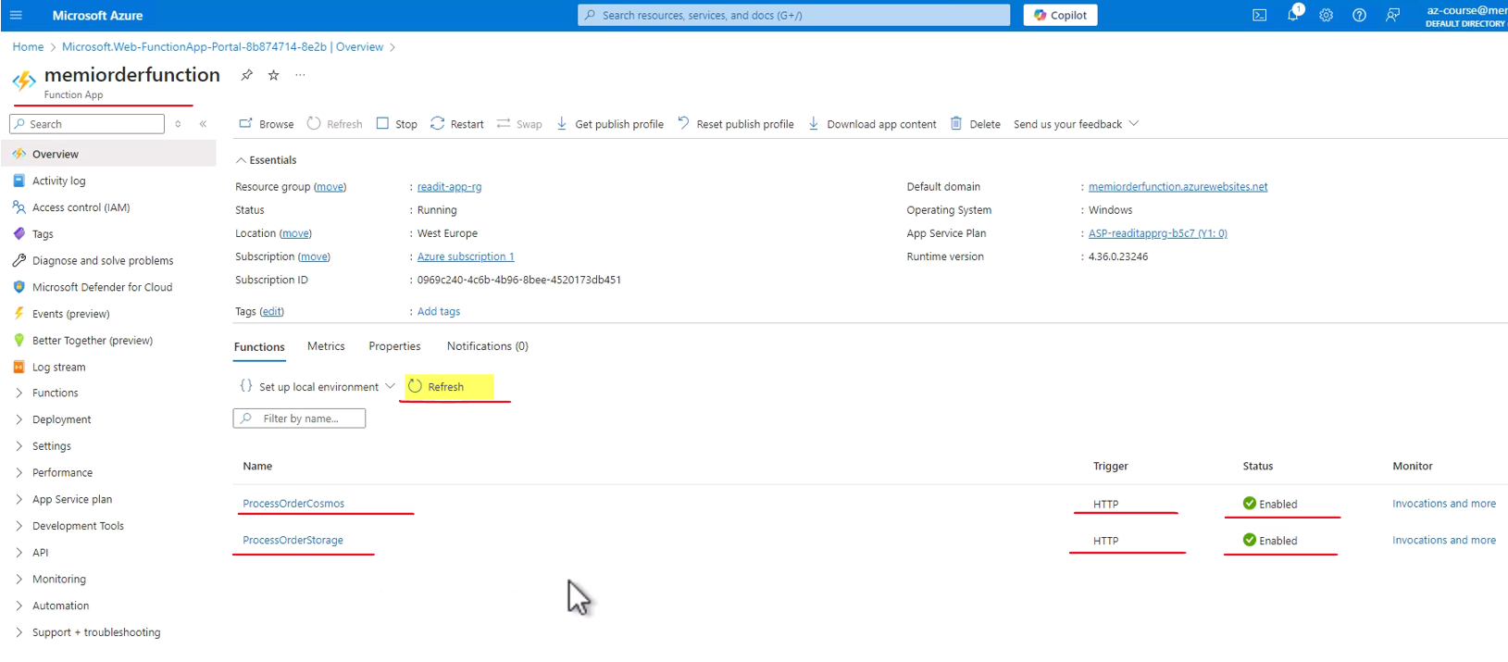

They are both enabled and note that they are both activated by the HTTP Toolkit as we saw in the code. Great. So now let's test these functions. And as before, we are going to test the ProcessOrderStorage. So click the functioning and this is the function page in the function app. And we are now in the code + test tab of the function.

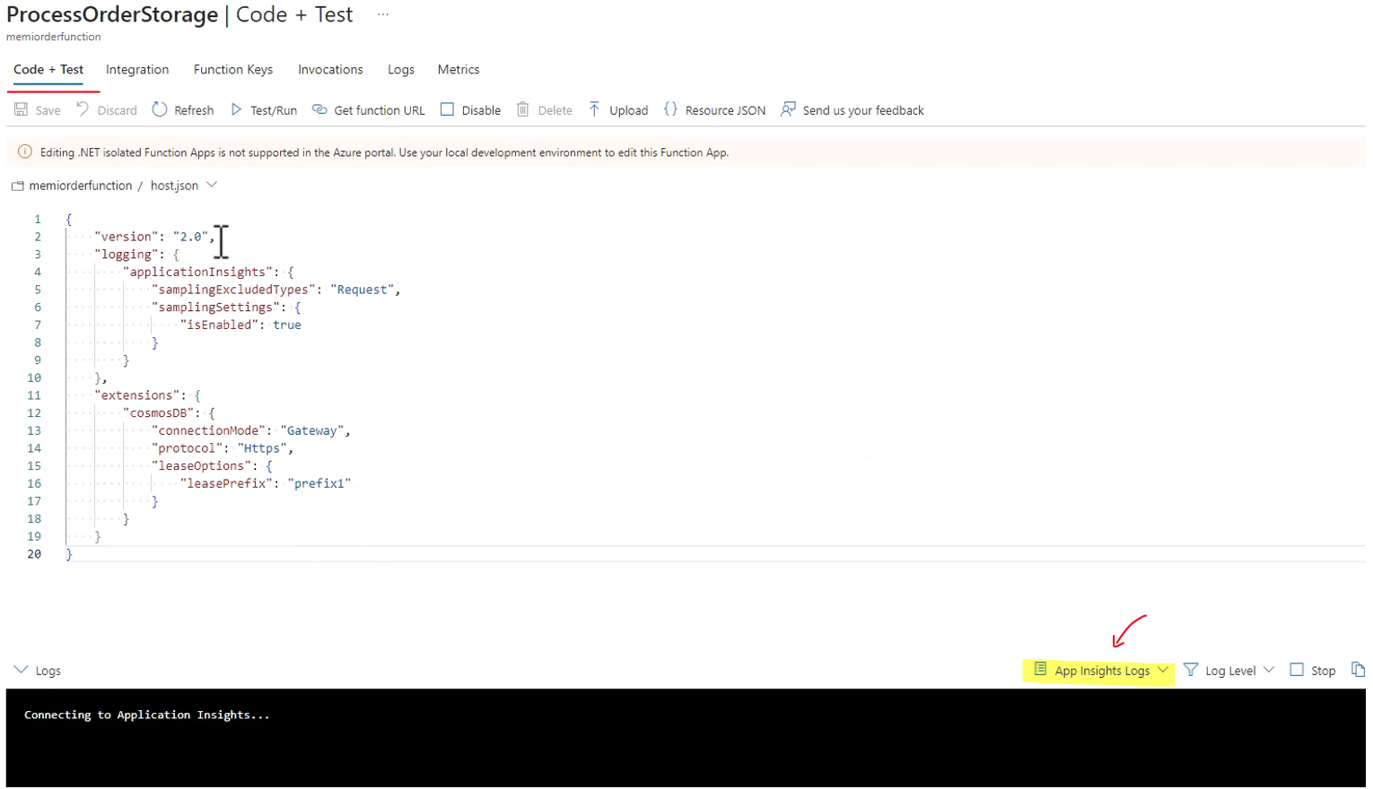

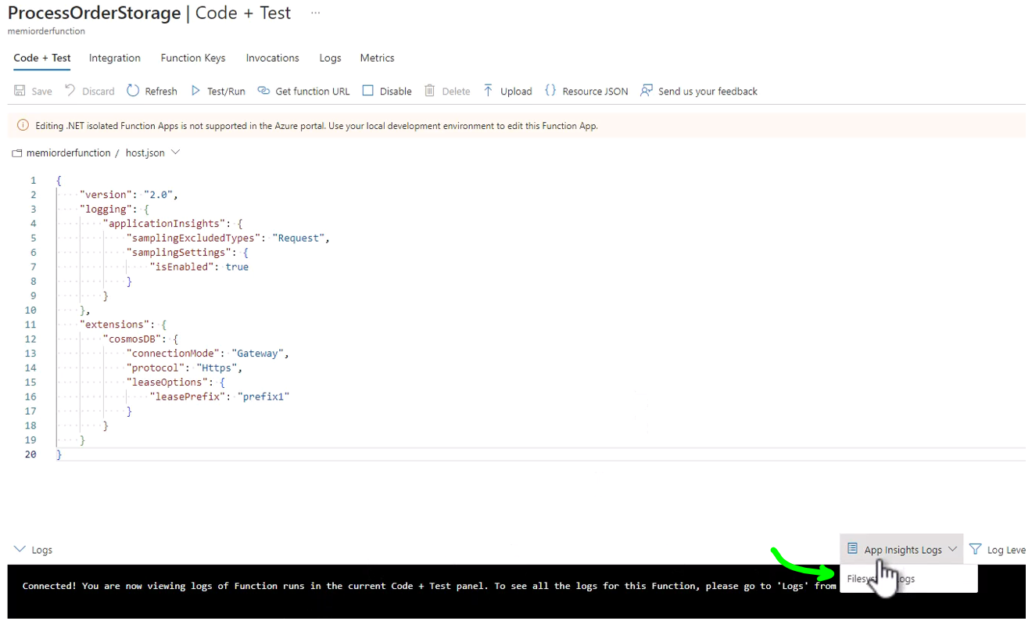

And this is the log console. Let's just switch the log source to be file system logs and okay, and now we can test our function. So how are we going to do that? Well, basically the exact same way we did it before using Postman. So click Get Function URL and here you see various URLs.

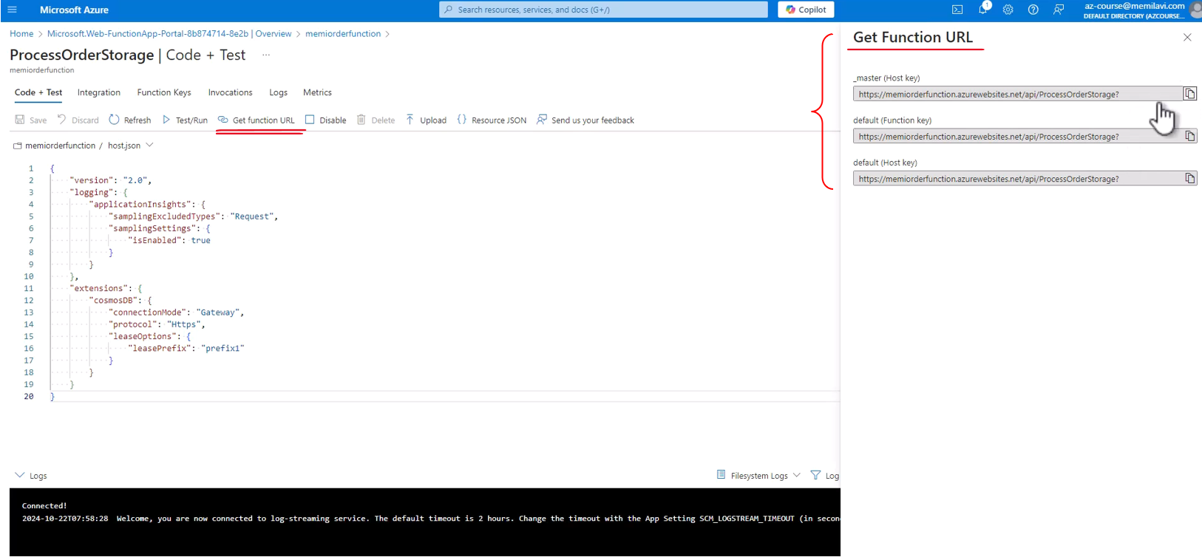

And since our function allows anonymous access, then all the URLs are the same. There isn't any key or authentication key attached to any of these URLs so copy whatever URL you want. They are exactly the same. Let's take the first one. And let's go back to Postman and replace the local URL with the one we just copied from Azure. We can remove the question mark at the end. Everything else stays the same, including the body payload and click send and let's see what will happen. So first we see that the response is the exact response we expected to get, which is 200 OK.

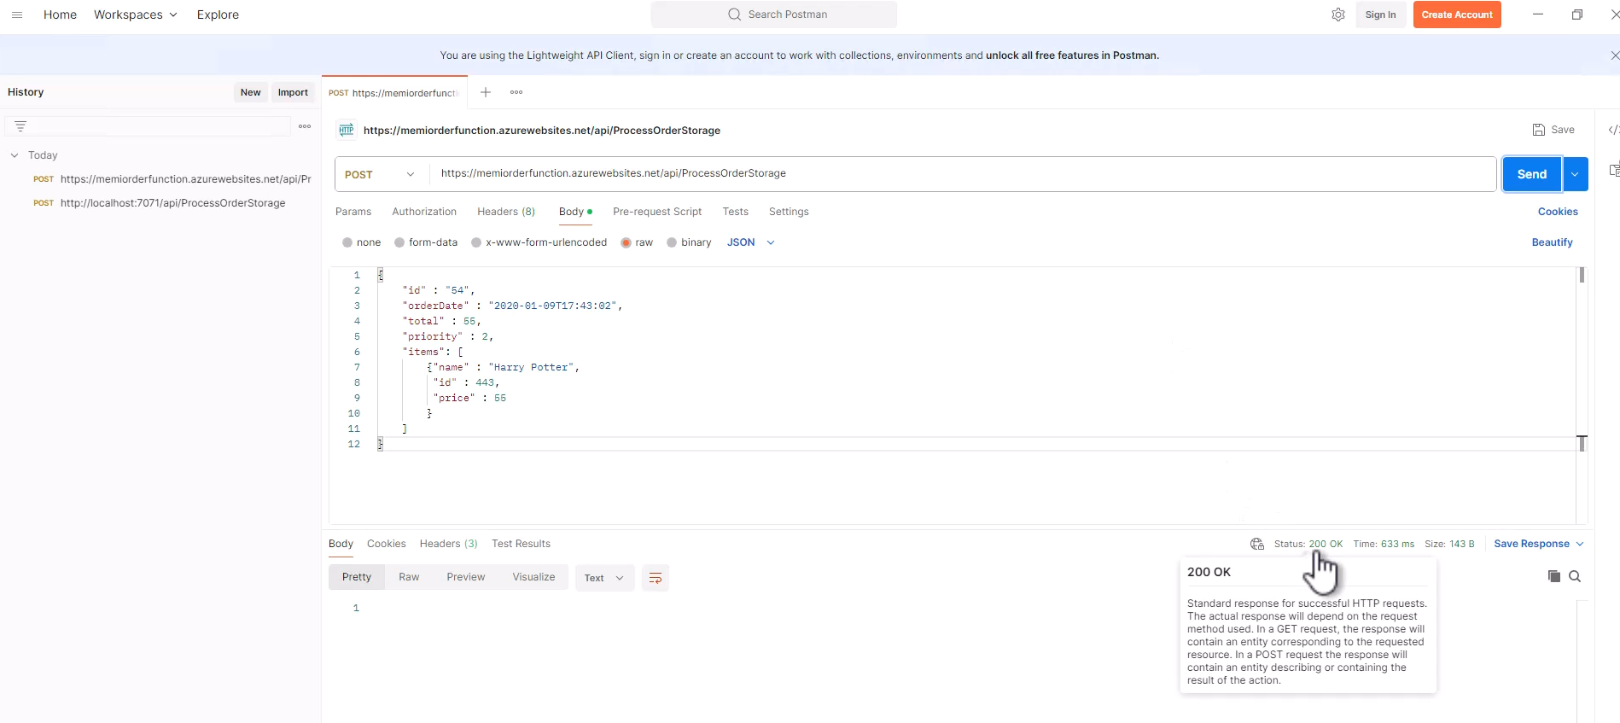

That's great. Now let's go back to the portal and you can see that something happened here. Let's close this popup. And this is the content of the log, as we saw before in VS Code. And it is now shown in the log console in the cloud.

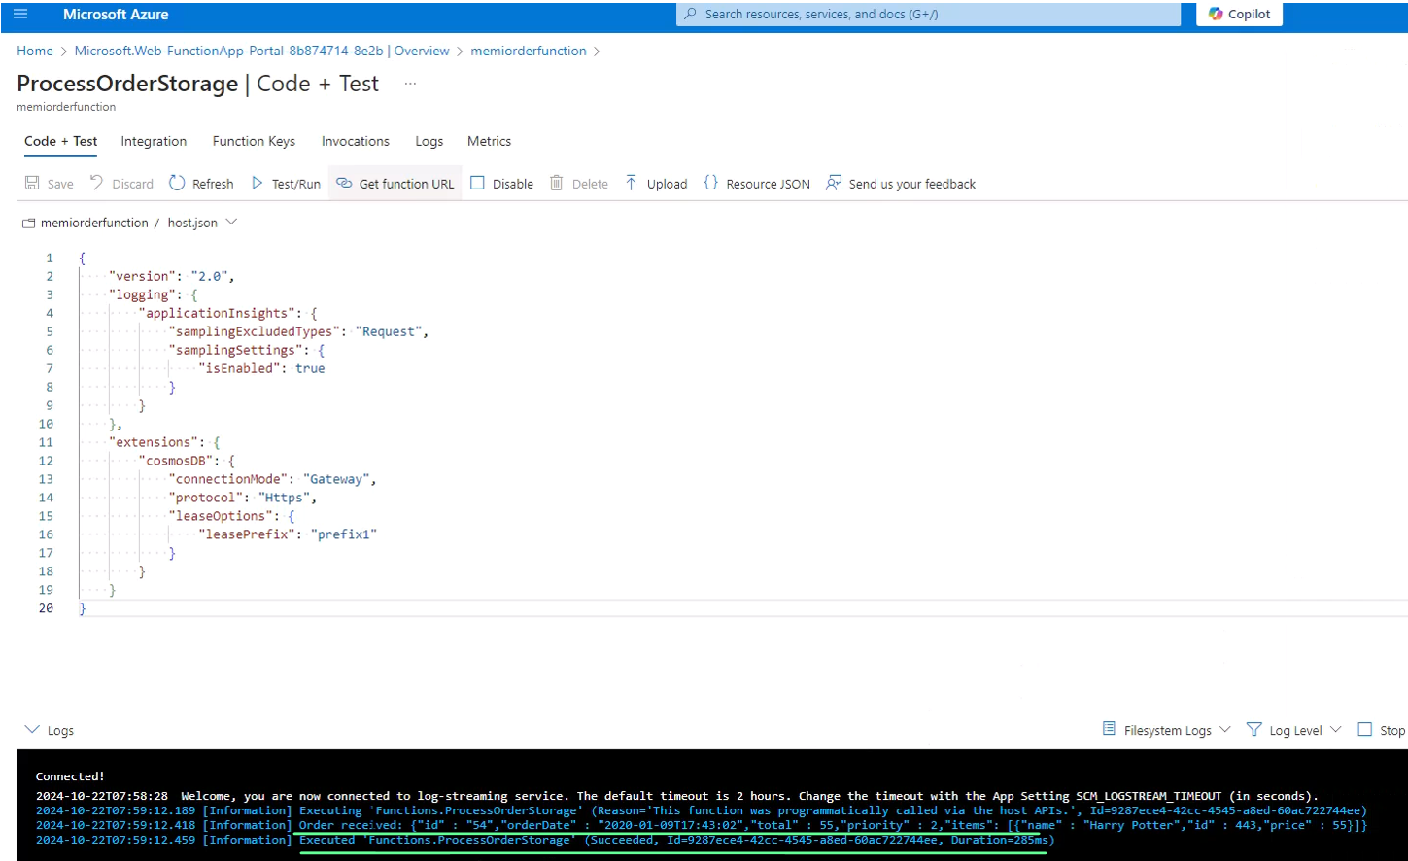

The contents are exactly the same. We can see that order received and then the JSON structure of the order. So that means that the function is working properly. We can connect to it, call it end, pass it parameters. Now admittedly, currently the function doesn't do much, but of course we are going to improve it substantially while we will progress through the course.

### Current Architecture

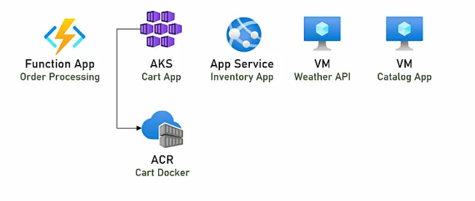

So in addition to what we already had, the two VMs, the App Service, and the AKS talking to the ACR, to the container registry, we now have also Function App, which is used for order processing. So this Function App contains right now two functions. Of course in reality, we will use only one.

So far we looked at virtual machines, we looked at app services, we looked at AKS, and we also looked at function app.

Don't forget to write down the AKS Cart Service URL and the Order Function URL in the Resources Helper List, this will help you later when you'll need to access them.

### How to choose the Compute Type?

We talked about four types of Azure compute services. We talked about virtual machines, about app services, about AKS with ACR, and about Azure Functions. And the question, of course, is how to choose the right compute type. There are four of them, and you have to make sure that you select the right one for your application. So how do you do that? Well, in order to help you to make this decision, I've created this flow chart. Use this flow chart when selecting the compute type for your system and I hope it'll help you choose the right one.

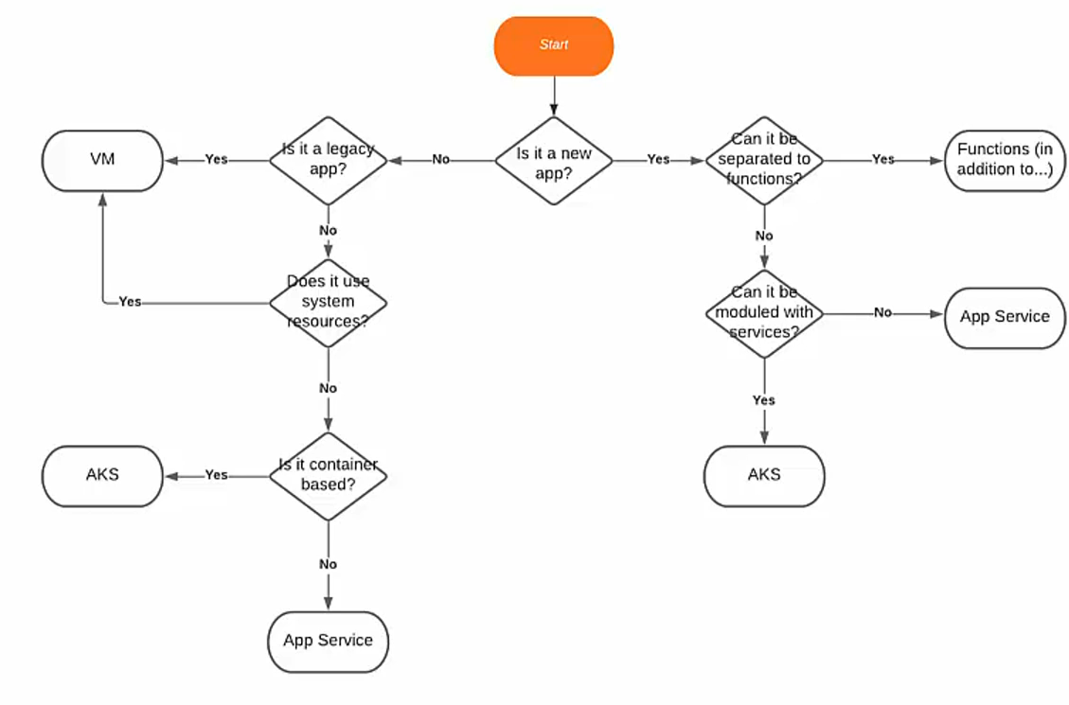

The first question that you need to ask yourselves is whether the app that you're installing in the cloud a new app? If the answer is yes, so go right in the chart. Then the next question is can it be separated to functions? In other words, can you model it, so that it will be composed of small focused code segments? Each performs a very specific task. If the answer is yes, then go with functions. Now, it's important to note that usually, you can't base a whole system solely on functions. Functions usually come in addition to something else but whatever you can put in functions, then do it.

Now, if the system can't be separated to functions or some parts of it cannot be separated to functions, then the next service is whether the system can be modeled with services. In other words, are you planning to implement a microservices-based system where each service is responsible for a specific functionality and the various services communicate with themselves? If the answer is no, meaning the system is basically a monolith, then go with App Service. If the answer is yes, then go with AKS and use Kubernetes and the Docker images to build and model your system.

So this is a scenario for new app. If the app is not a new one, then the next question is is it a legacy app? And by this question, what I mean is whether this app is based on outdated technologies, such as C++ or classic ASP or similar. If the answer is yes, then go with virtual machine because no managed platform in Azure support legacy apps or legacy technologies. If the answer is no, so the app is not based on legacy technologies, then the next question is does it use system resources, such as sockets or registry or similar? And here too, if the answer is yes, then go again with a virtual machine because no managed solution in Azure allows access to system resources. Now, if the answer is no, and the system does not require system resources, then the next question is is it container based? Is this system already uses containers for its deployment? And if the answer is yes, then go with AKS because AKS, of course, supports deployment using containers. And if the answer is no, then go with App Service. So this is a flow that I use when selecting the compute type. Now, of course, this is only a guideline and I'm sure there will be exceptions to it, but as a general guidance, it definitely does a very good job.

See Also

<https://learn.microsoft.com/en-us/azure/architecture/guide/technology-choices/compute-decision-tree>

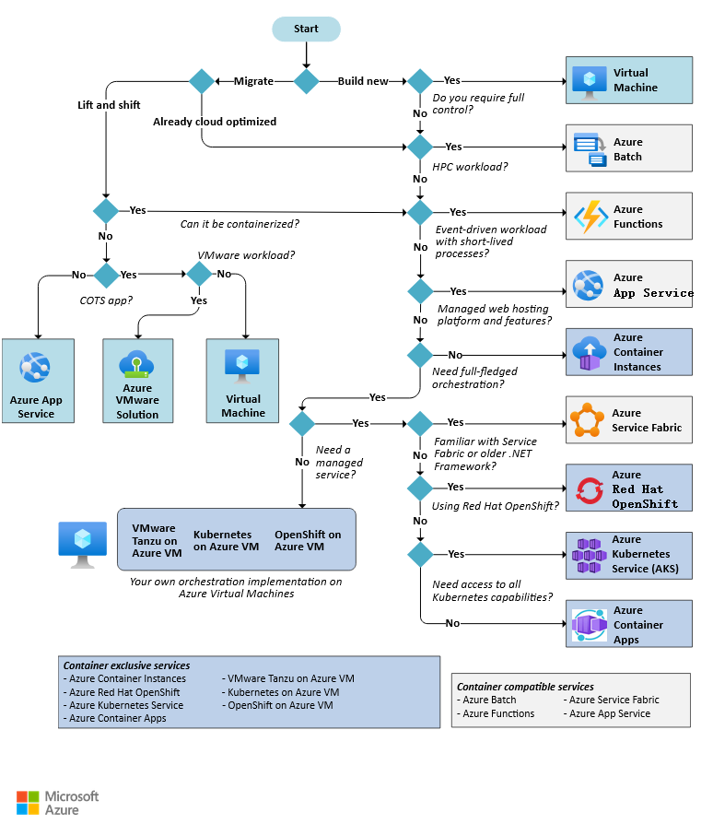

<https://learn.microsoft.com/en-us/azure/architecture/microservices/design/compute-options>

<https://learn.microsoft.com/en-us/dotnet/architecture/modern-web-apps-azure/choose-between-traditional-web-and-single-page-apps?toc=https%3A%2F%2Flearn.microsoft.com%2Fen-us%2Fazure%2Farchitecture%2Ftoc.json&bc=https%3A%2F%2Flearn.microsoft.com%2Fen-us%2Fazure%2Farchitecture%2Fbread%2Ftoc.json>

### More Compute Options

We discussed four types of compute services, the virtual machine, the App Service, AKS, and Azure Functions. But actually, there are more, and these are not the only compute options that you can find in Azure. So for example, you can find Logic Apps, which is basically a workflow that integrates with Azure services and can execute various logic steps.

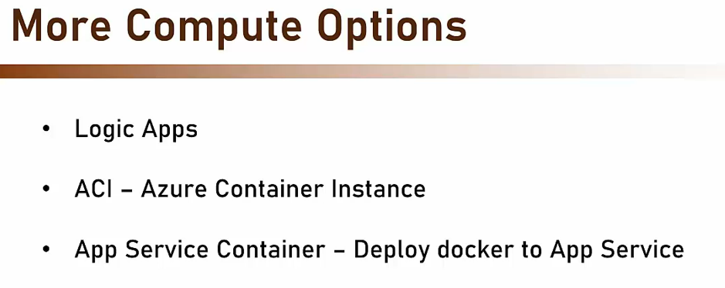

There is also the ACI, Azure Container Instance, which runs Docker container without the AKS. So if you don't need all the complexity of Kubernetes but just want to run a single container instance, then this is the way to go. And there is also the App Service Container, which allows you to deploy Docker to App Service. What we discussed with App Services is how to deploy your code to App Services, but in fact, you can also deploy a container image. Now, I didn't discuss these three types of compute services because they are less common, and chances are you are not going to use them, but you should be aware that they exist.

## Identity Management – Azure AD ( ENTRA )

Recently Microsoft changed the name of Azure AD, the identity management service in Azure, to Microsoft Entra. However, in the industry the name Azure AD stuck and is still being used, and therefore you'll see in this section the names Azure AD and Microsoft Entra interchangeably.